Guideline setup

1. Download and install Webserver (Tomcat 8. Or higher)

[How to download and install Tomcat 9 on windows - YouTube](https://www.youtube.com/watch?v=4qF8LZMLM64)\

Or you can use any webserver( for example: GlassFish server to use at the class ).

1. ưserver.

Open the service window to start/stop

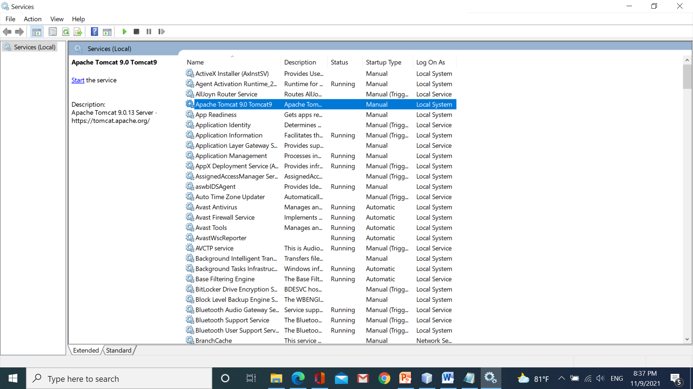

Start or stop by cmd [How to Start and Stop Apache Tomcat from the Command Line (Windows) | Webucator](https://www.webucator.com/article/how-to-start-and-stop-apache-tomcat-from-the-comma/#:~:text=%20To%20learn%20how%20to%20start%20and%20stop,a%20series%20of%20messages%20will%20appear%2C...%20More%20)

Or start/stop from NetBeans

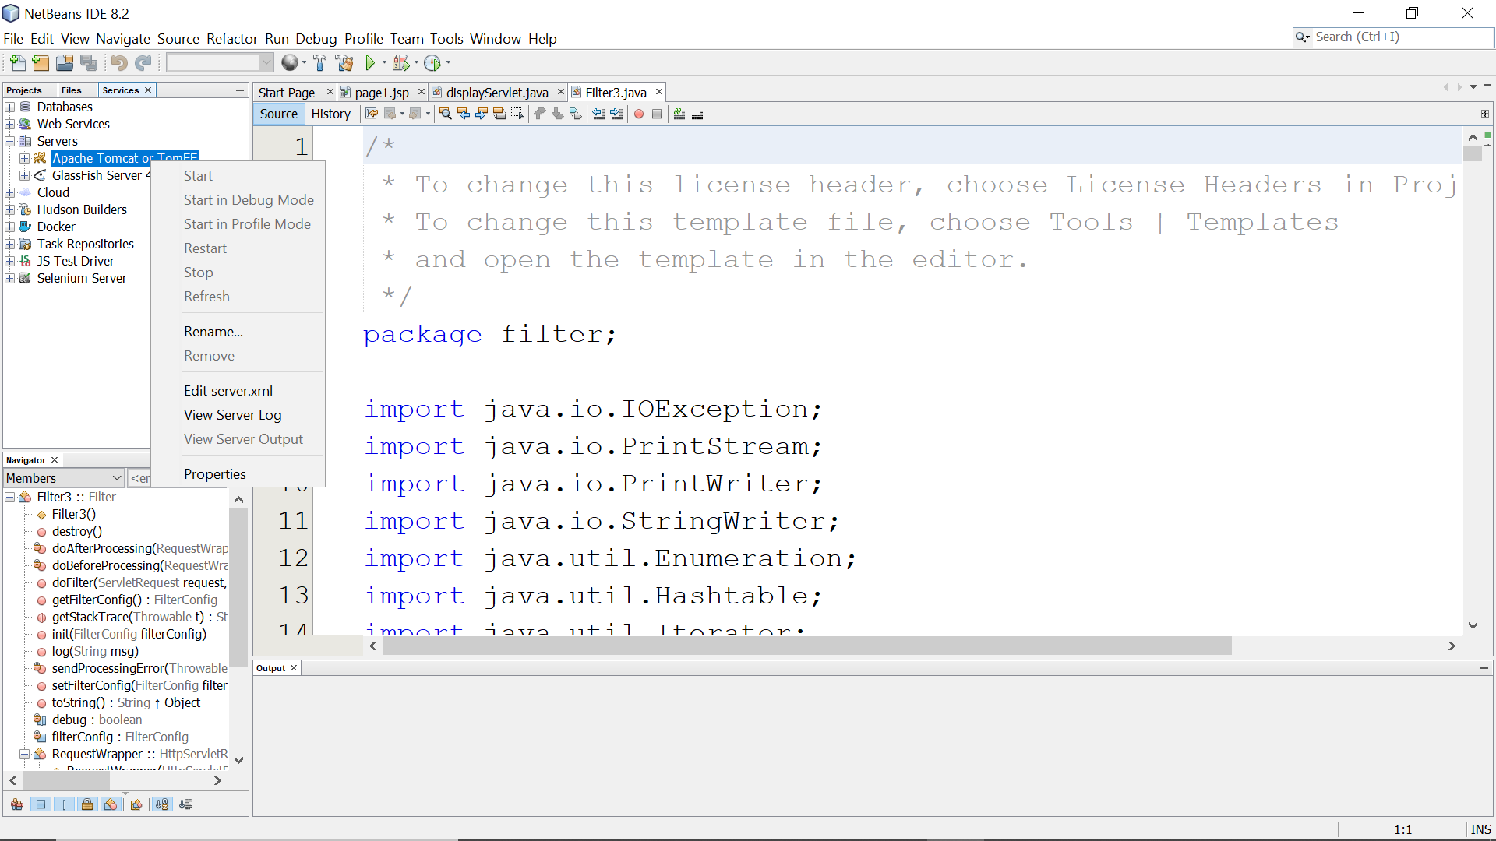

1. Install JavaEE in the Netbean ( use this to create a new web app )

[I don't see "Java Web" in the NetBeans IDE under available projects - Tips (sentientmindz.com)](http://www.tips.sentientmindz.com/2018/02/11/i-dont-see-java-web-in-the-netbeans-ide-under-available-projects/#:~:text=%E2%80%9C%20Java%20Web%20%E2%80%9D%20project%20type%20is%20not,and%20search%20for%20%E2%80%9C%20Java%20EE%20Base%20%E2%80%9C.)

1. Download sqljdbc4.jar (Use this to connect to the MS SQL Server)

[Download Microsoft JDBC Driver 4.2 for SQL Server from Official Microsoft Download Center](https://www.microsoft.com/en-us/download/details.aspx?id=54671)

1. To use web server(TomCat) qickly from NetBean. You need to add a new user/account to manage your app on the Tomcat server.

Open file “tomcat-users.xml” in path C:\Program Files\Apache Software Foundation\Tomcat 9.0\conf. type like below:



And save***.*** *Use username and password is created when you installed Tomcat.*

1. To your web app can connect to the SQL server. Open “SQL Server Configuration Manager” and set up all ports in the SQLServer like the figure

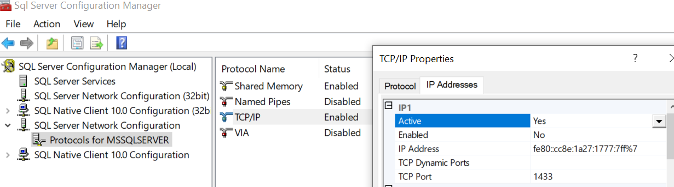

1. Create a database for doing all workshops and assignments. Run the code below

create database PlantShop

GO

use PlantShop

GO

create table Accounts(

accID int identity(1,1)primary key,

email varchar(30) unique,

password varchar(30),

fullname varchar(30),

phone varchar(12),

status int check(status =1 or status=0),-- 1:active; 0:inactive

role int check(role=1 or role=0) --:admin, 0:user

)

GO

create table Categories(

CateID int identity(1,1) primary key,

CateName varchar(30)

)

GO

create table Plants(

PID int identity(1,1) primary key,

PName varchar(30),

price int check(price>=0),

imgPath varchar(50),

description text,

status int, --1:active, 0:inactive

CateID int foreign key references Categories(CateID)

)

GO

create table Orders(

OrderID int identity(1,1) primary key,

OrdDate date,

shipdate date,

status int check(status =1 or status=2 or status=3),--1:processing, 2: completed, 3: cancel

AccID int foreign key references Accounts(AccID)

)

GO

create table OrderDetails(

DetailId int identity(1,1) primary key,

OrderID int foreign key references Orders(OrderID),

FID int foreign key references Plants(PID),

quantity int check(quantity>=1)

)

GO

**Create a new JavaWeb Project**

**8. Create a new project**

step 1: open Netbean/new Project/Java web/Web application

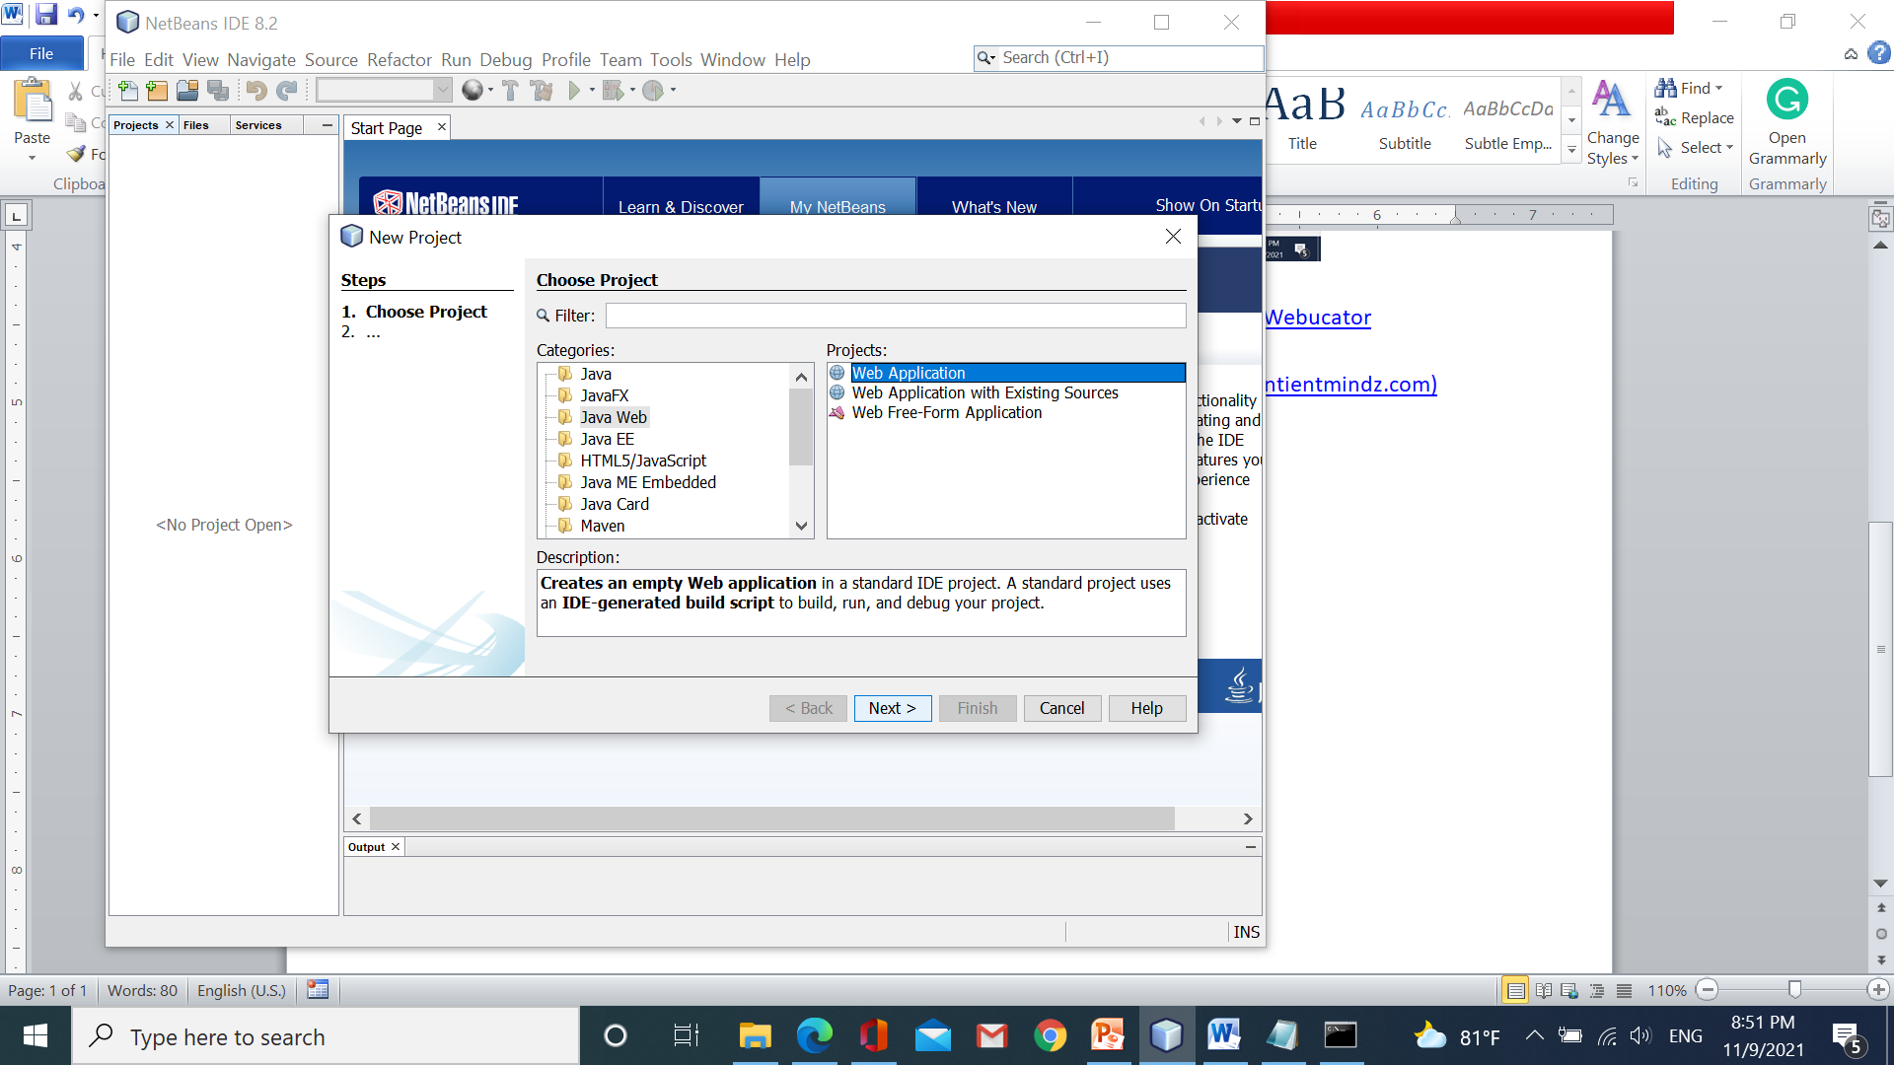  
 step 2: give a project name, project location and click Next

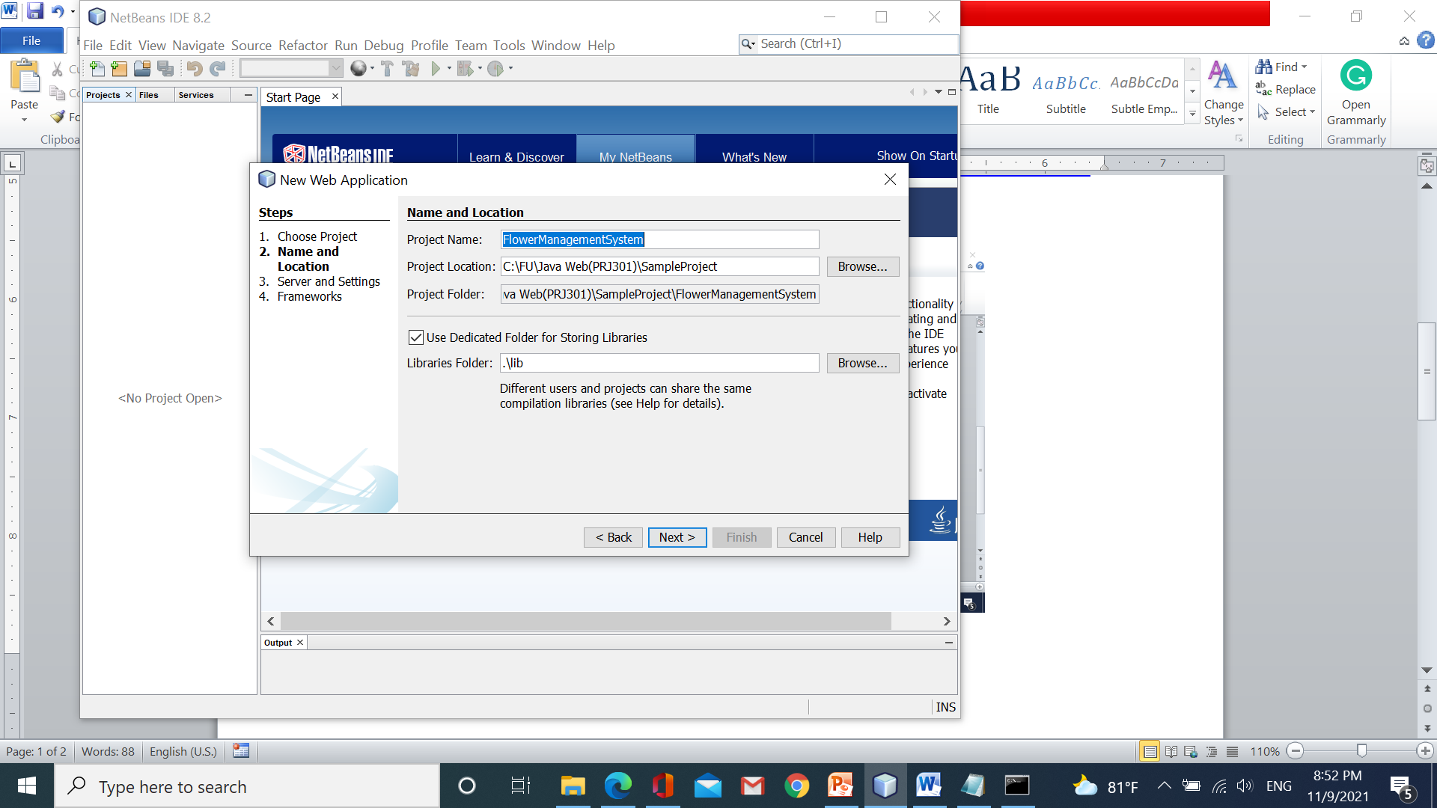

Step 3: Click Add and choose web server Tomcat, or any webserver, click Next

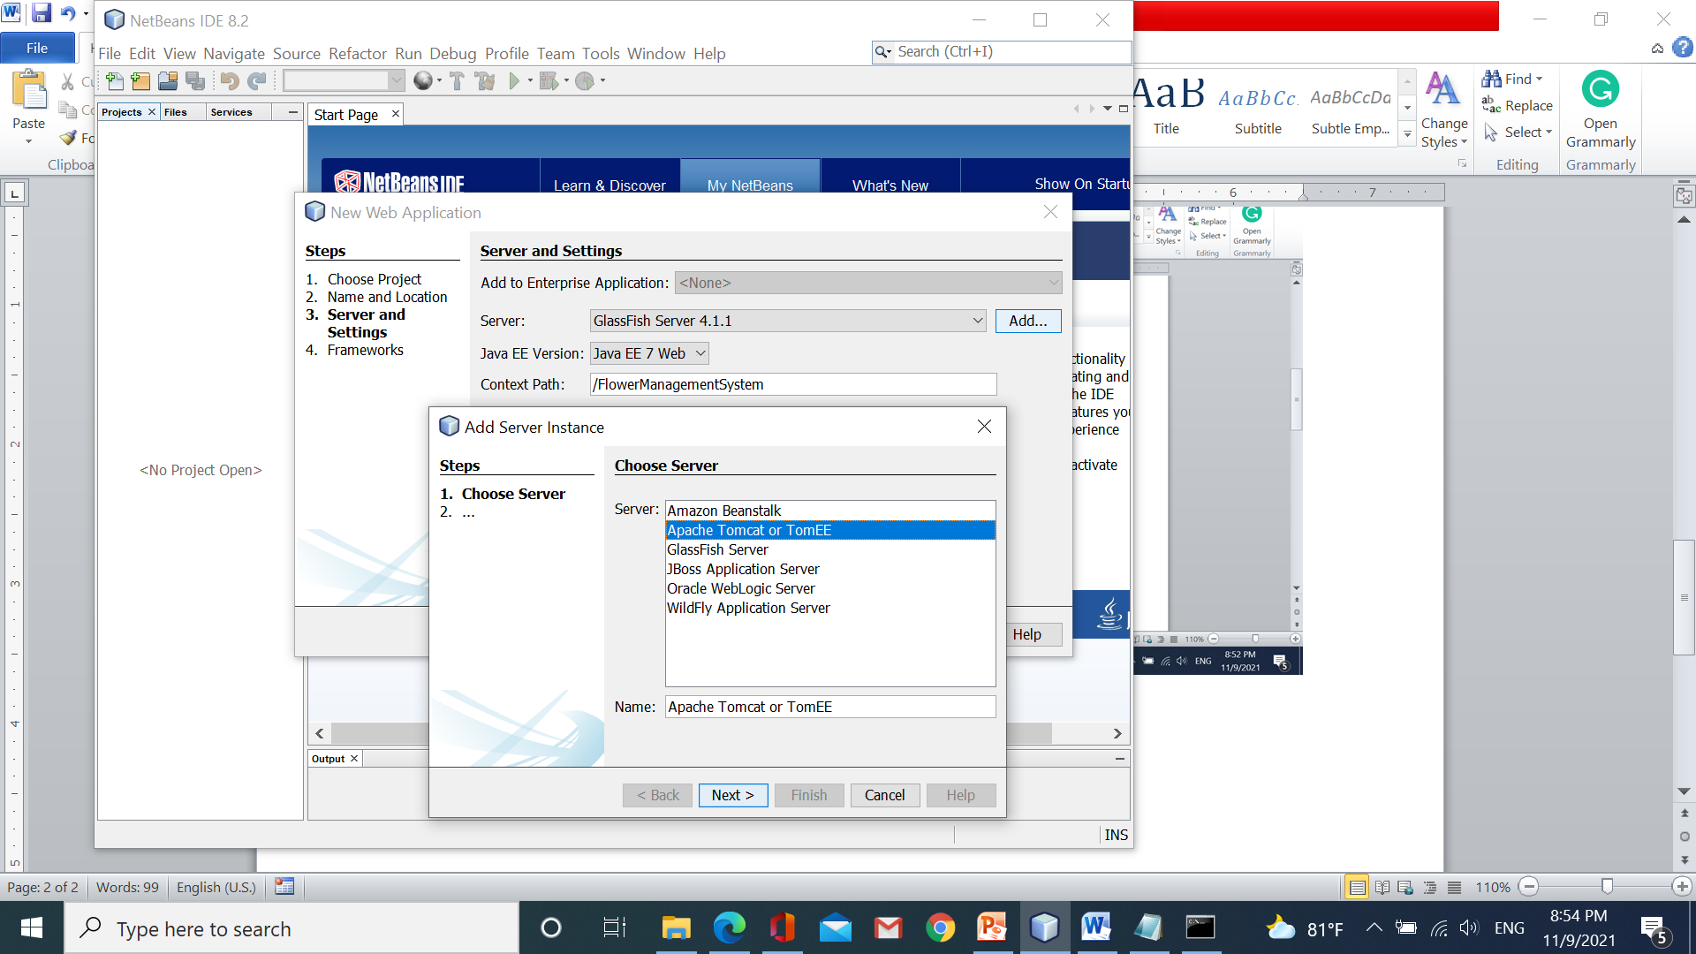

Step 4: choose the server location and input username=”admin”, password=”admin” (account of the user that is stored in the file tomcat_user.xml )/click finish

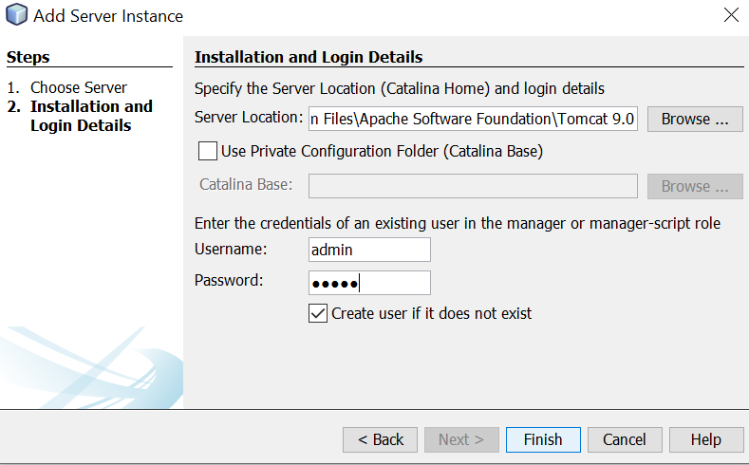

**Problem:** Develop a web app to introduce plants that are orchids, roses,..etc. Users can buy plants from this app, track their orders. Besides, this app supports a dashboard for the admin. The website has three roles: guest, admin, and members.

**The common functions for all roles (guest/member) :**

* Search Plants by their name or category
* View information of plants
* Buy plants

**The guest functions:**

* Registrate a new account

**The member functions after login:**

* log out to the system
* View himself/herself orders ( all days, or filter from date to date).
* Cancel the order ( only cancel orders whose status is processing)
* Order again (only perform on orders whose status was canceled)
* Change his/her profile

**The admin functions after login:**

* Manage accounts: view all accounts, block/unblock an account
* View all orders, filter orders between from date and to date, filter orders of any customer.
* Manage plants ( view,create,update plants)
* Manage categories: view, create, update
* Log out

**Requirement:**

* The problem is broken down into some parts that include basic parts and advanced parts
* The basic parts(highlighted) are used to get the workshop’s mark. These parts will be guided step by step
* The advanced parts are used to get the assignment’s mark. You must perform these parts by yourself.
* The workshop/assignment is evaluated in the 10th week.

**Workshop 1: Learn JDBC, Servlet**#HTML #Form # JDBC #Request Object #Response Object # Servlet

**Learning outcome:**

* Learn JDBC
* Learn servlet
* Perform the login function

Part 1: Learning JDBC

**Step 1: The student creates some packages, files like the figure:**

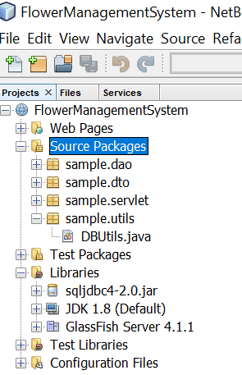

Add this file from downloaded driver

DBUtils.java

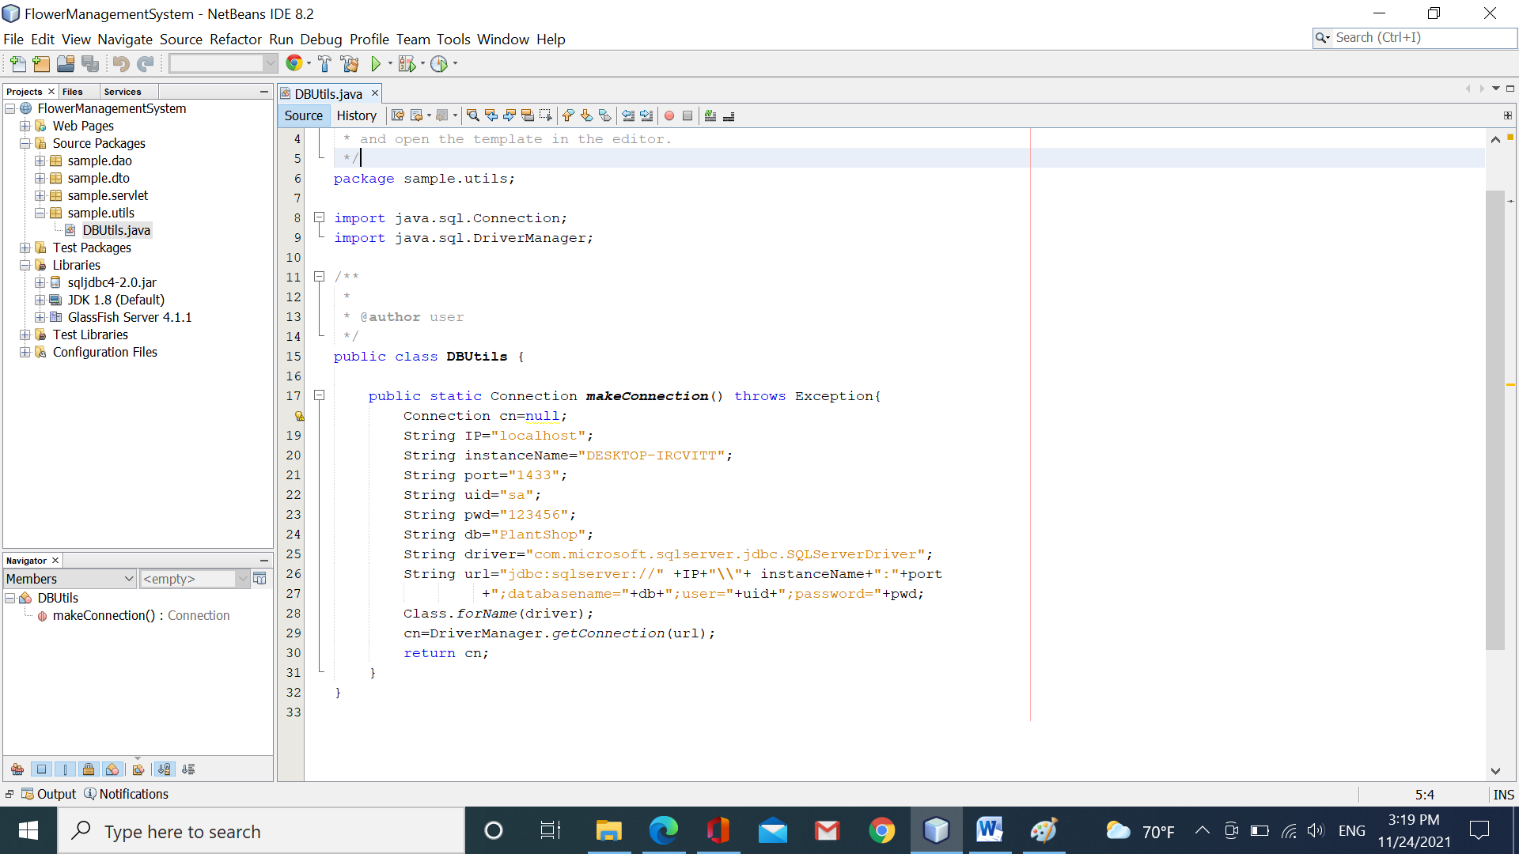

Change instanceName,username,password based on yours

**Account.java**

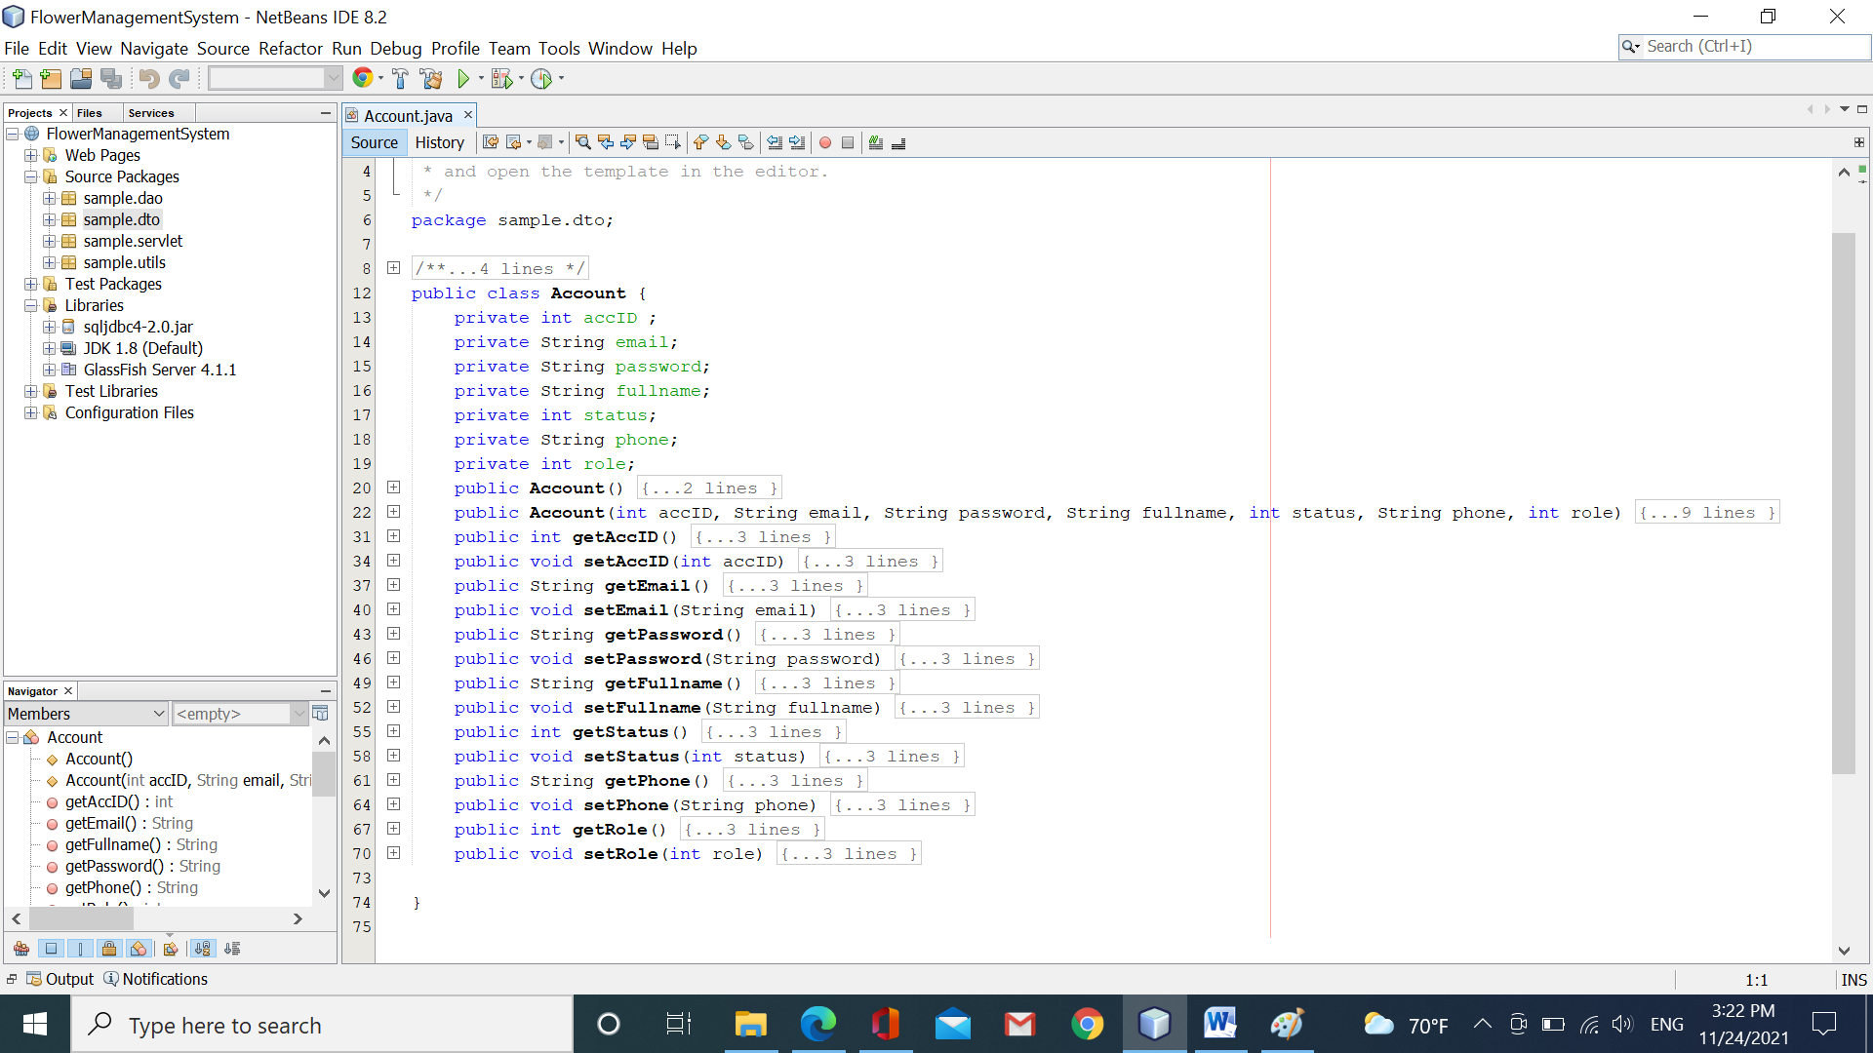

**AccountDAO.java**

You write the method “getAccount(String email, String password)” to return the account that equals the given parameters.

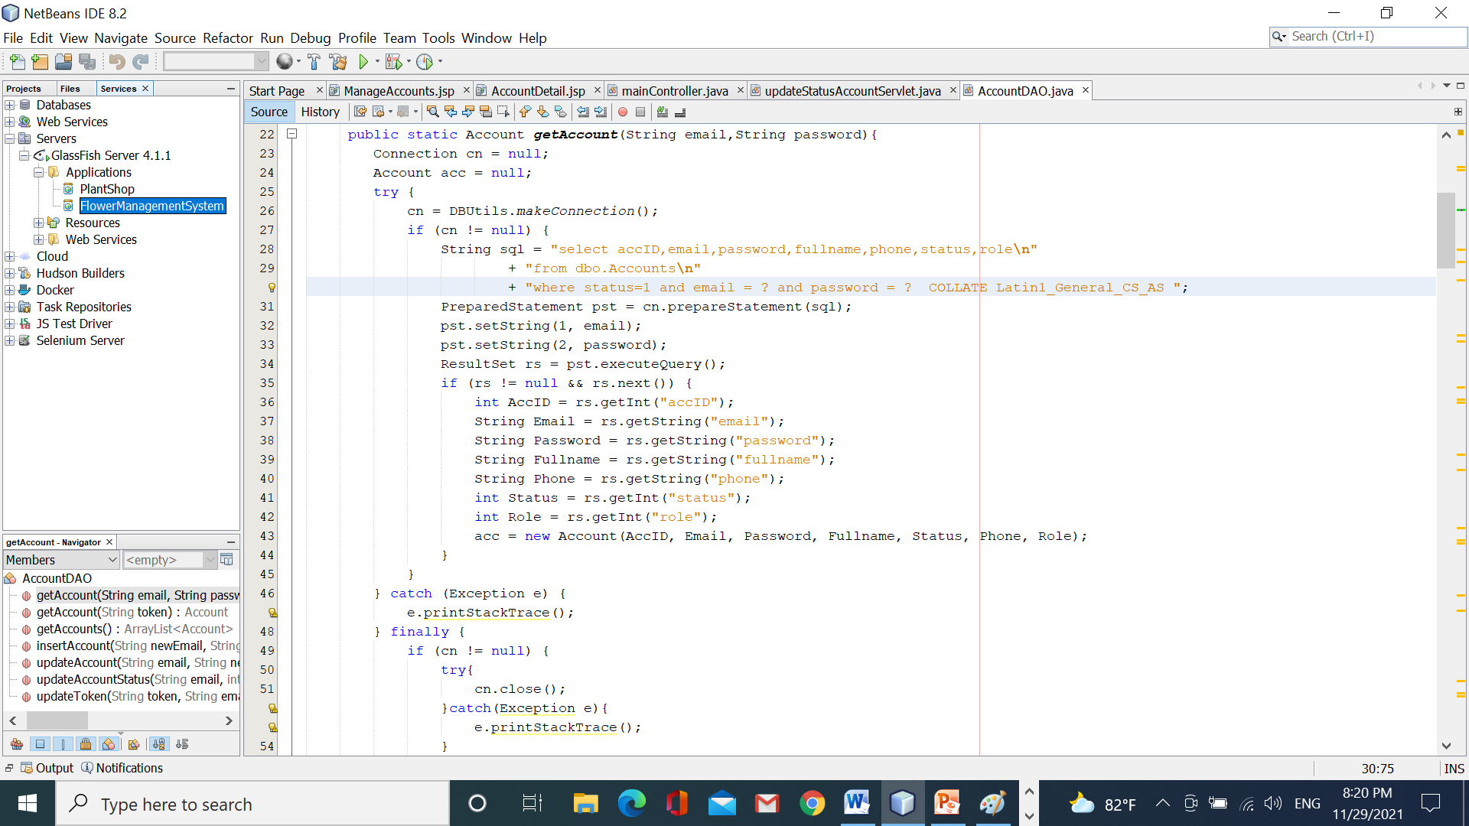

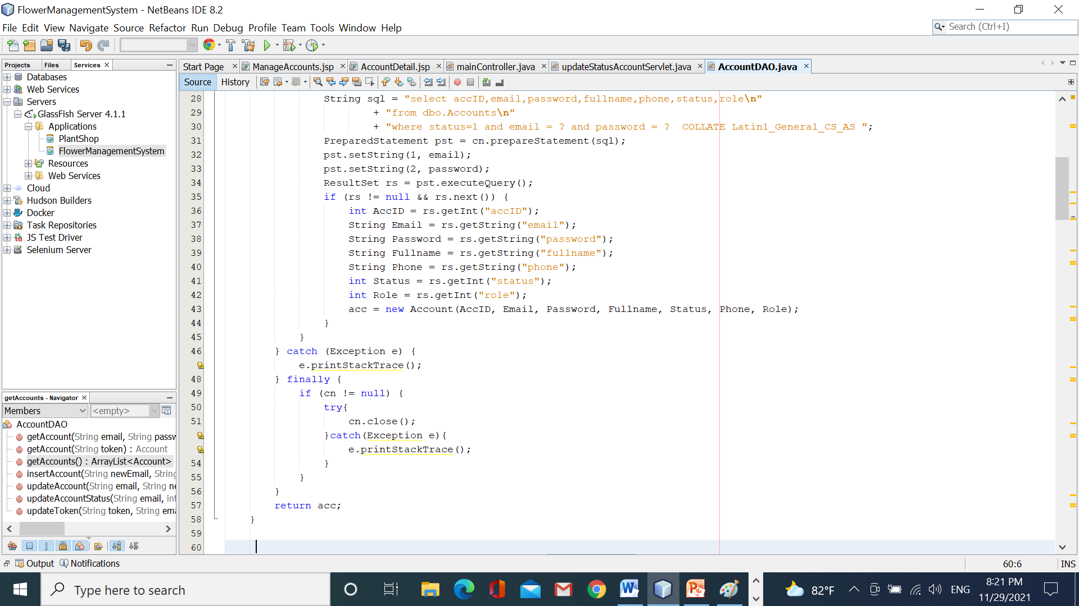

**Step 2: to test the code, we create a file named “testConnection.java” in the package** “sample.dto”. In the table Accounts, you must input sample tuples like

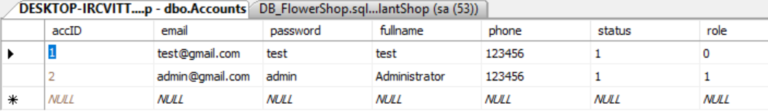

and run this file with input data email= “[test@gmail.com](mailto:test@gmail.com)”, password=”test”.

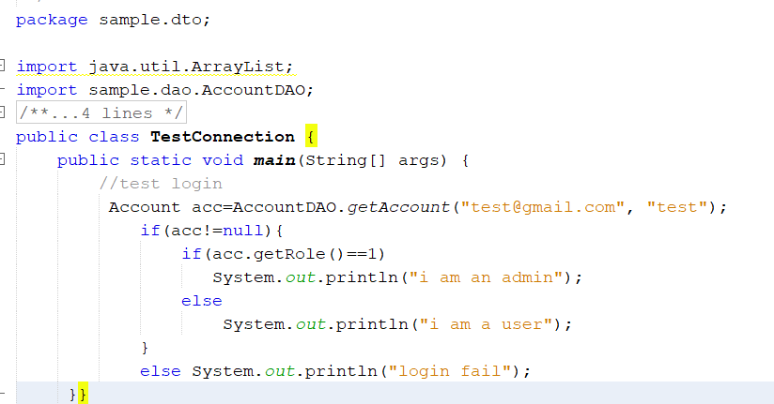

So, you have learned about JDBC (just a little, ☺).

The advanced challenge:

1. In the file AccountDAO, write the function   
   public static ArrayList<Account> getAccounts(){…}. This function returns the list of accounts that are got from the table Account. You test this function in the main method.
2. In the file AccountDAO, write a function named public static boolean updateAccountStatus(String email, int status). This function will update the account’s status based on the given email and return true/false
3. In the file AccountDAO, write a function named public static boolean updateAccount(String email, String newPassword, String newFullname, String newPhone). This function is used to update the full name, phone, password of the account based on the given email and returns true/false.
4. In the file AccountDAO, write a function named public static boolean insertAccount(String newEmail, String newPassword, String newFullname, String newPhone, int newSatus,int newRole). This function is used to insert a new account into the table Accounts and return true/false.

You can use the sample to test the methods above

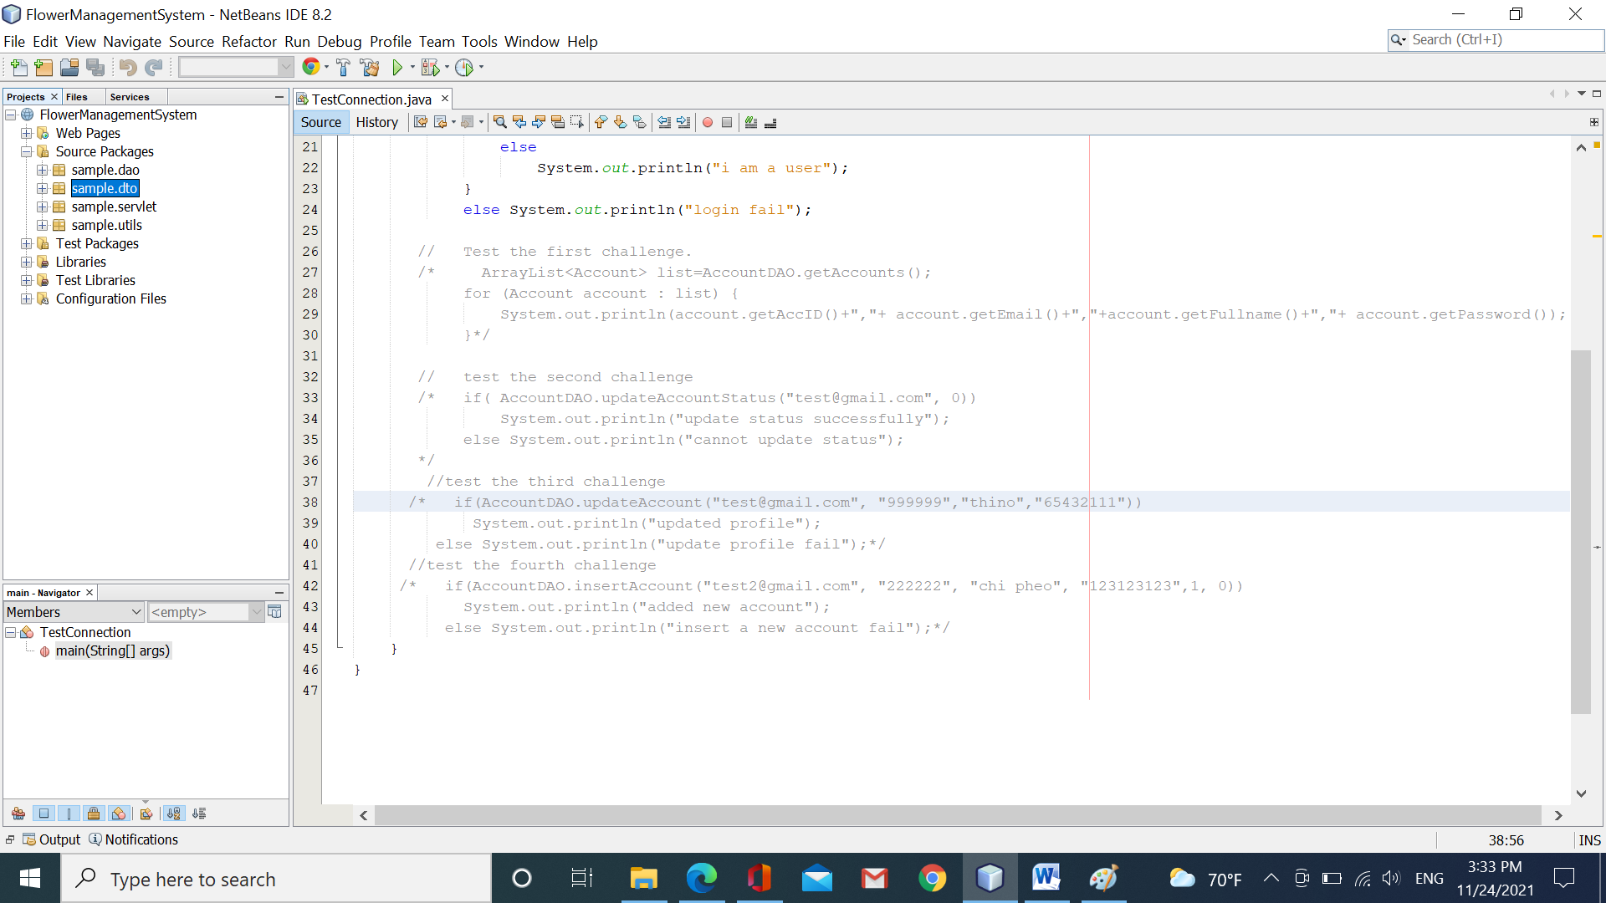

Part 2: perform the login function.

Step 1: You create three files HTML in the folder “Web Pages” and one file loginServlet in the package “sample.servlet” like the figure:

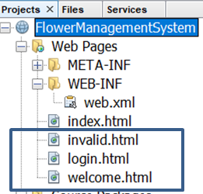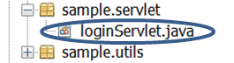

login.html

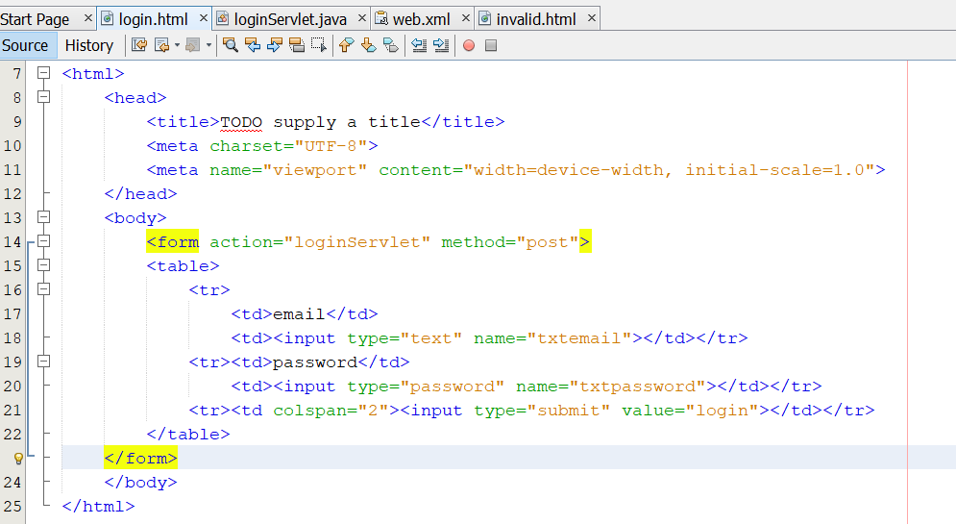

invalid.html

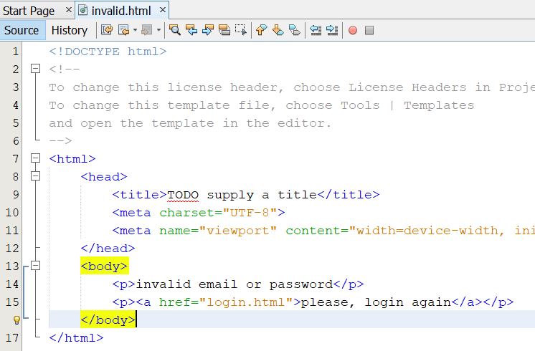

Welcome.html

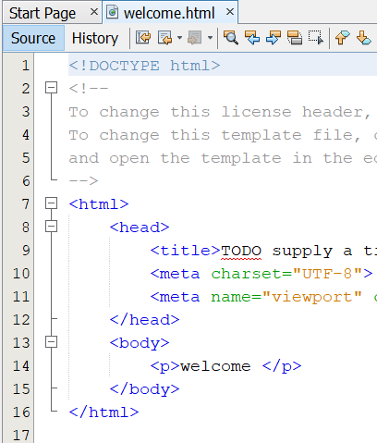

loginServlet.java

right-click in the package “sample.servlet”/new servlet/finish.

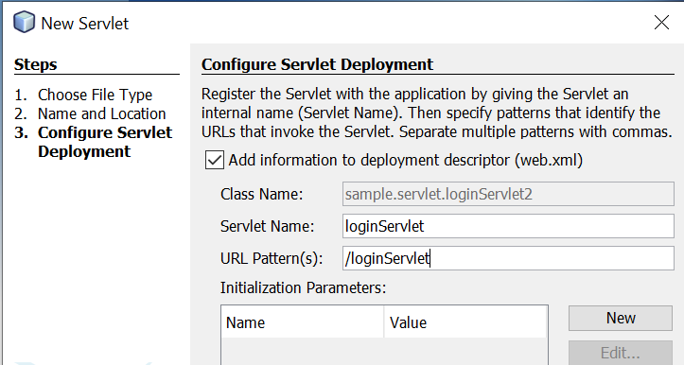

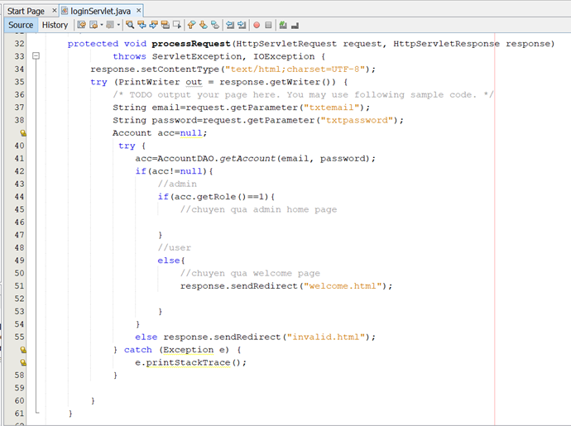

Open the file web.xml to set up the first page to run.

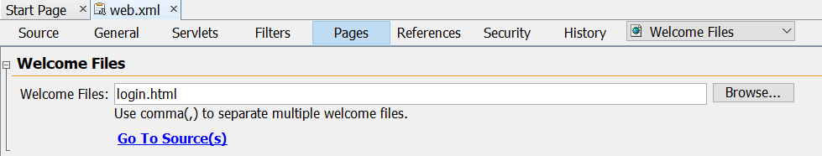

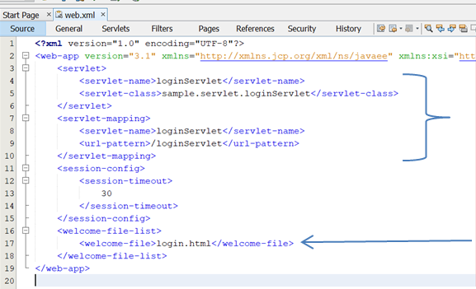

Now, you click “clean and build”/right-click on the project/deploy.

Deploy your app to copy *.war to the webserver. From now, you can run the web without needing Netbean.

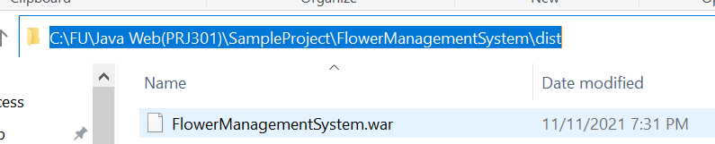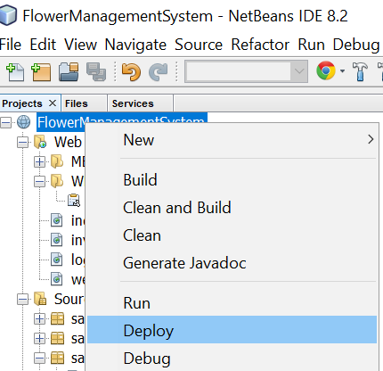

And then, click open in the browser

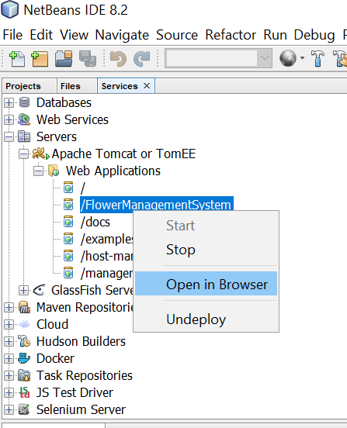

The result:

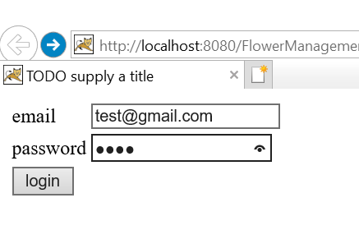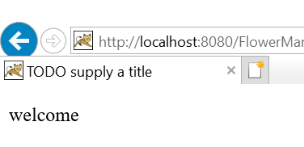

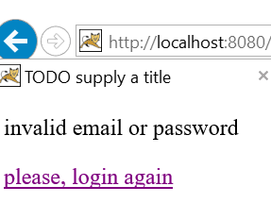

Congratulations!!!! you have finished workshop 1 ☺ ☺

**Workshop 2: Learn JDBC , Servlet**

#HTML #Form # JDBC # Servlet

**Learning outcome:**

* Students can create the register form
* Students use technologies of JDBC
* Students can create servlets to insert a new account into the database.

Part 1: how to create a registration form

**Step 1: Students edit the file index.html like the code below:**

<html>

<head>

<title>TODO supply a title</title>

<meta charset="UTF-8">

<meta name="viewport" content="width=device-width, initial-scale=1.0">

<link rel="stylesheet" href="mycss.css" type="text/css" />

</head>

<body>

<header>

<nav>

<ul>

<li><a href=""><img src="images/logo.jpg"></a> </li>

<li><a href="index.html">Home</a></li>

<li><a href="registration.html">Register</a></li>

<li><a href="login.html" >Login</a></li>

<li><form action="searchServlet" method="post" class="formsearch">

<input type="text" name="txtsearch">

<select name=”searchby”>  
 <option value=”byname”>by name</option><option value=”bycate”>by category</option>  
 </select>

<input type="submit" value="search" name="action" >

</form></li>

</ul>

</nav>

</header>

<section>

</section>

<footer>

<p></p>

</footer>

</body>

</html>

* *All pages contain header tag the same, they are differences in the section tag.*

**Step 2: Student create a new file named “mycss.css”**

*{

box-sizing:border-box;

}

html{ font-family: arial;

font-size: 12px;

}

header,section,footer,nav,ul { float: left;width: 100%;}

header, nav, footer{ height: 100px;

background-color: #e1f5eb;

}

section { height: auto;}

header li{width:10%;

list-style-type: none;

text-align: center;

float:left;

}

a { color: #006666;

font-size: 1.5em;

text-decoration: none;

}

header li:last-child { width:30%; float:right;}

#logo { width: 100px; height: 100px; }

.form table{width:50%;}

.product {width: 20%; height: auto; float:left; margin: 5%;}

.order { border: 1px solid #cccccc; width:100%; margin: 1%;}

.order tr:first-child{ width:100%; background-color:#e1eee7 ; color: #006666;}

.order td{ color:black; width: 15%;}

.plantimg { width:100px; height: 100px;}

.shopping { width:70%;}

**Step 3: Create a new file named “registration.html”**

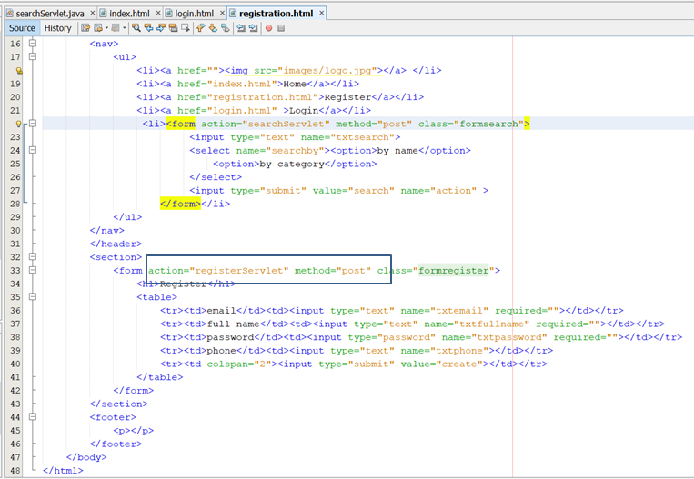

**Step 4: create a new file named “registerServlet.java” in the package “sample.servlet”**

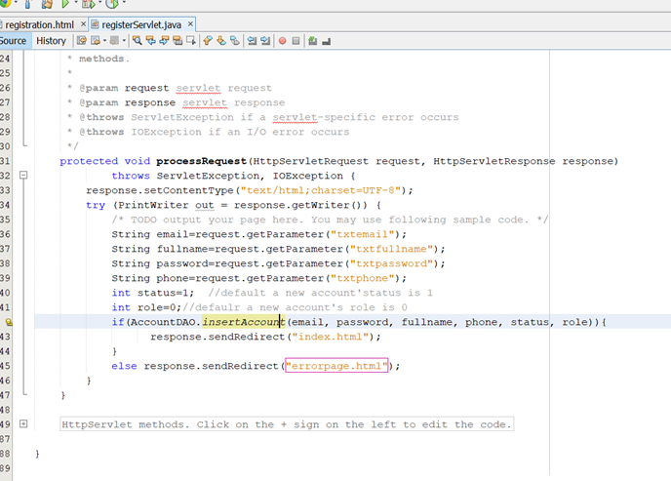

**Step 5: Create a file named “errorpage.html”**

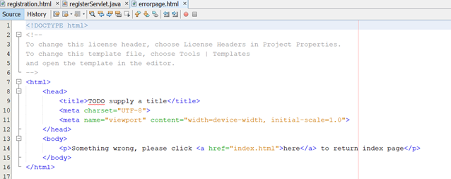

Step 6: run your app, click the link “register”

Sample

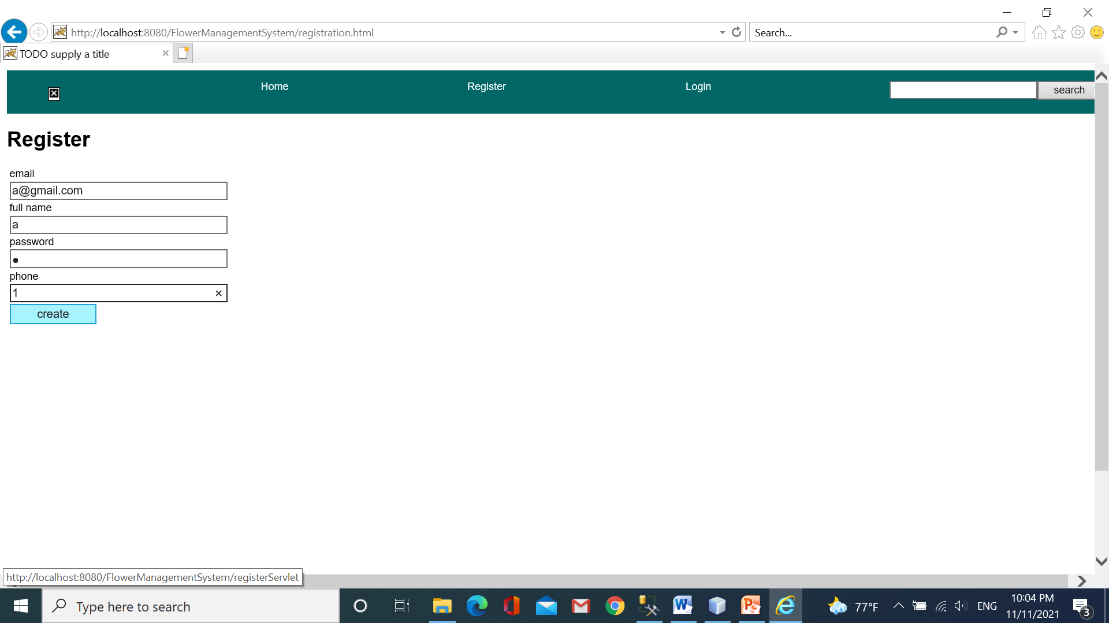

* After running, the web returns the index page.

Part 2: do the search function.

Step 1: input the table Categories and Plants some tuples.

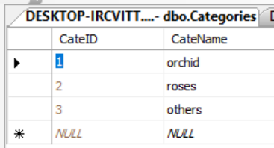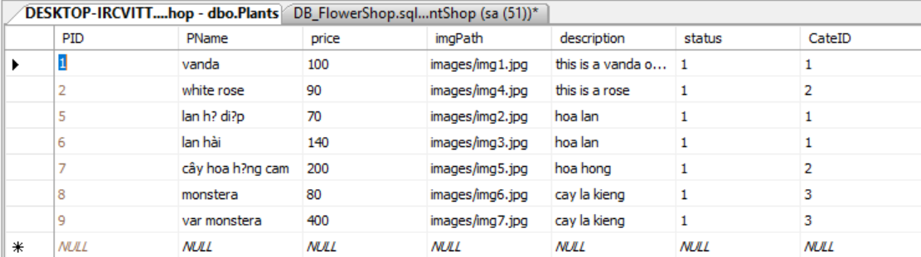

Step 2: Prepare your images

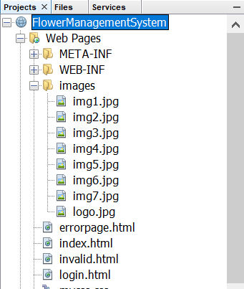

Step 3: In the package sample.dto, create a new file named “Plant.java”

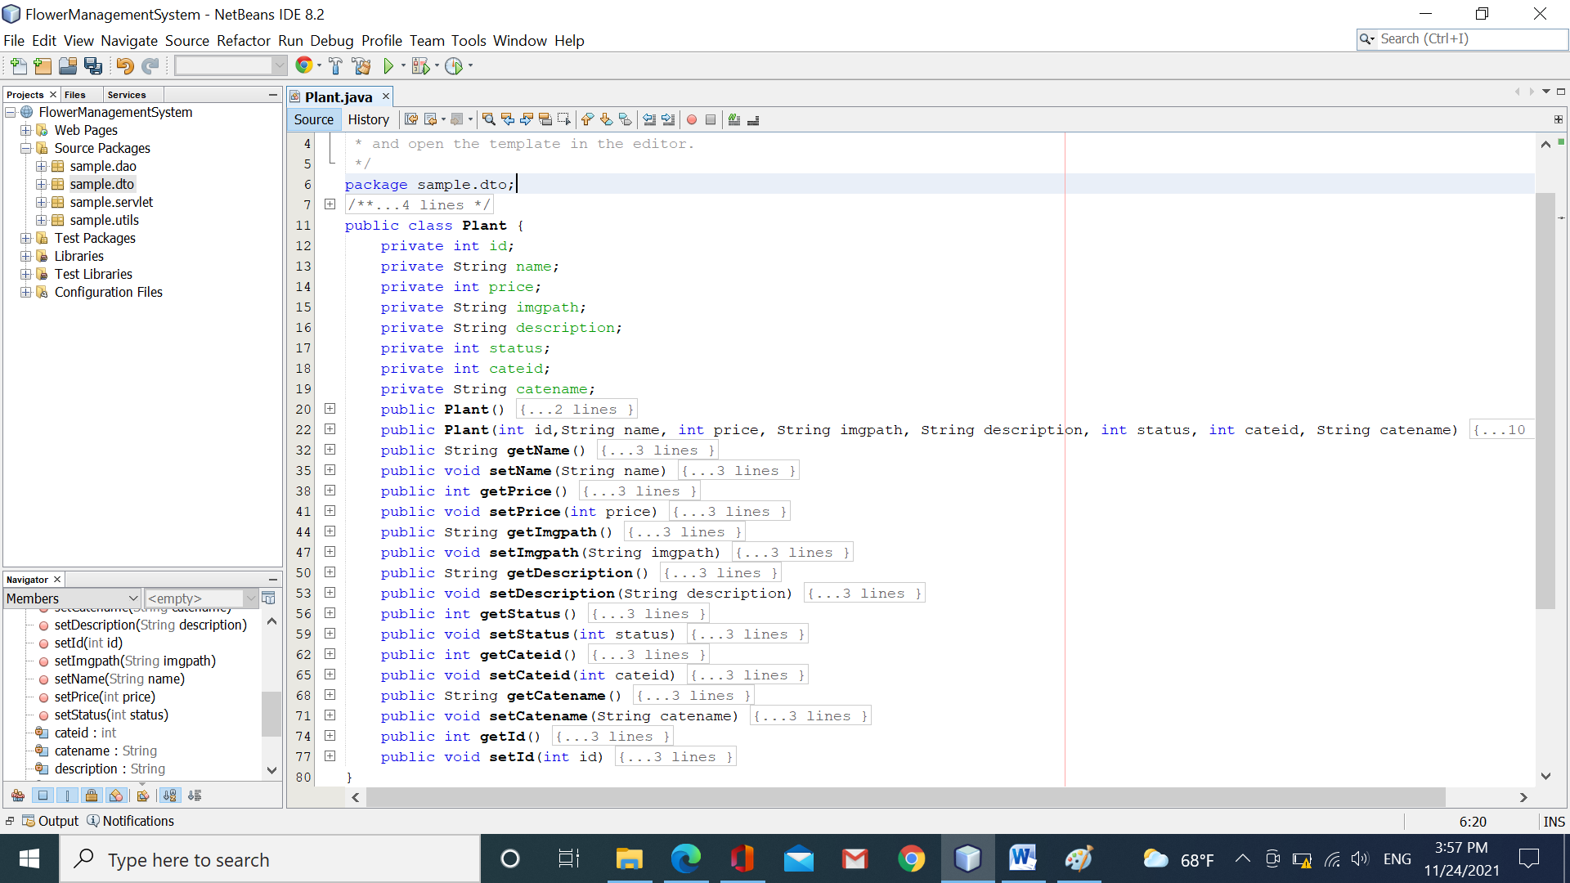

Step 4: In the package “sample.dao”, create a new file named “PlanDAO.java”.

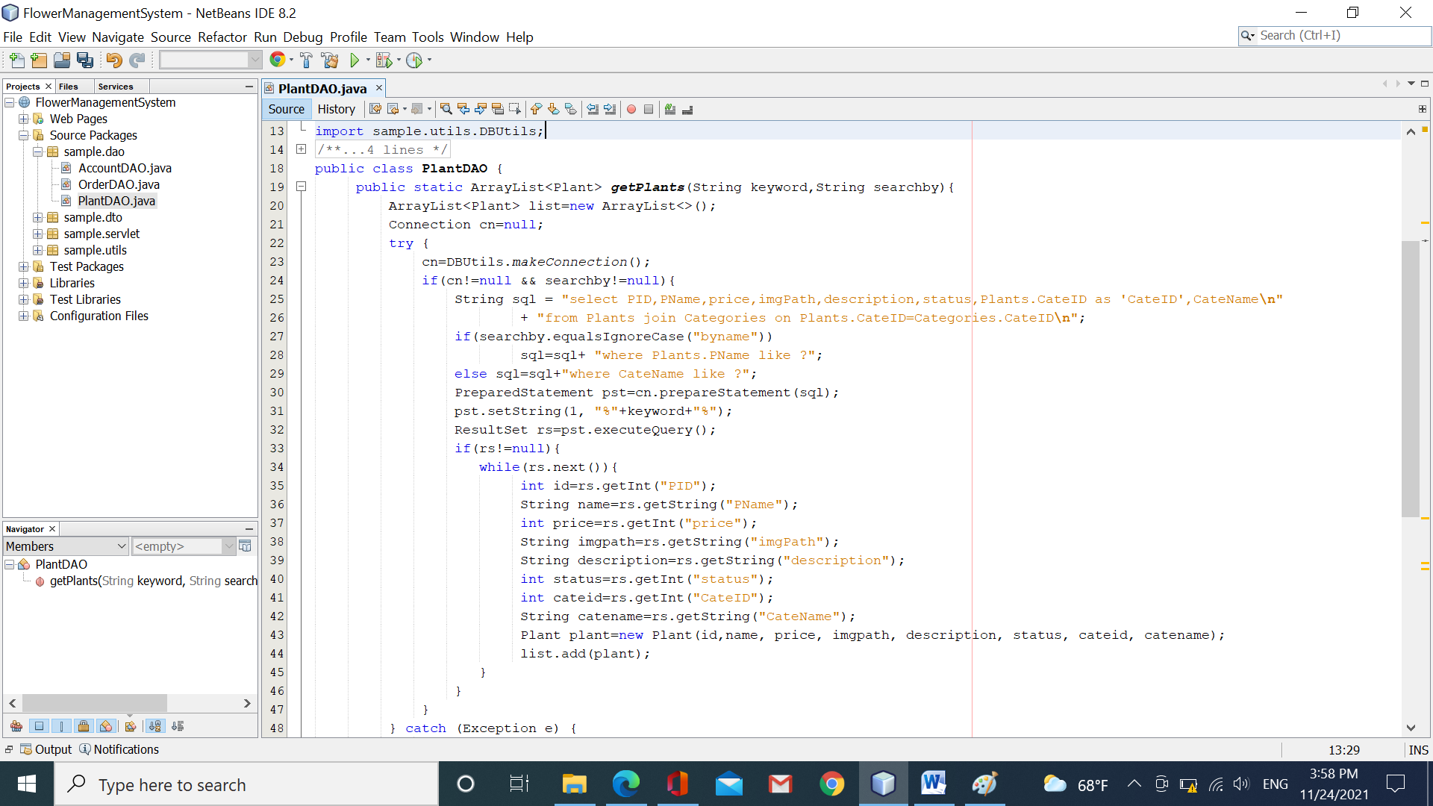

Step 5: In the package “sample.servlet, create a new file named “searchServlet.java”

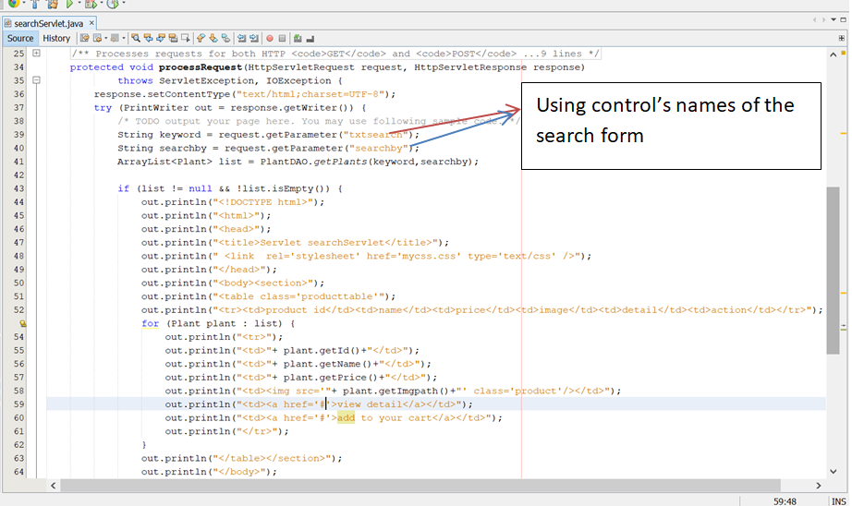

Step 6: run your app to get the result

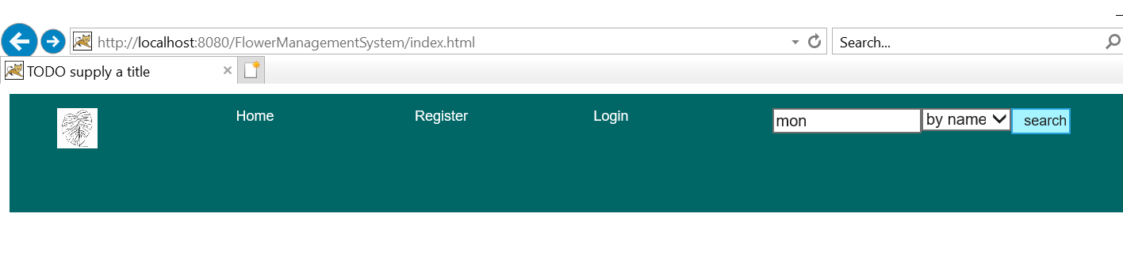

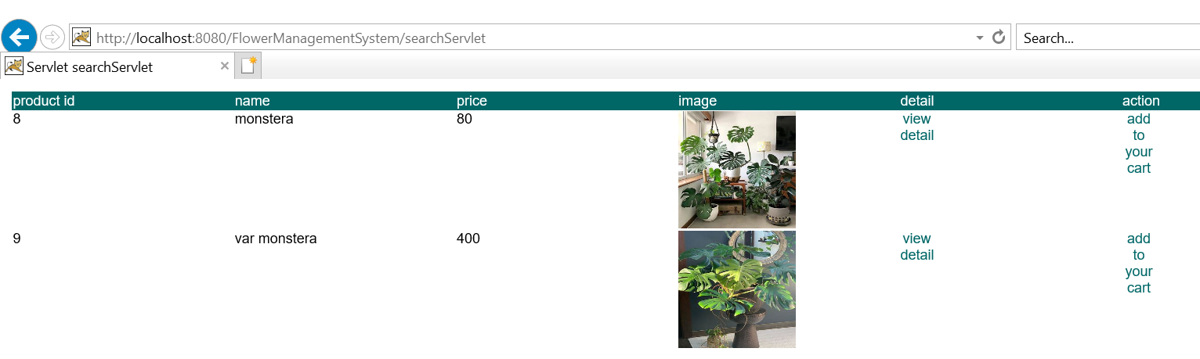

Congratulations!!!! you have finished workshop 2 ☺ ☺

**Workshop 3: transfer from resources to others with/without data/objects?**

#initial parameters #scope # deploy # transfer

**Learning outcome:**

* Understand context and servlet initial parameters and how to define and access them from using web.xml file
* Understand the request, session, context scope term, and use memory suitably for storing data
* Understand transfer data from the resource to other resources

Part 1: Define the initial parameter in the context(web app), and display it in all servlets

Step 1: Open the file “web.xml”, do the followings

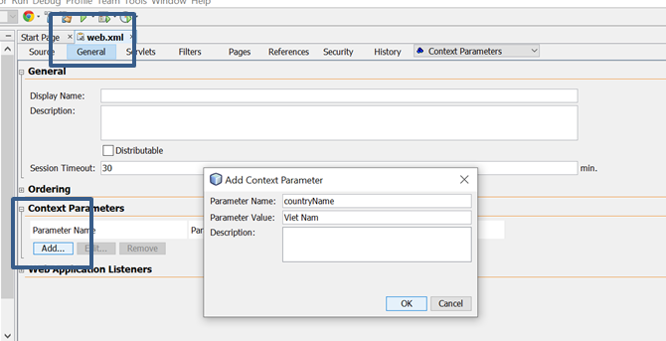

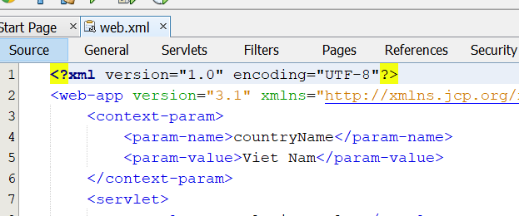

Step 2: display the country name in the servlet “searchServlet”, or any servlet(if any)

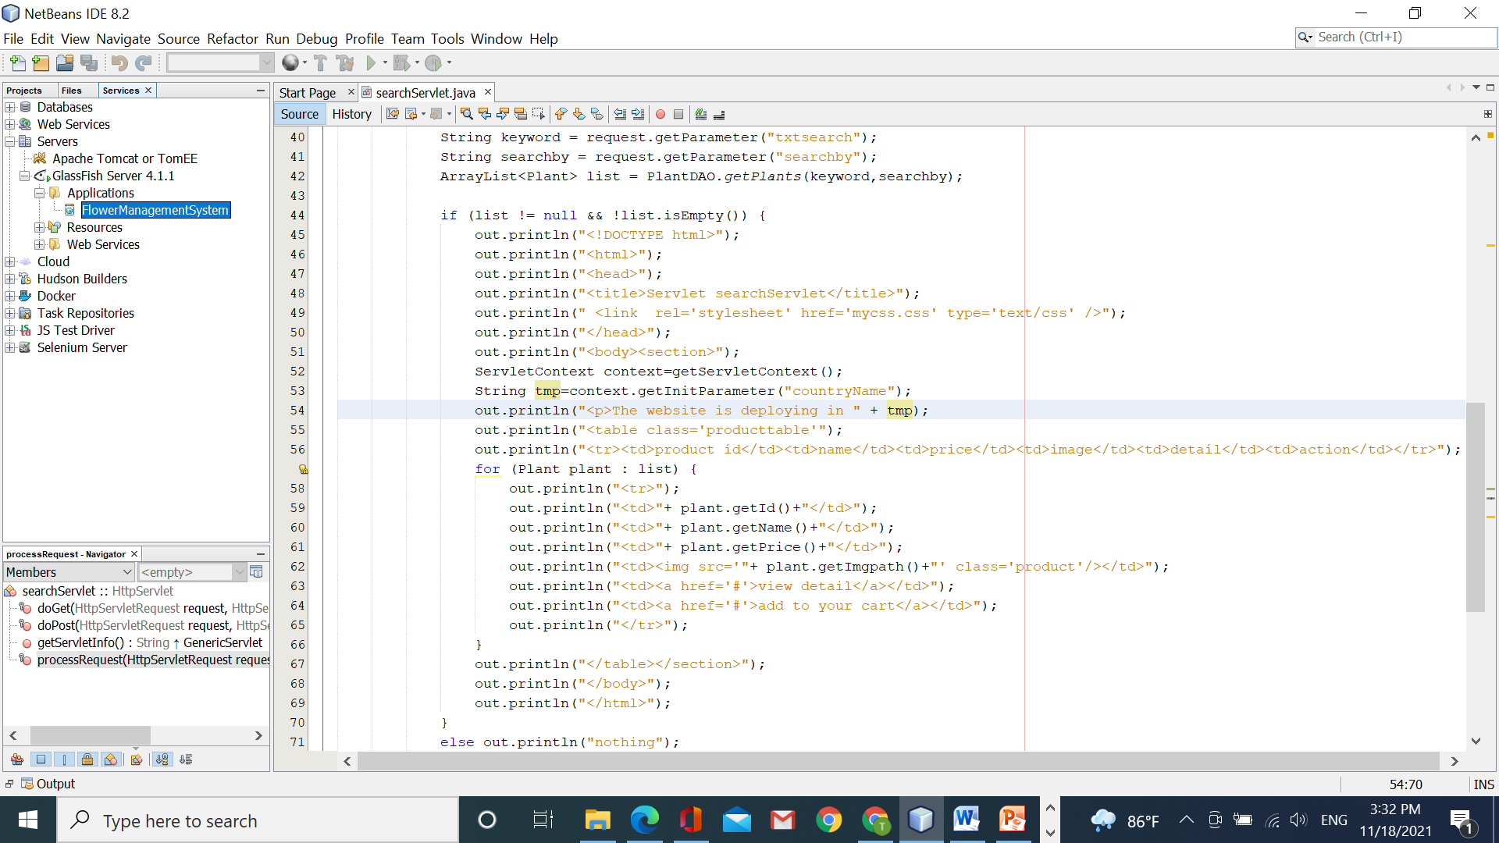

Part 2: define only the initial parameter on the servlet only.

Step 1: Open the file “web.xml”, at “search servlet”, type the followings

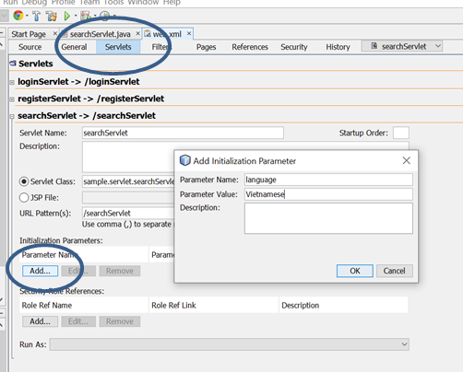

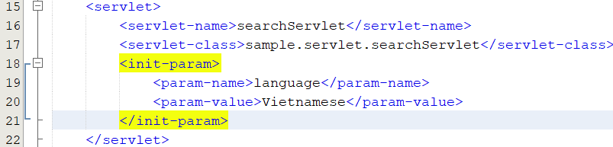

Step 2: Open the file “searchServlet”, and type

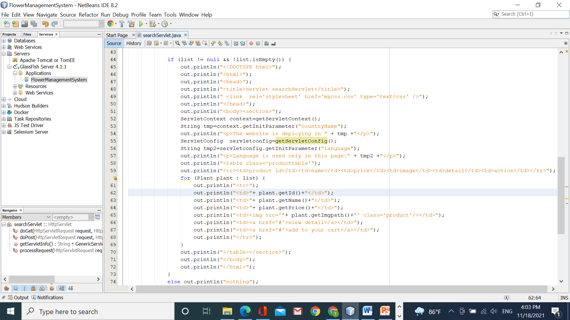

The result:

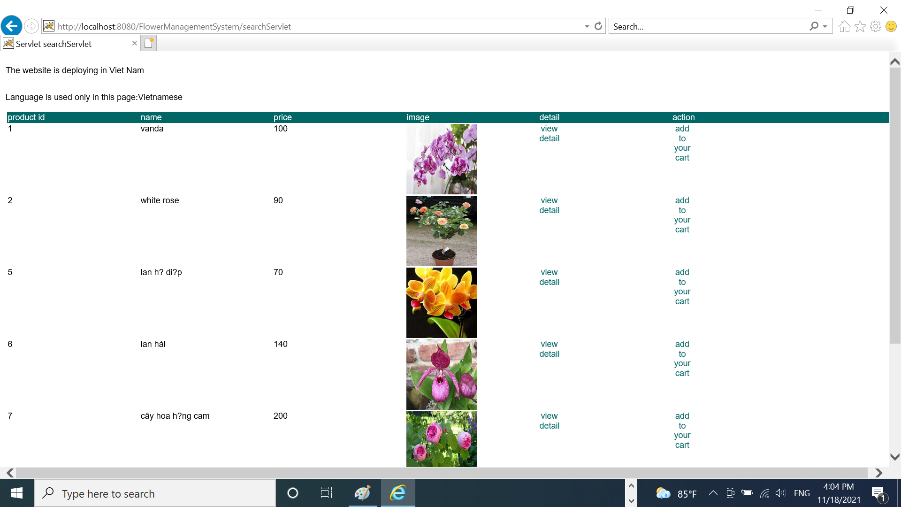

Part 3: Transfer data from the servlet to other servlets by the method **forward**

Step 1: Open the file “registerServlet.java”, and edit the code

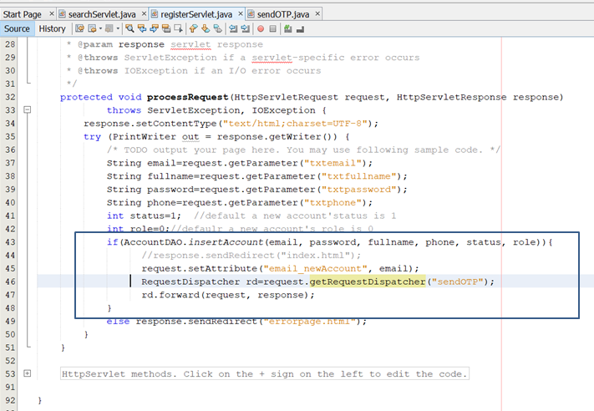

Step 2: In the package “sample. servlet”, create a new servlet named “sendOTP.java”

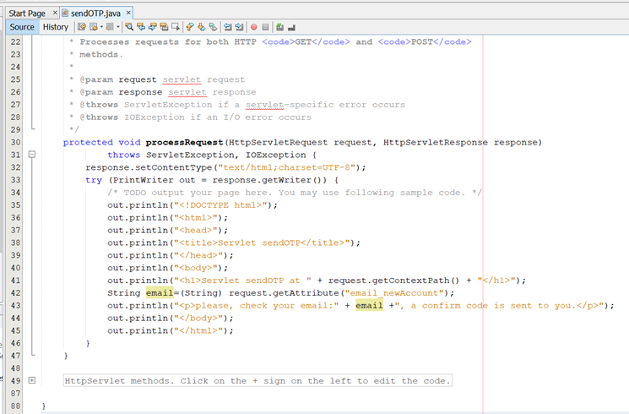

Step 3: run the web, click the link “register” to create a new account and you will see the result.

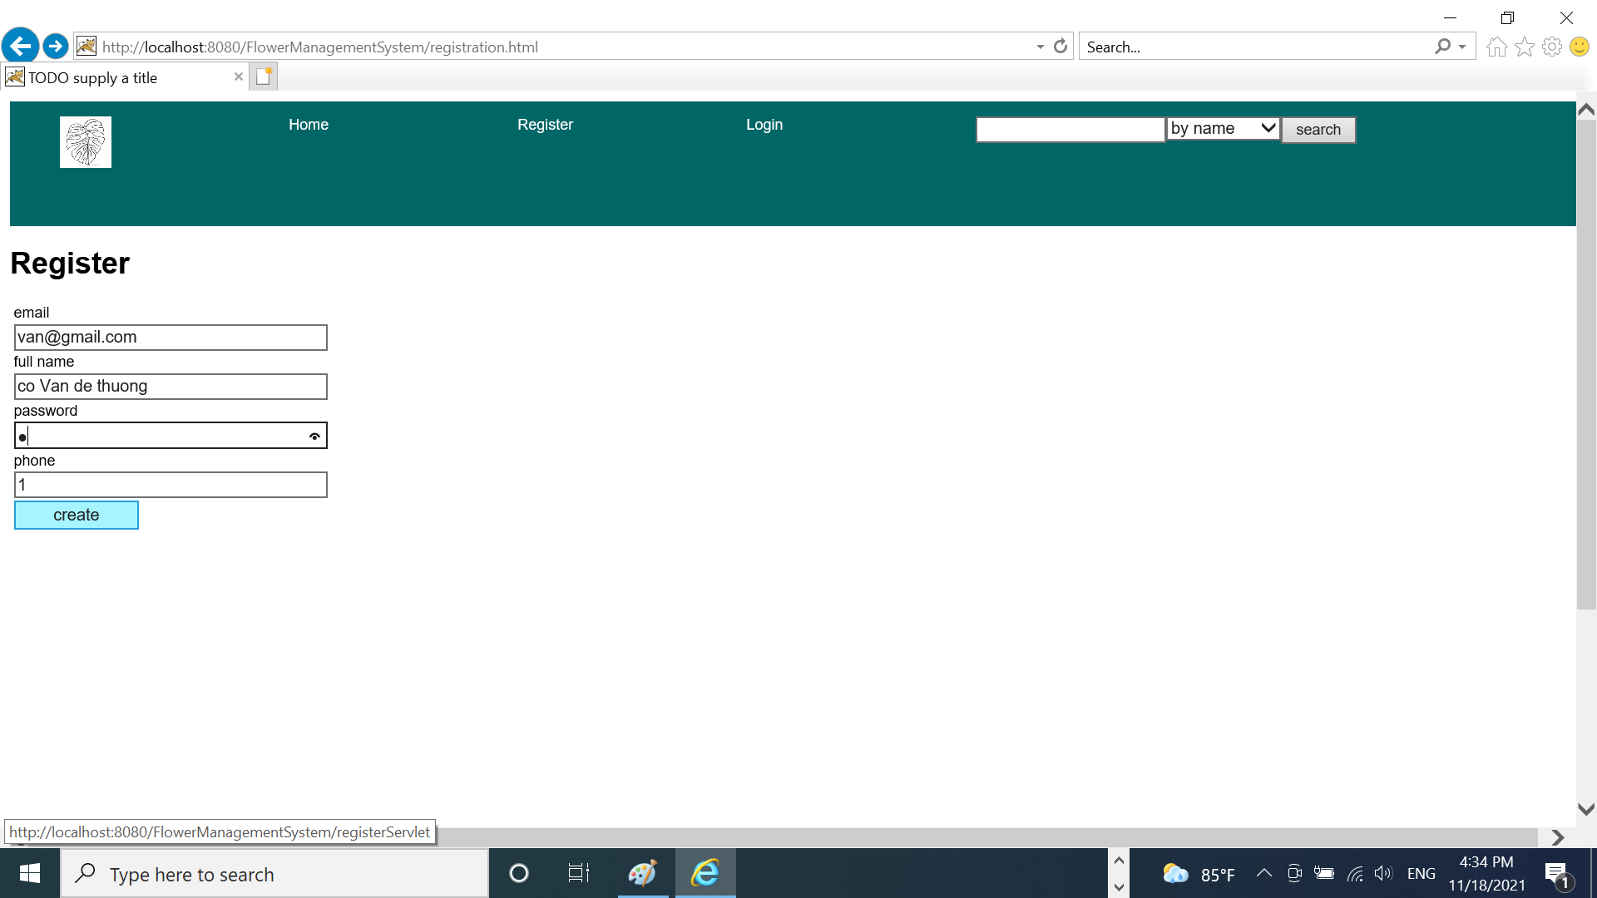

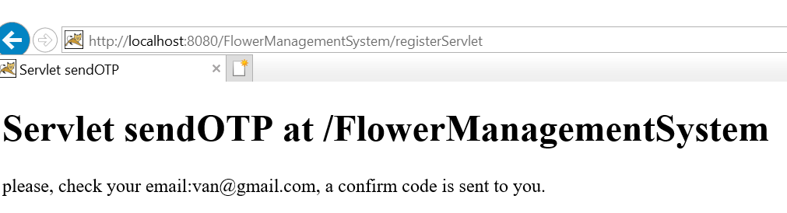

The content of the servlet “sendOTP”

Part 4: Transfer data from the servlet to other servlets by the method **include**

Step 1: In the package ‘sample. servlet”, create a new servlet named “contactServlet”

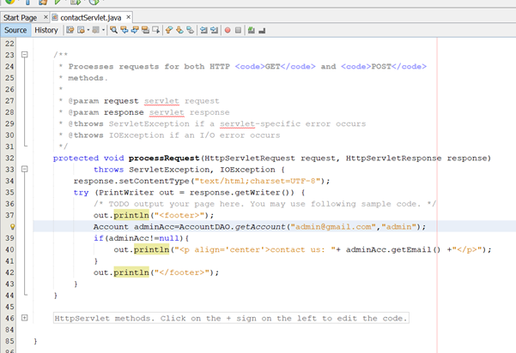

Step 2: In the servlet “sendOTP”, edit the code:

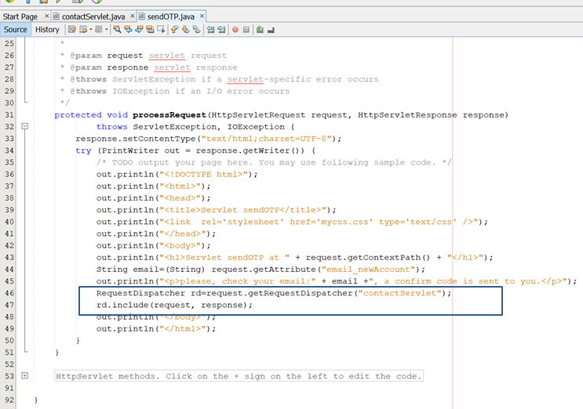

Step 3: Run the page register.html to create a new account, the result will be:

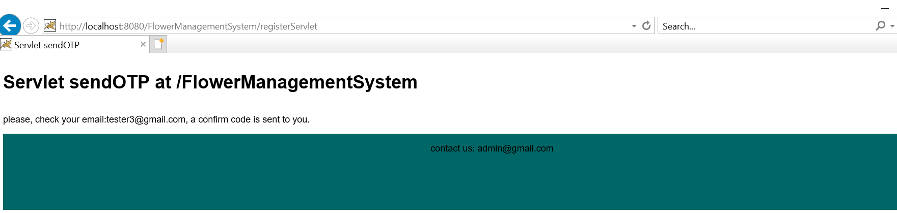

Congratulations!!!! you have finished workshop 3 ☺ ☺

**Workshop 4: learn MVC2 design**

#session #JSP #Impicit objects #MVC2

**Learning outcome:**

* Study using a servlet to make the main controller that accepts all requests from the client
* Study using JSP pages to presentation content
* Using Session to store the user’s full name after login
* Perform the user’s all functions.

Part 1: Create a “mainController” using servlet . This servlet has a role like a gatekeeper. All requests should transfer to the mainController. It dispatch to decide upon the appropriate logic to handle the request

Step 1: in the package “sample.servlet”, create a new servlet named “mainController”

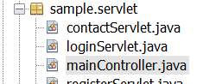

Step 2: You will create two new pages named “header.jsp”, “footer.jsp”.   
header.jsp

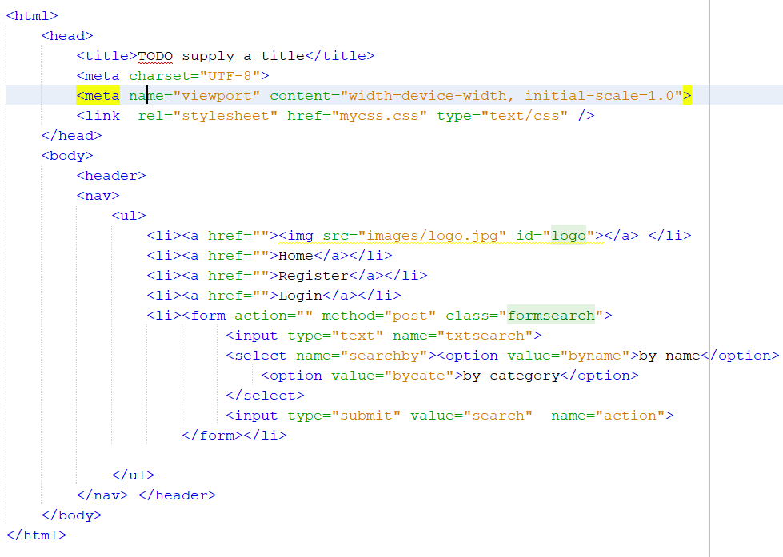

Footer.jsp

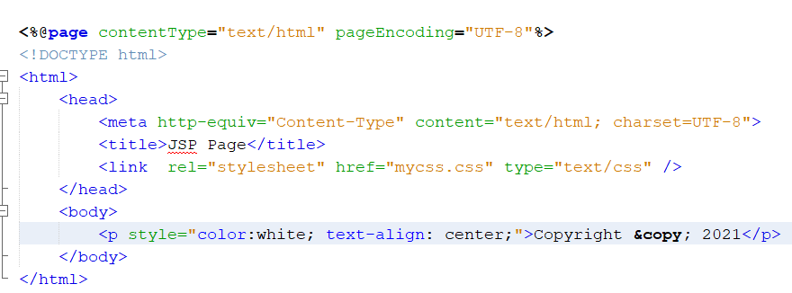

Step 3: create a new page named “index.jsp”

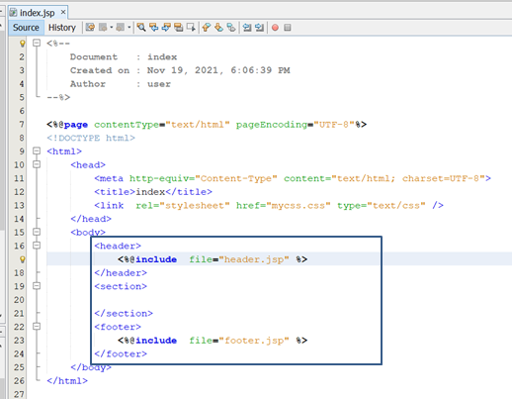

Step 4: do again some functions: login, registration using pages JSP, not HTML

Create a new page named “login.jsp”

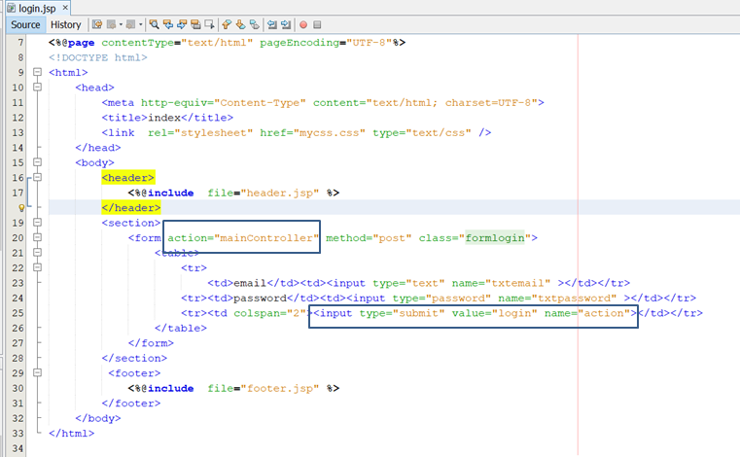

Create a new page named “registration.jsp”

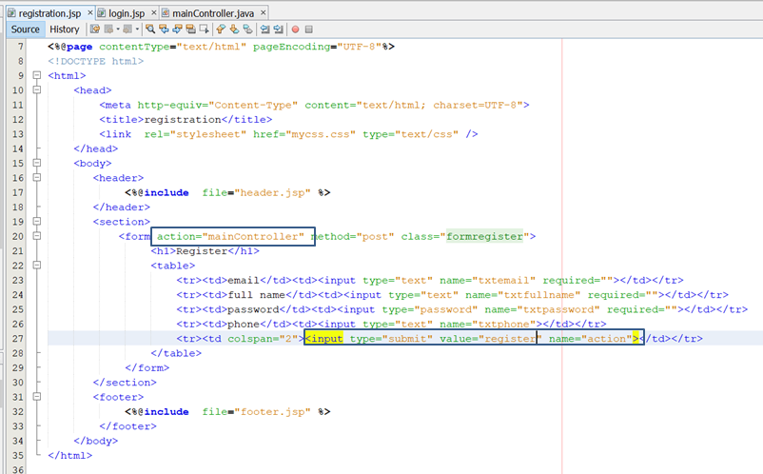

Step 5: In the servlet “mainController”, edit the code:

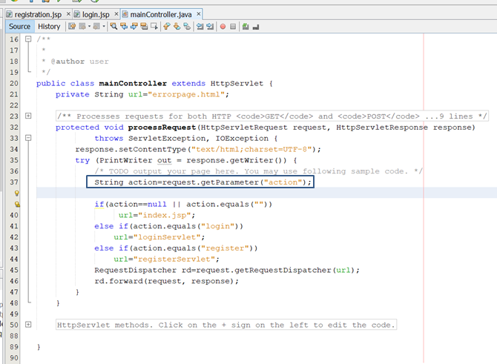

Step 7: Open the file web.xml, set up the page “index.jsp” is the first page, deploy your app. And run your app

Conclusion:

*The key idea is all requests from the client using the format:   
 <input type=“submit” name=”action” value=”….”>*

*In the mainController, we get this action parameter to decide what servlet will be called.*

Part 2: Using session to store the login user’s name and create a new file JSP named “personalPage.jsp”

Step 1: Open the file “loginServlet.java”, edit the code

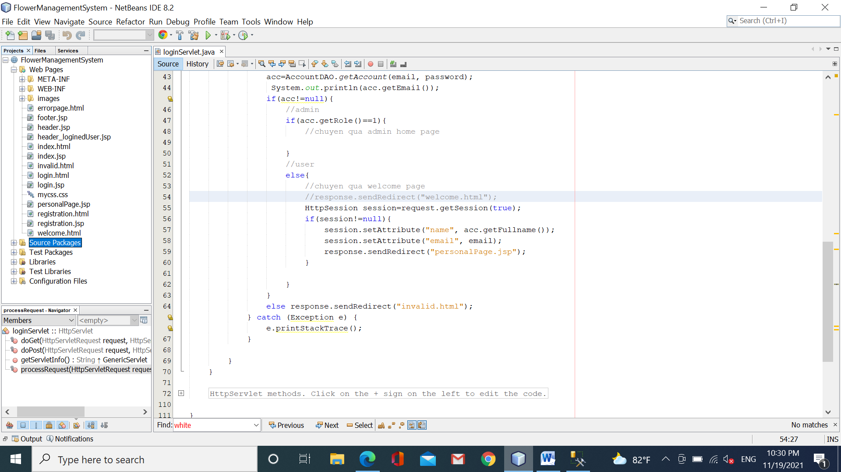

Step 2: create two new pages named “header_loginedUser.jsp”, “personalPage.jsp”.

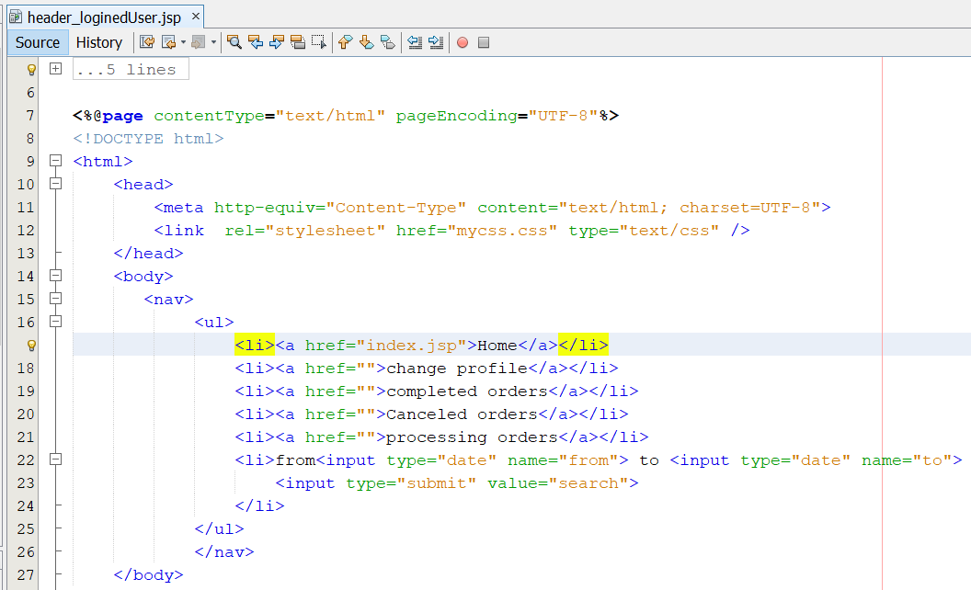

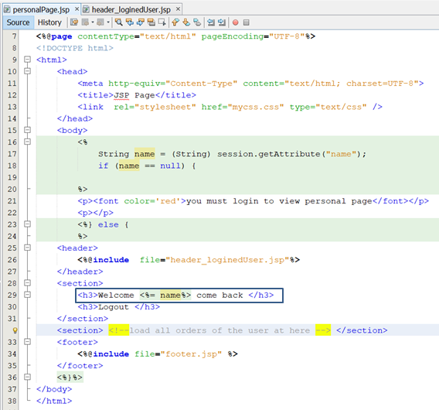

On the page “personalPage.jsp”, we will check user authentication. If the user is valid then open this page otherwise display a warning.

Step 4: run your app to get the result

Case 1: login successfully

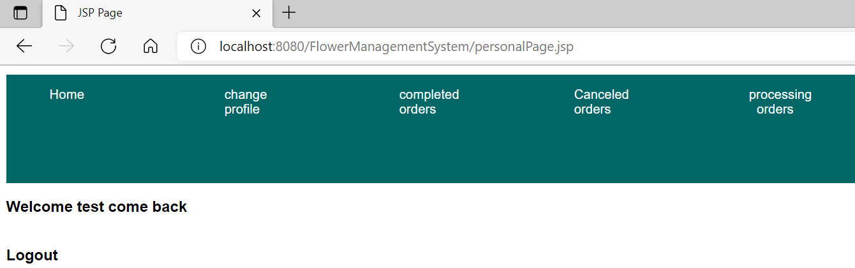

Case 2: from the address bar, you type “http://localhost:8080/FlowerManagementSystem/personalPage.jsp”

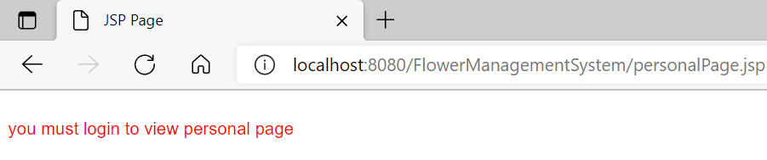

The advanced challenge: You must finish the logout function. When the user clicks “logout”, the website will remove the attribute “name” in the session’s memory, and go to the page “index.jsp”.

personalPage.jsp

  
logoutServet

HttpSession session=request.getSession();  
 session.invalidate();  
 response.sendRedirect("index.jsp");

Part 3: You will perform the function ”view all orders”.

Step 1: Create a new class named “Order”

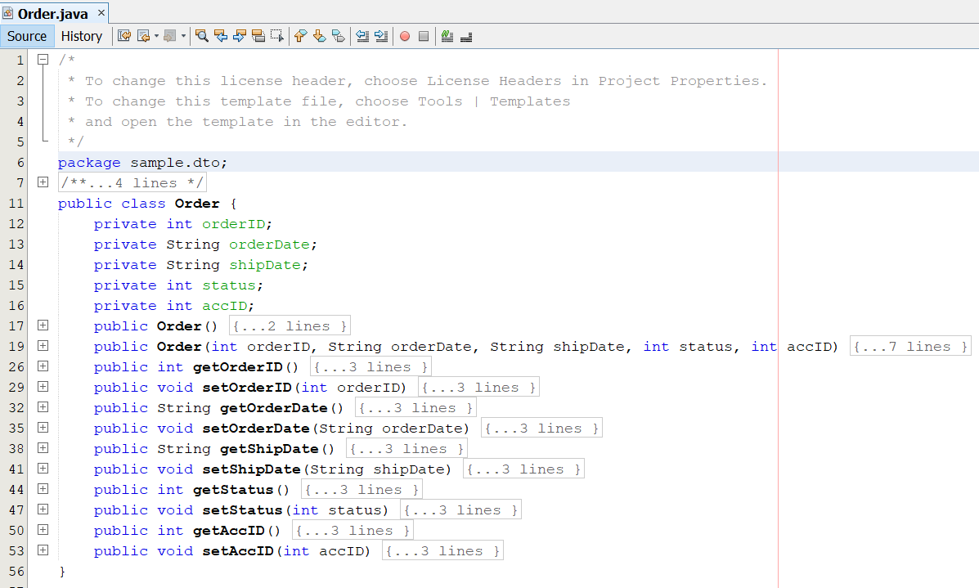

Step 2: Create a new class named “OrderDAO”

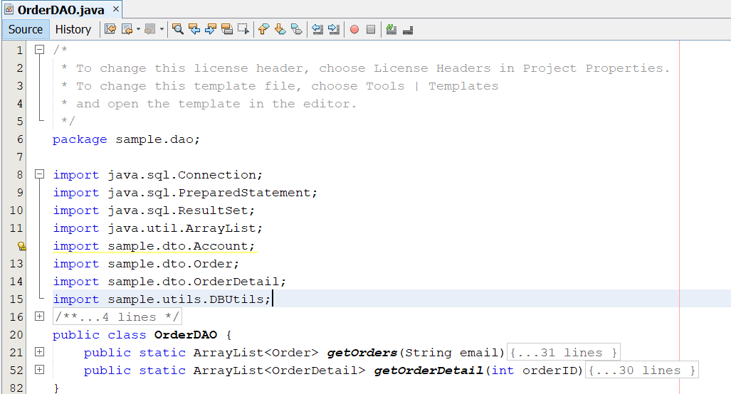

Step 3: Open the page “personalPage.jsp”, edit the code:

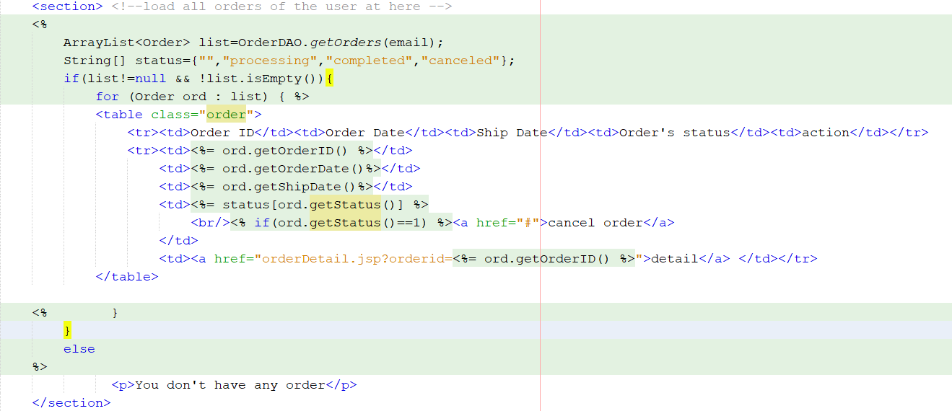

Step 4: Now, you insert some tuples into tables: Orders, OrderDetails

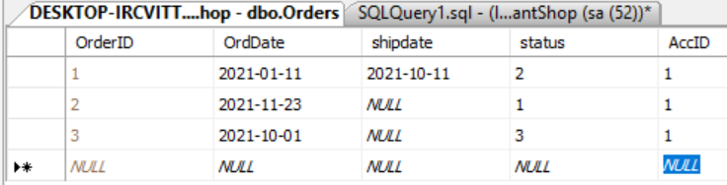

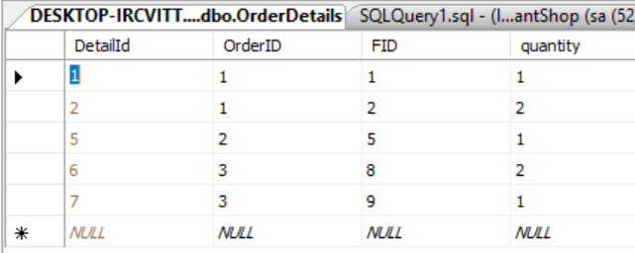

Step 5: run your app to get the result

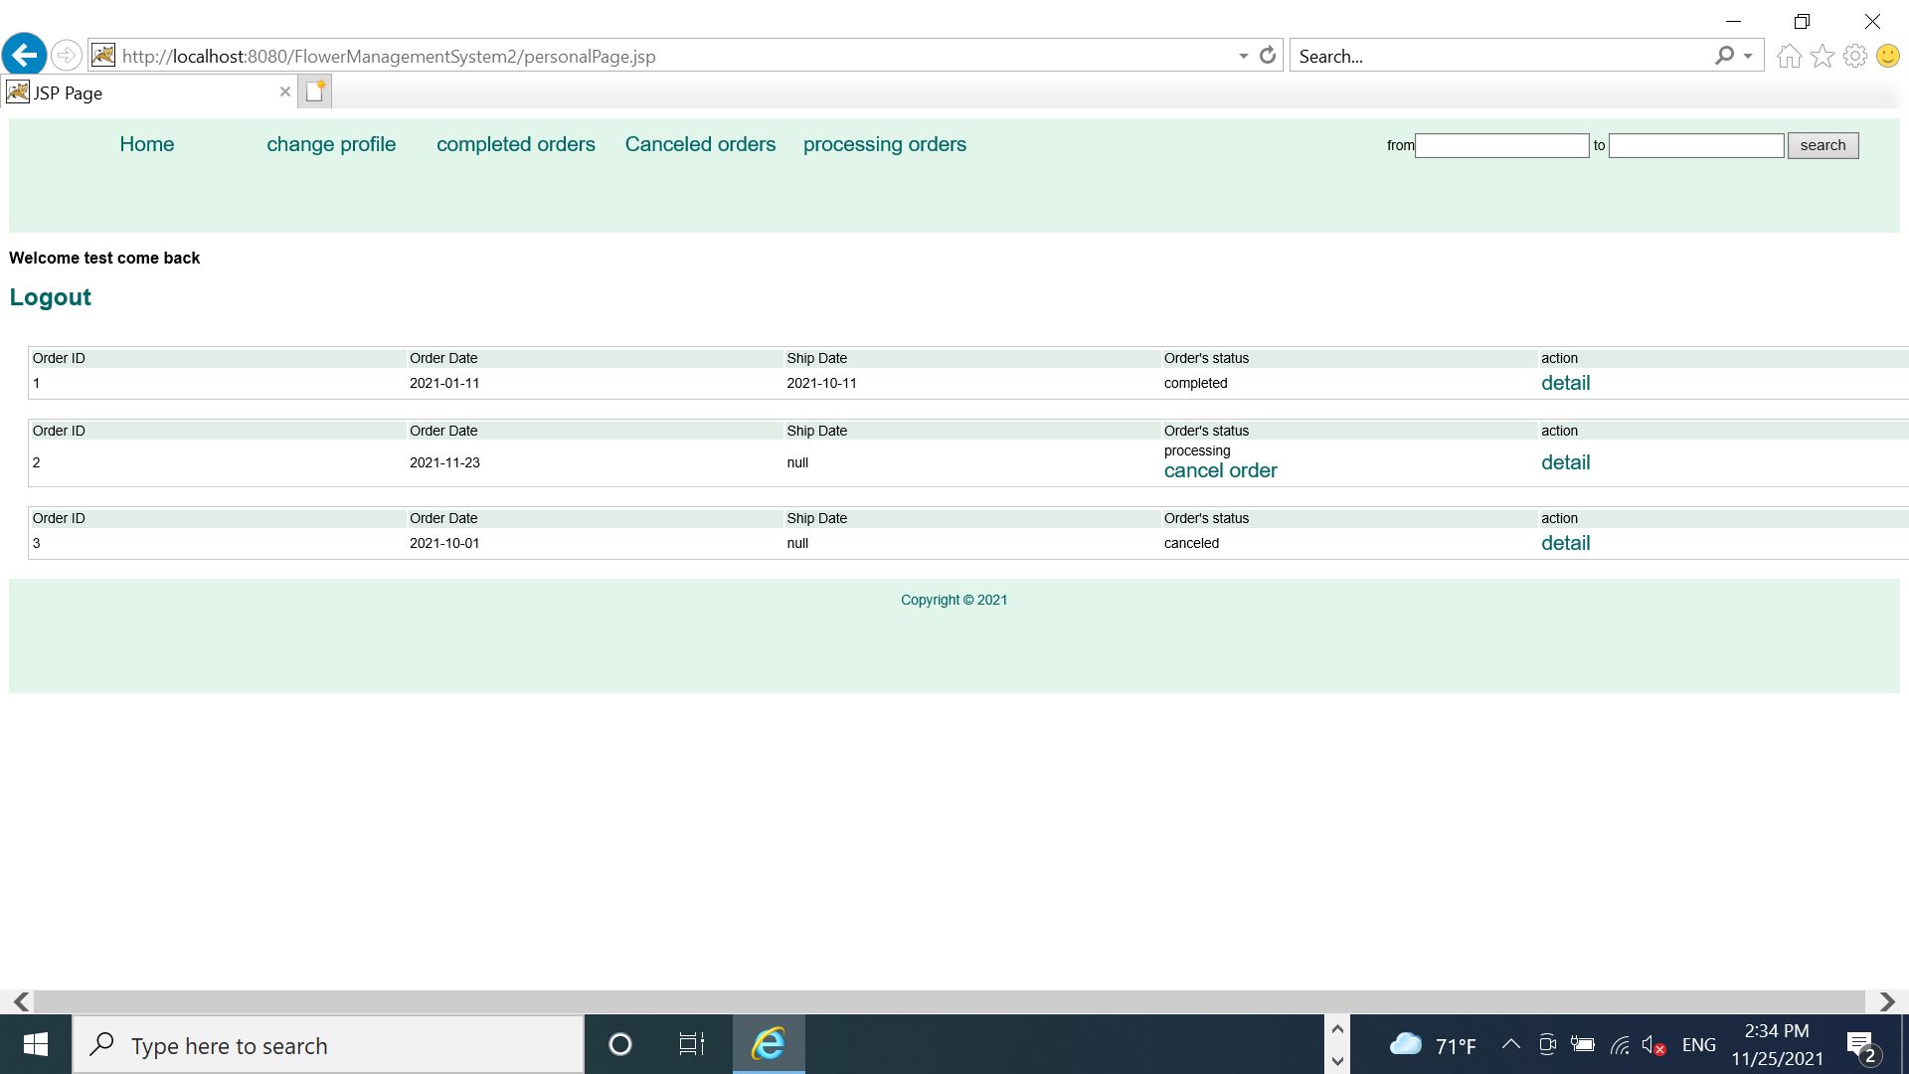

Part 4: View order detail of the order

Step 1: In the package “sample.dto”, create a new class named “OrderDetail.java”

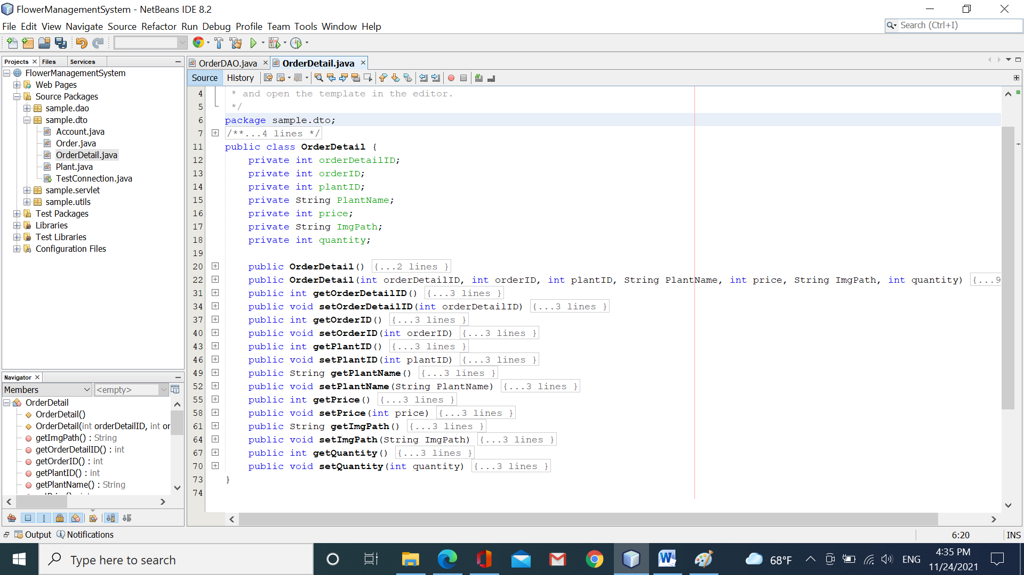

Step 2: In the file OrderDAO.java, add more the method “getOrderDetail(int orderID)”

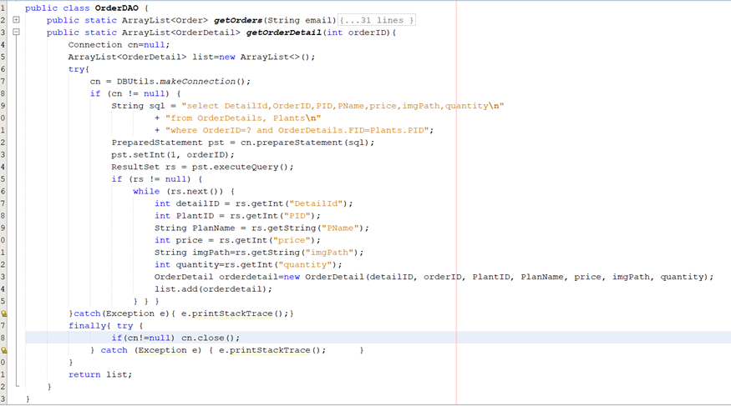

Step 3: Create a new page named “OrderDetail.jsp”.

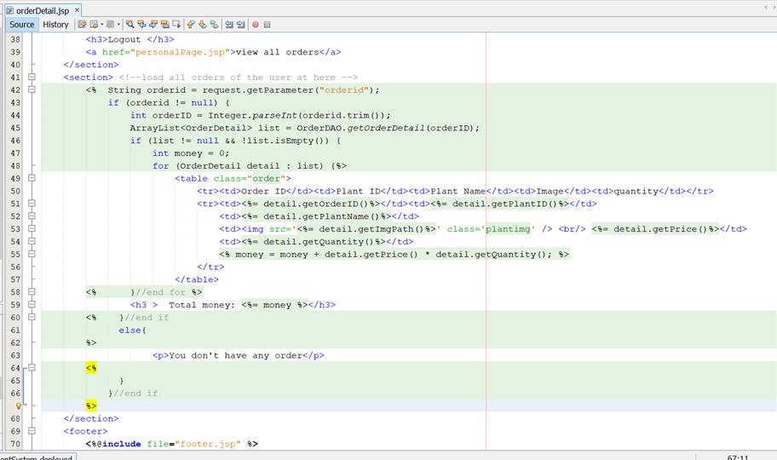

Step 5: run your app. On the page “personalPage.jsp”, click the link “detail” to view this order’s detail.

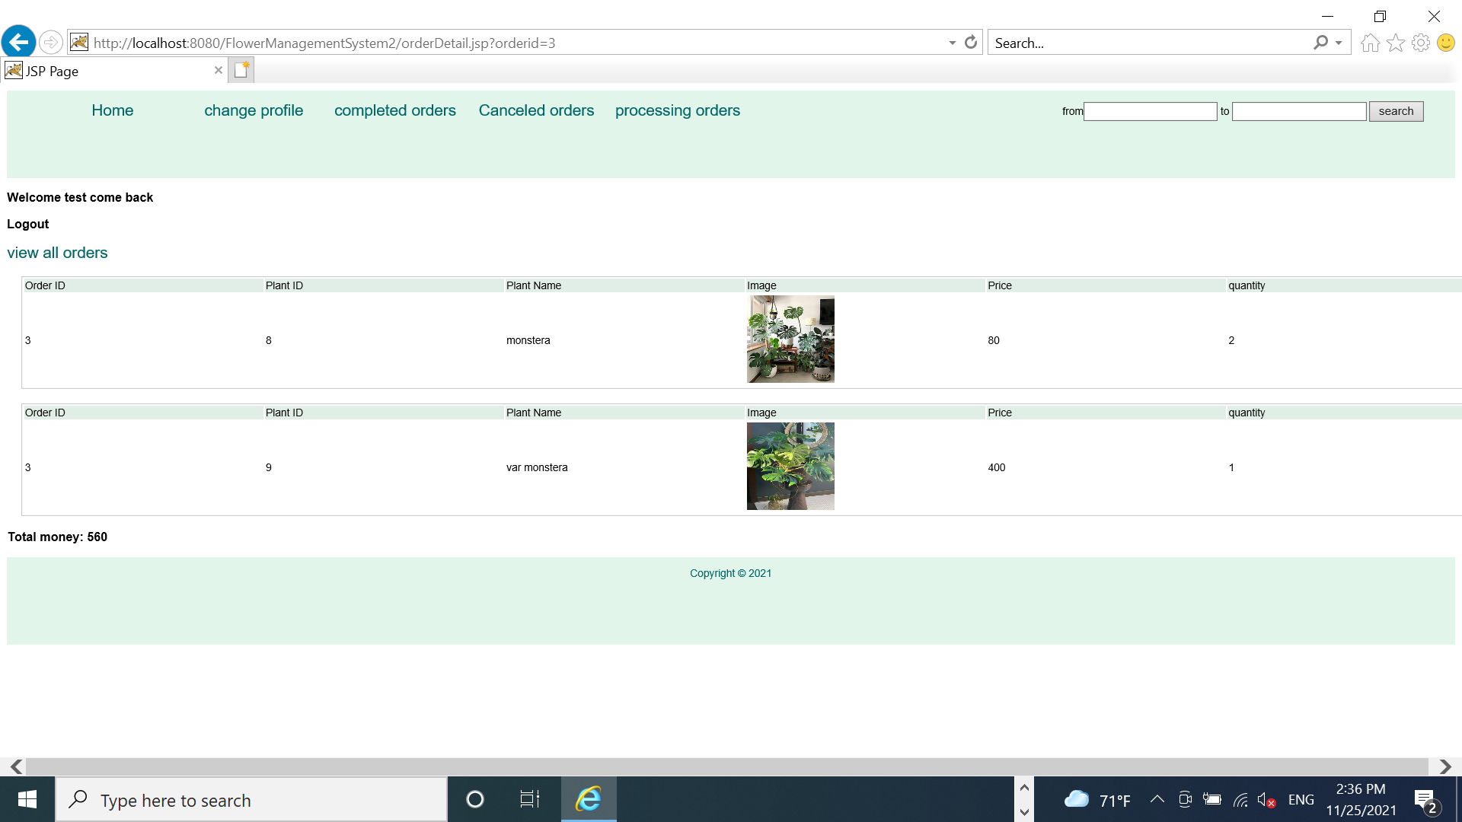

**Part 5: Load all products to the index.jsp, use index.jsp to display the result of searching.**

When the user opens the page “index.jsp”, all products will be displayed.

When the user searches for the product by name/by category, only appropriate products are displayed.

**Step 1: Open the page “header.jsp”, edit the code:**

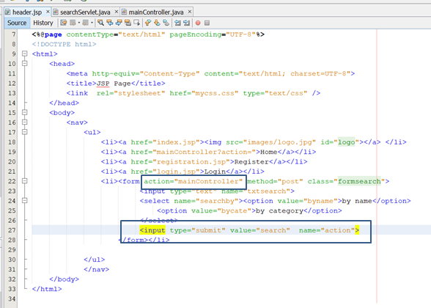

**Step 2: Open the file “mainController”, edit the code:**

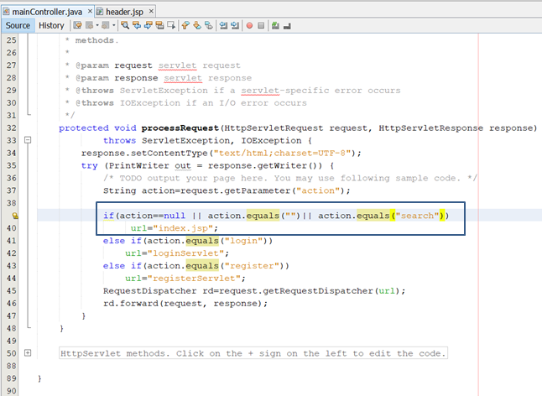

**Step 3: Open the page “index.jsp”, edit the code:**

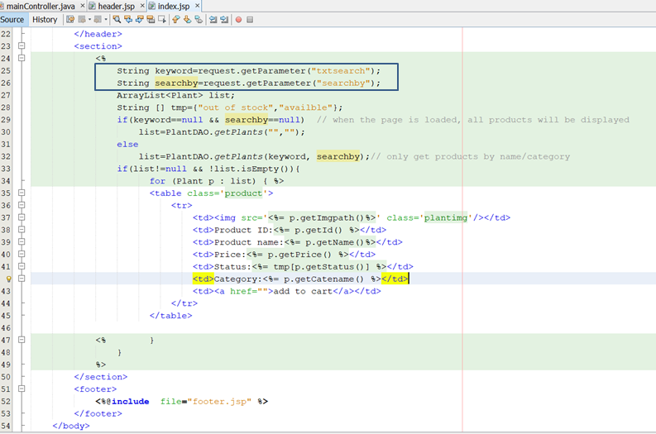

**Step 4: run your app**

The sample: the user inputs “other”, and click the button “search”

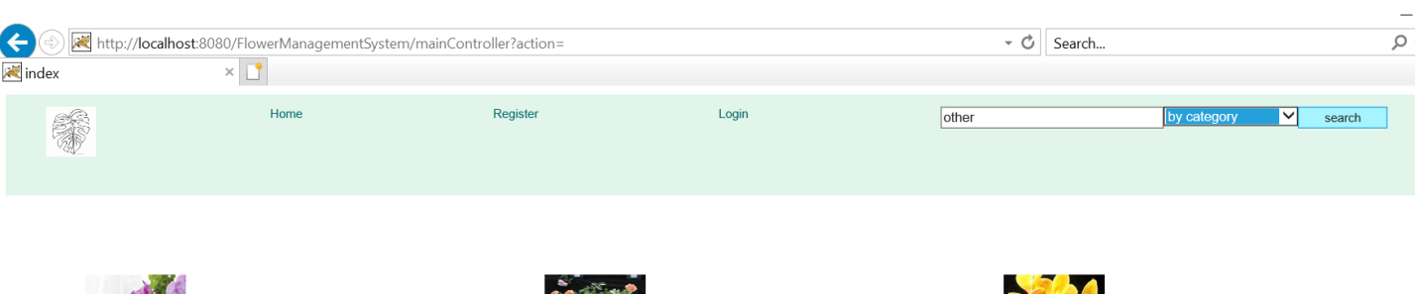

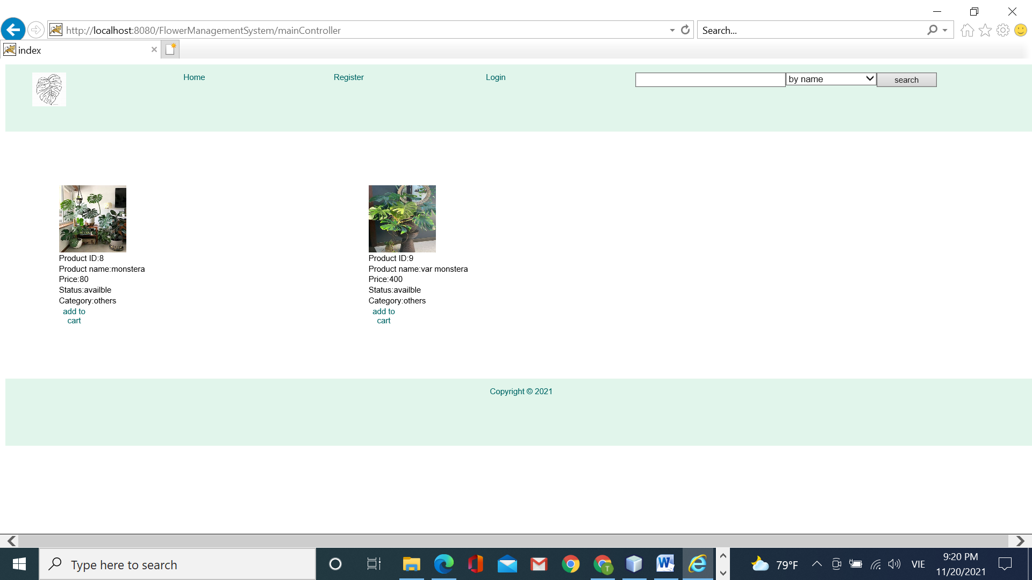

After searching, the appropriate products are displayed. However, ***the input text control can not keep*** the user’s search. So, we should edit the page “header.jsp” to overcome this.

**Step 5: Open the page “header.jsp”, edit the code**

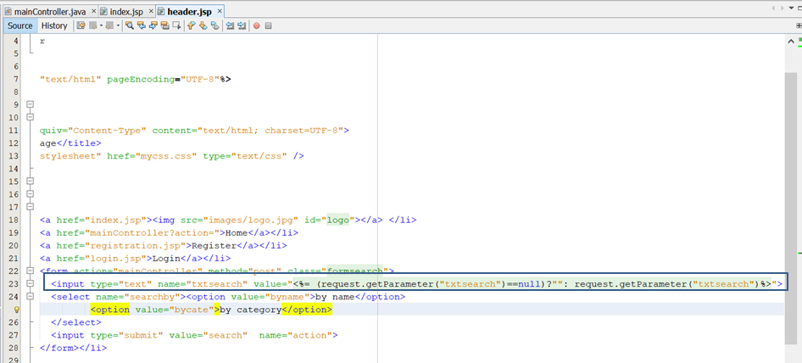

Step 6: Run your app again.

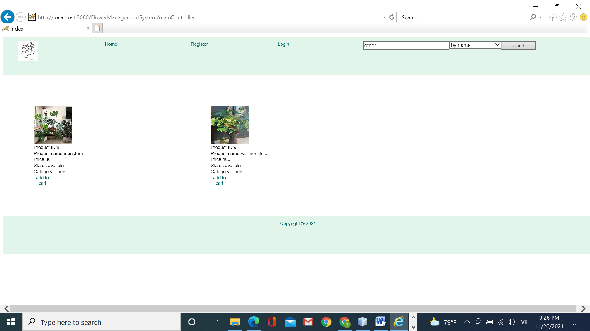

Now, the user’s searches are kept and rewrote to the input text control.

The advanced challenge:

1. You must perform the function view completed orders, processing orders, canceled orders.
2. You must perform the function order again on canceled orders.
3. You must perform the change your profile function (only update full name, phone).

Congratulations!!!! you have finished workshop 4 ☺ ☺

**Workshop 5: Using Cookie, Session**

# RewriteURL #HiddenField #Cookie # Session #Exception Handling

**Learning outcome:**

* Know to use the cookie to save login information
* Know to use the session to create the shopping cart
* How to handle exceptions

**Part 1: Save the user’s login information.**

Describe the login function

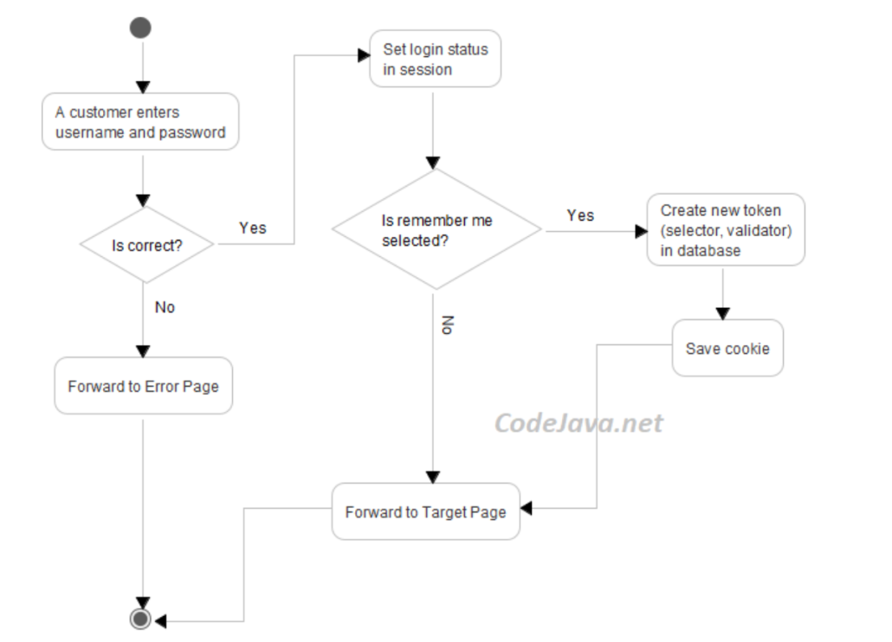

Using the cookie to login

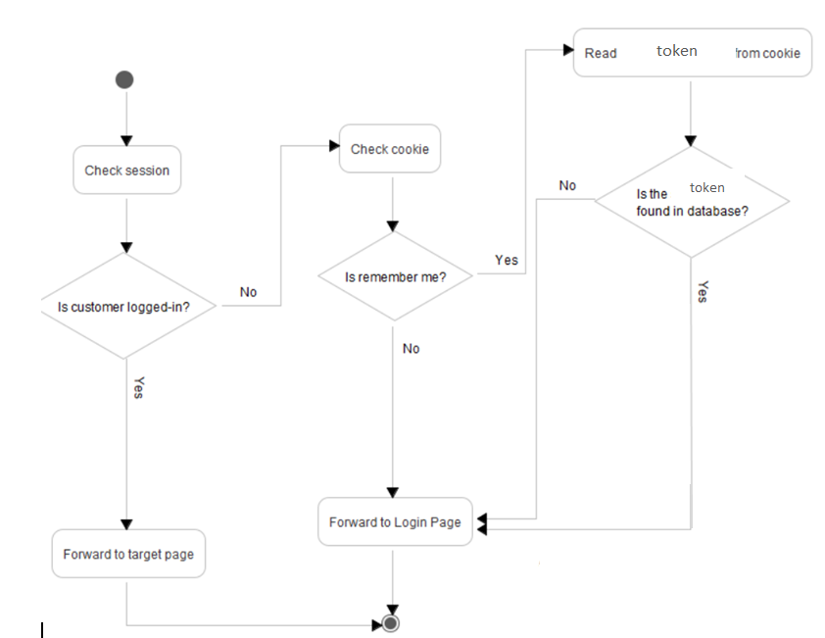

Step 1: add one more column “token” in the table Accounts.

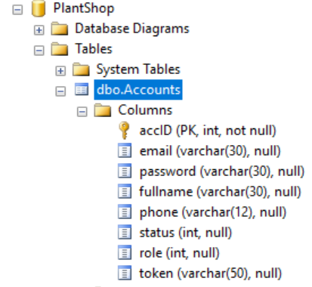

Step 2: Add one more checkbox control in the page “login.jsp”

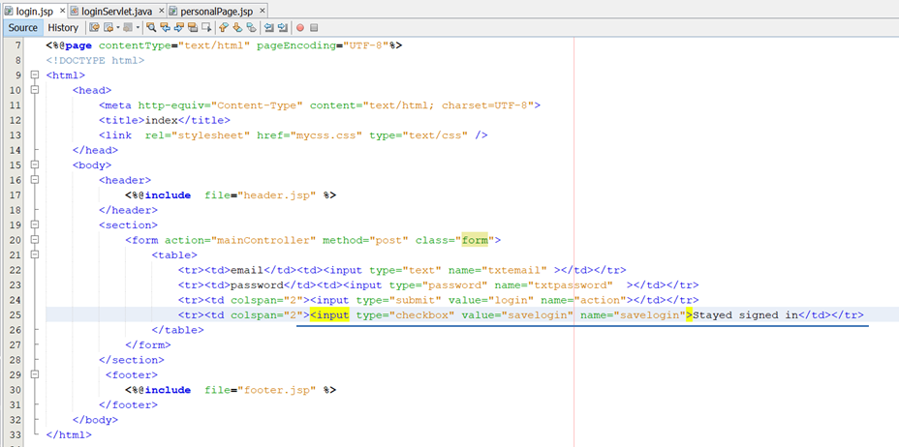

Step 3: On the page “loginServlet”, edit the code:

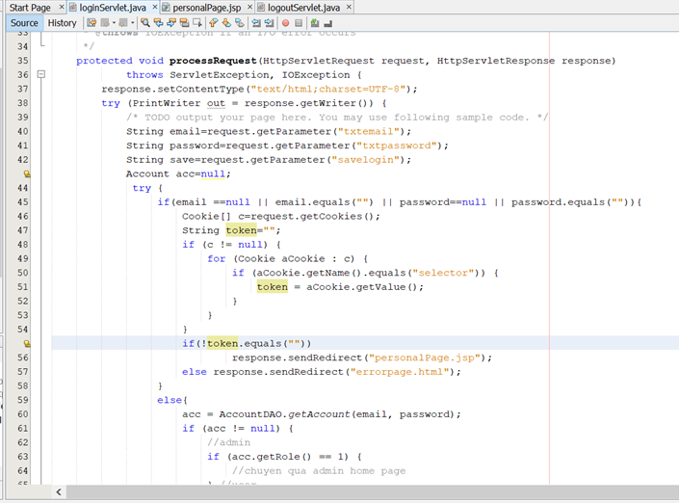

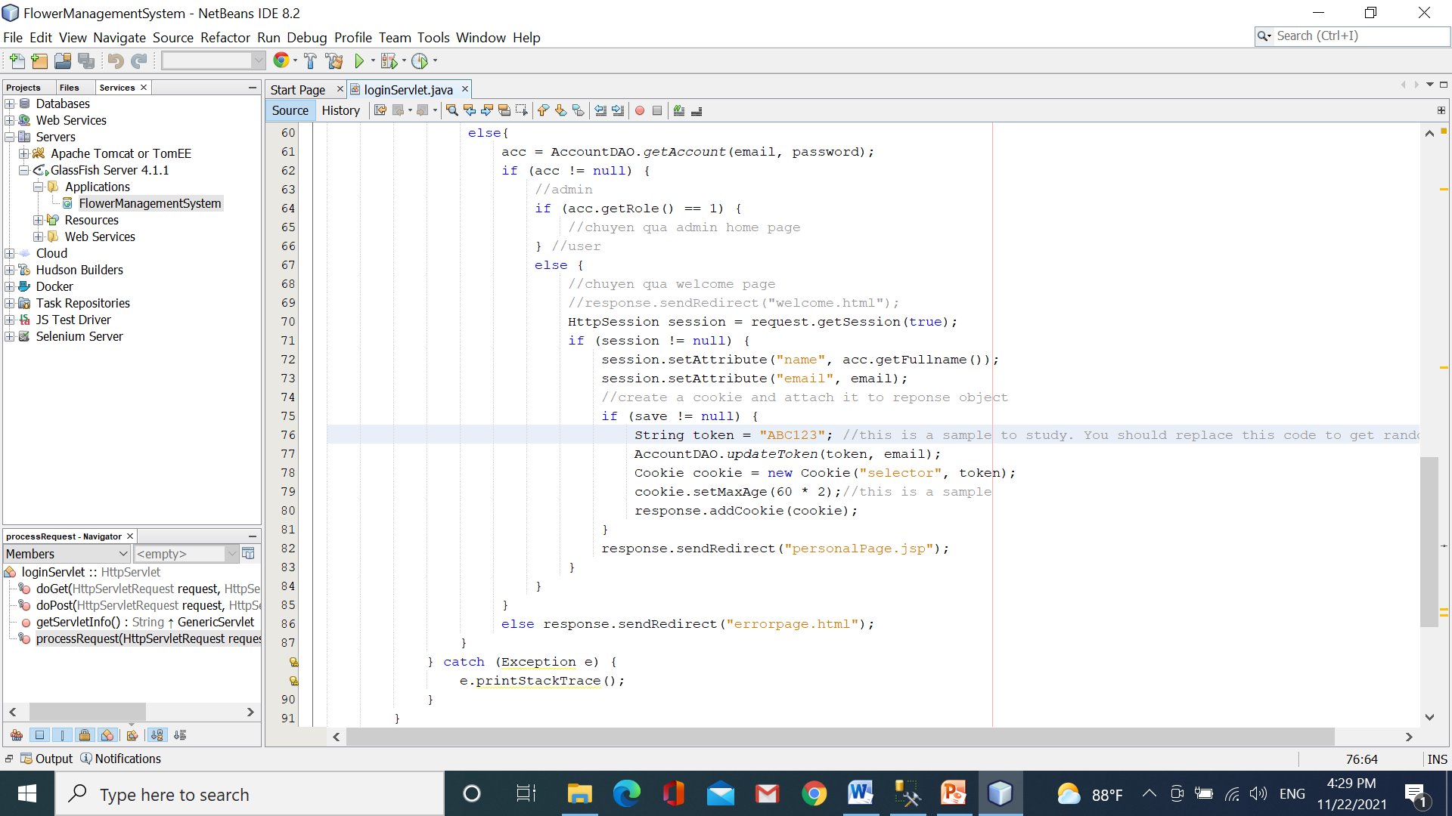

Step 4: On the page “personalPage.jsp”, edit the code:

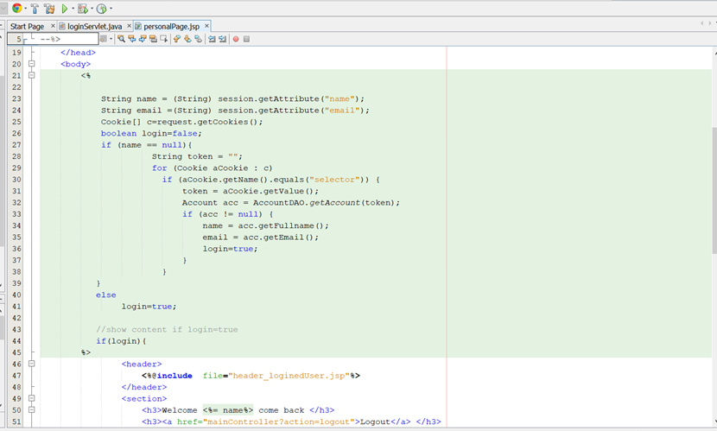

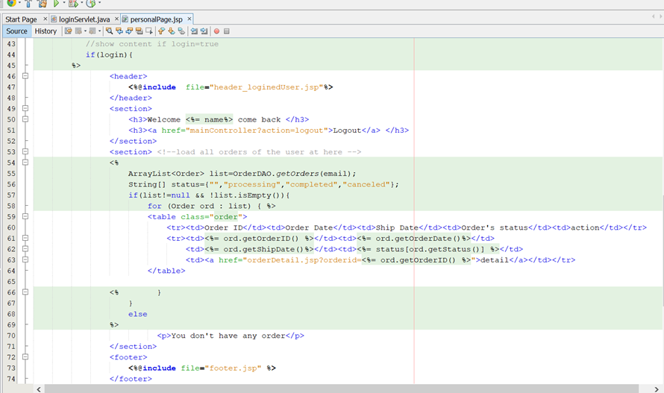

Step 5: run your app to test this function

Part 2: Using session to store the user’s shopping cart.

We use HashMap<String, Integer> to store the customer’s cart. The key is the productid and value is the quantity. Cart object is stored in the session memory on the server-side (you can change this using cookies to store the customer’s cart on the client-side).

Step 1: Get the product id when the user hovers the link “add to cart”.

Open the page “index.jsp”, edit the code

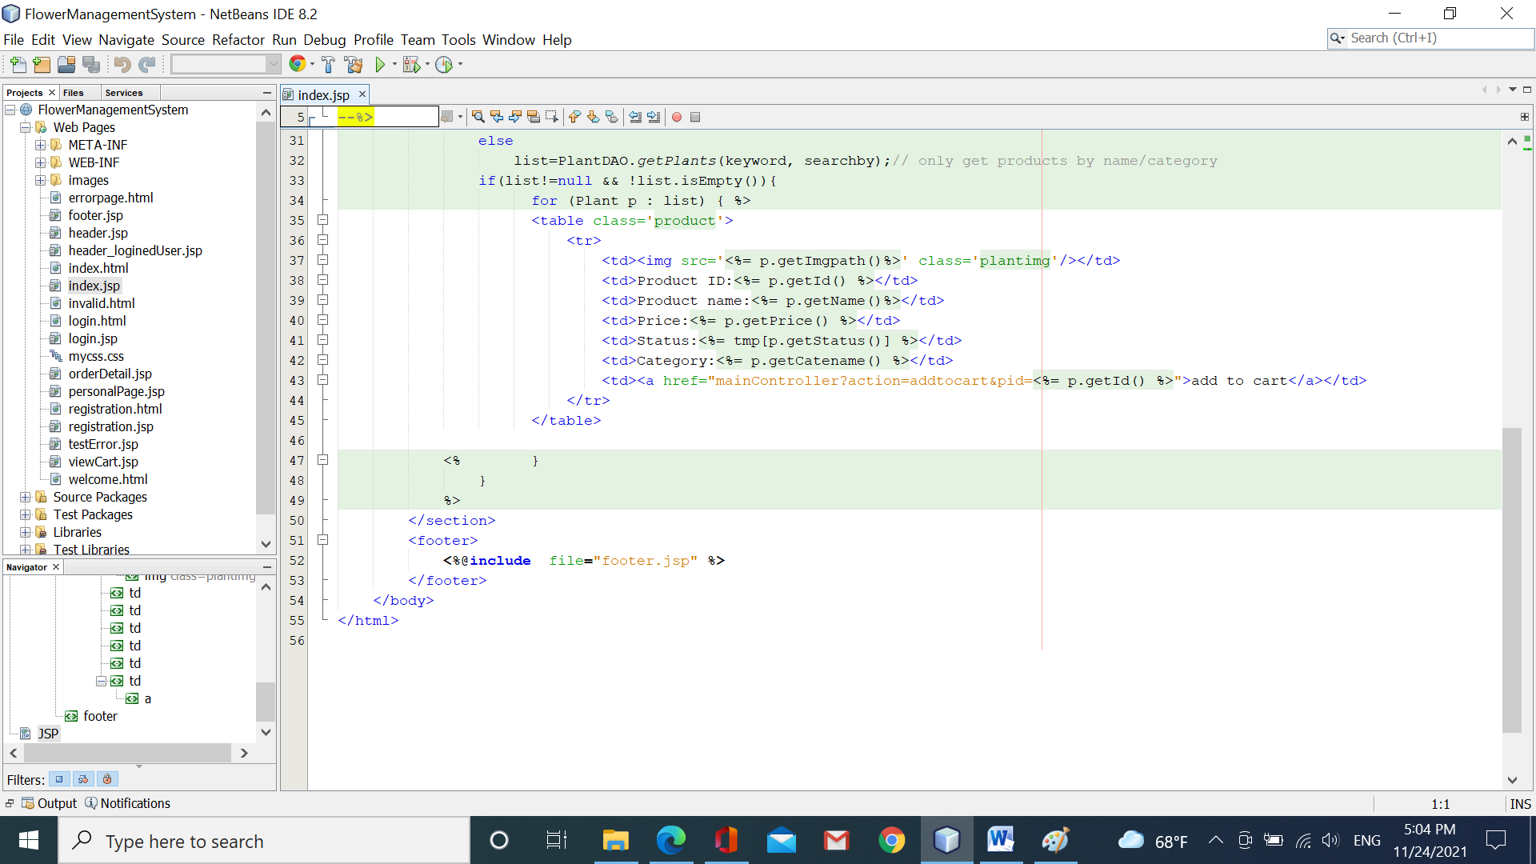

Step 2: open the servlet “mainController”, edit the code:

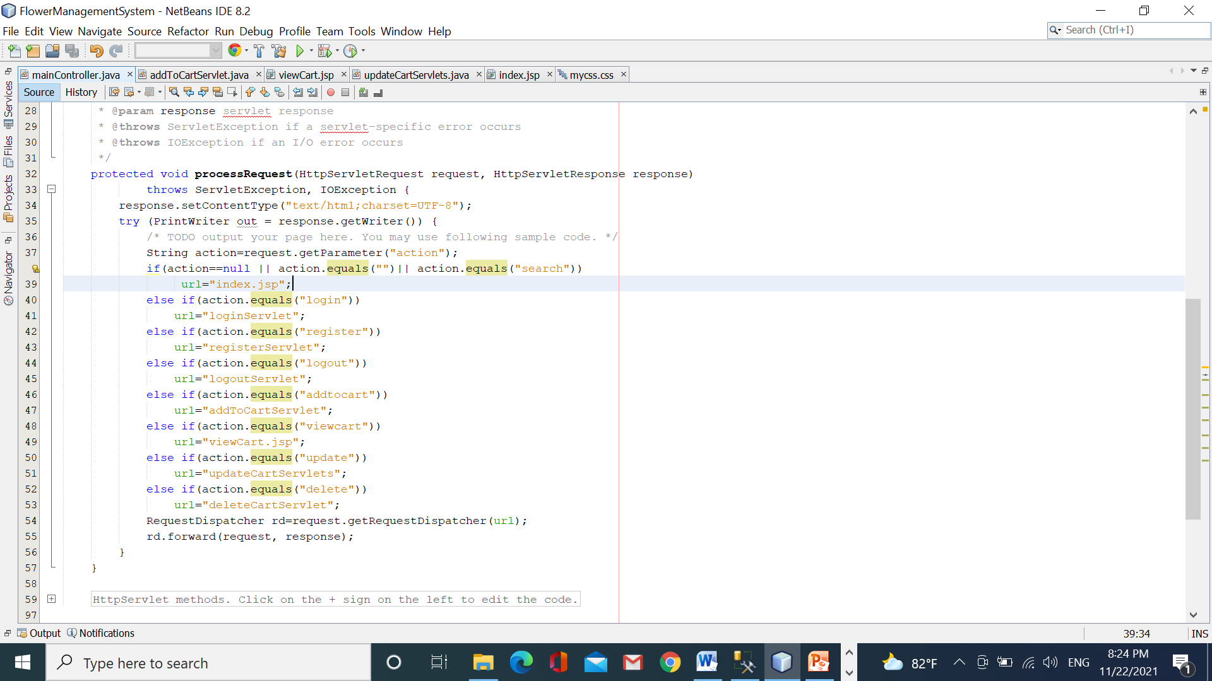

Step 3: create new new servlet named “addToCartServlet”

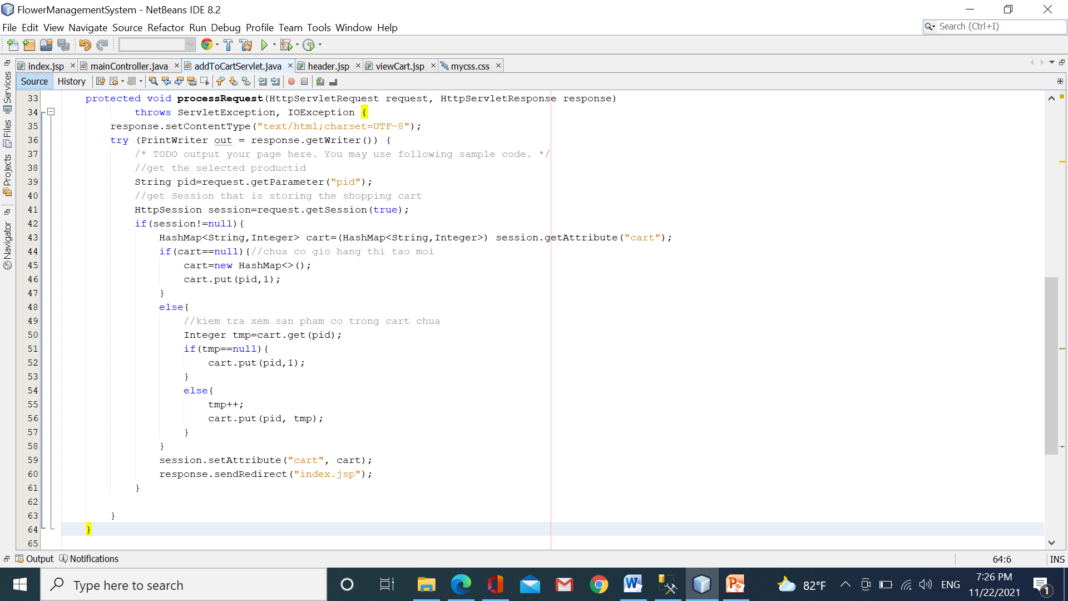

Step 4: View the shopping cart.

Open the page “header.jsp”, add one more the link “view cart”

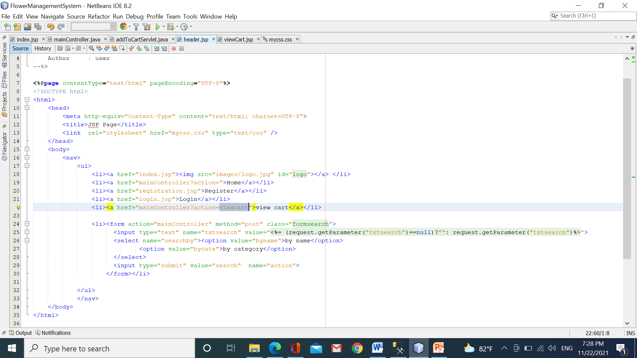

Create a new page named “viewCart.jsp”

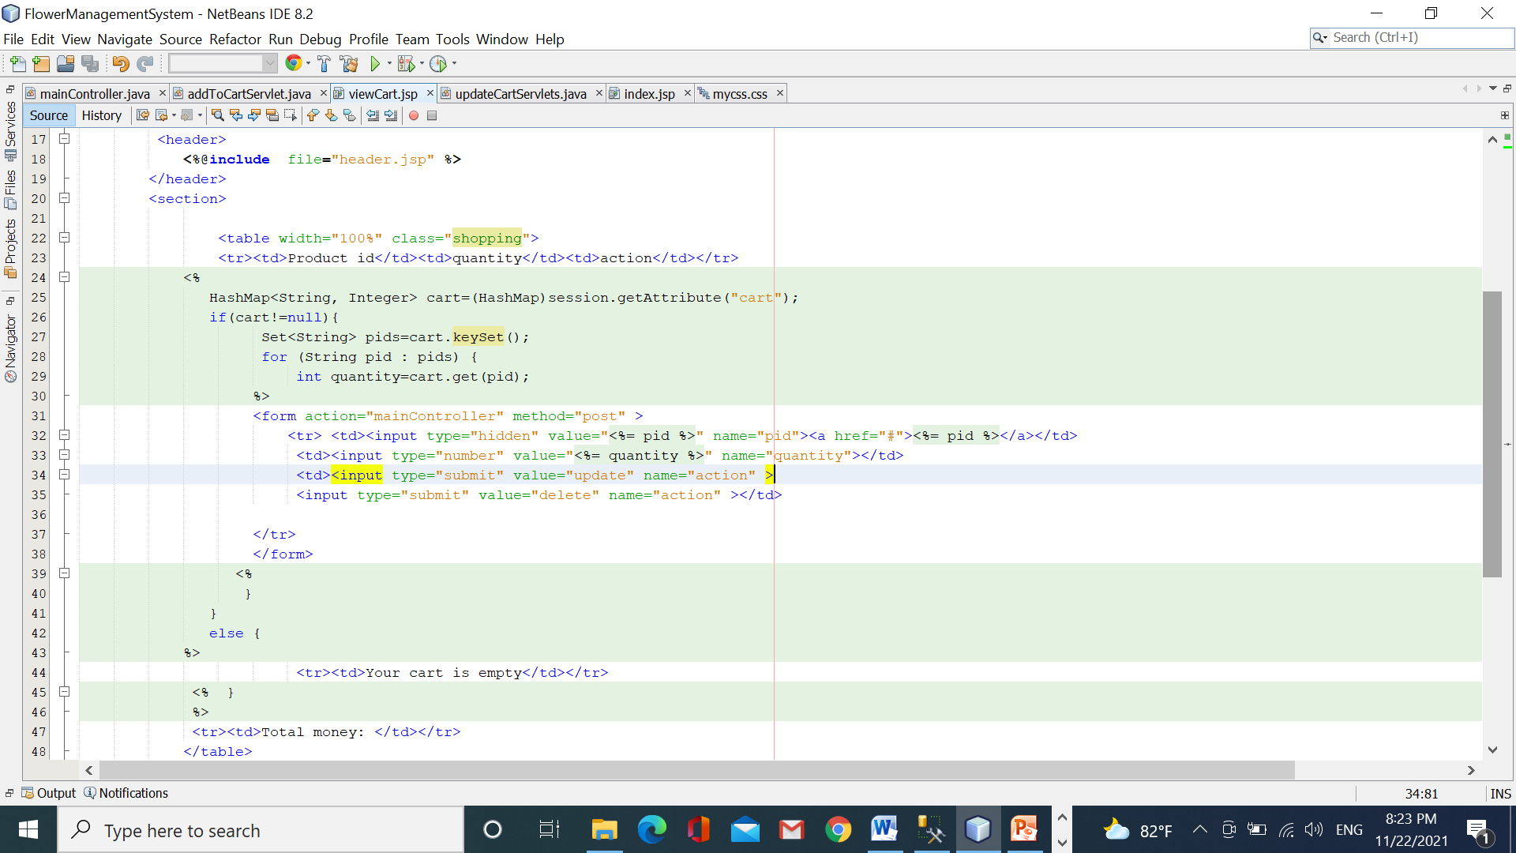

Step 5: Run your app

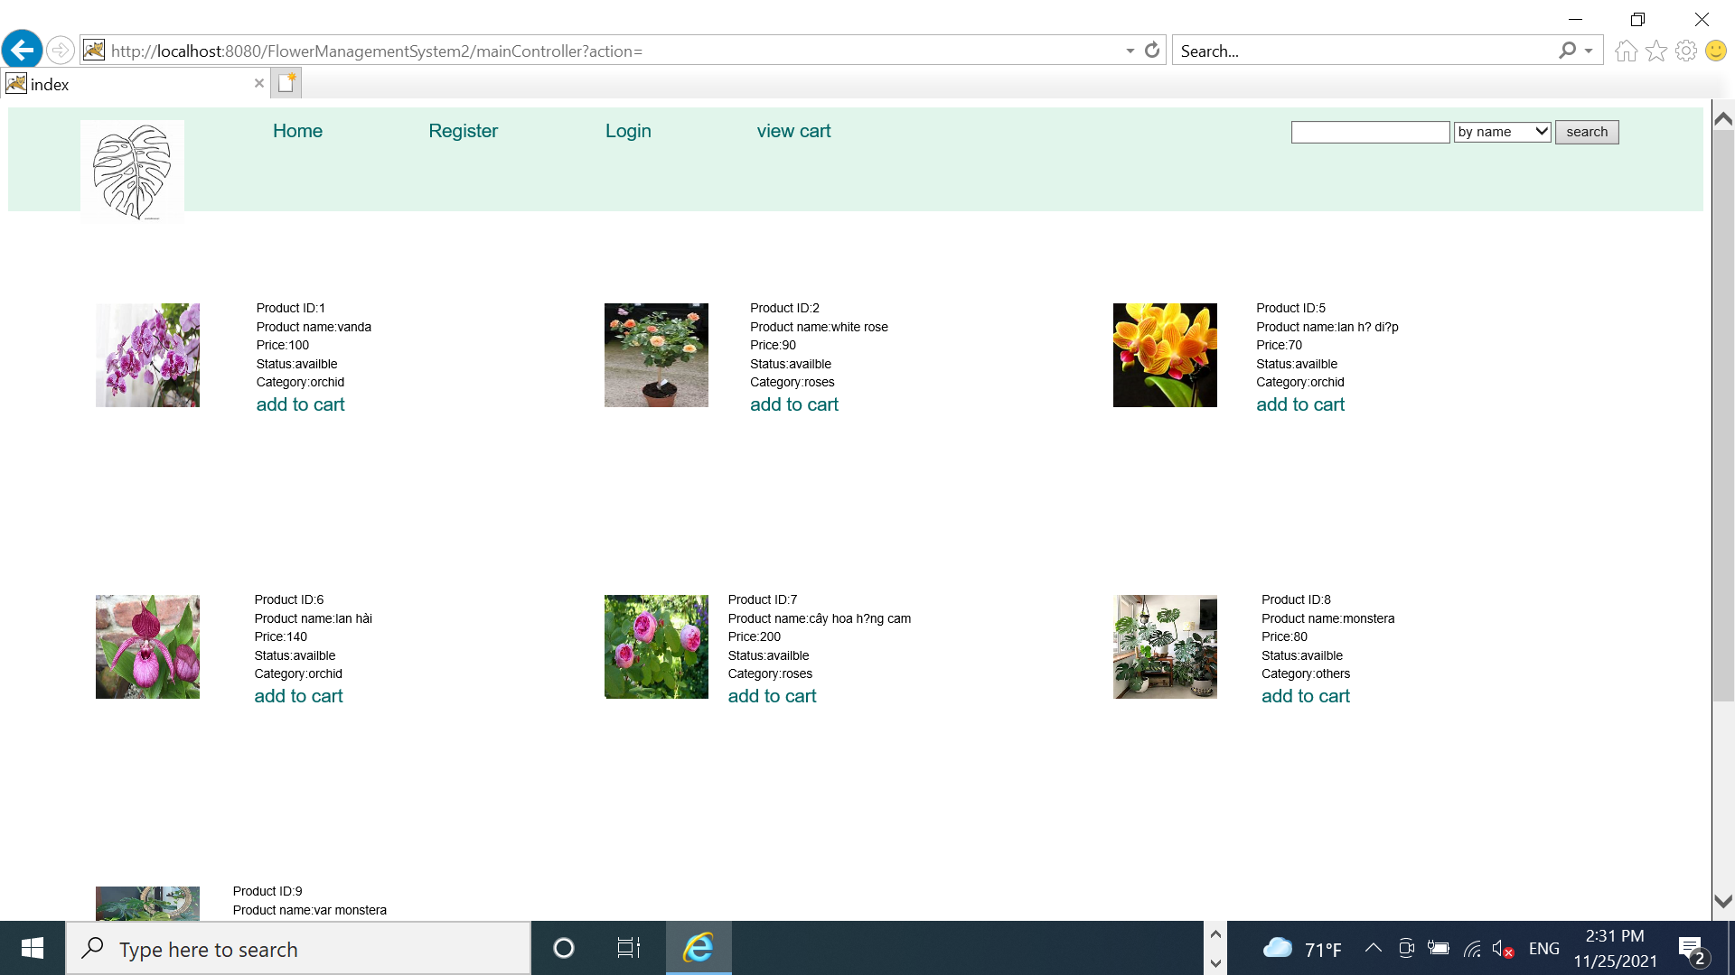

Click “view cart” from the header

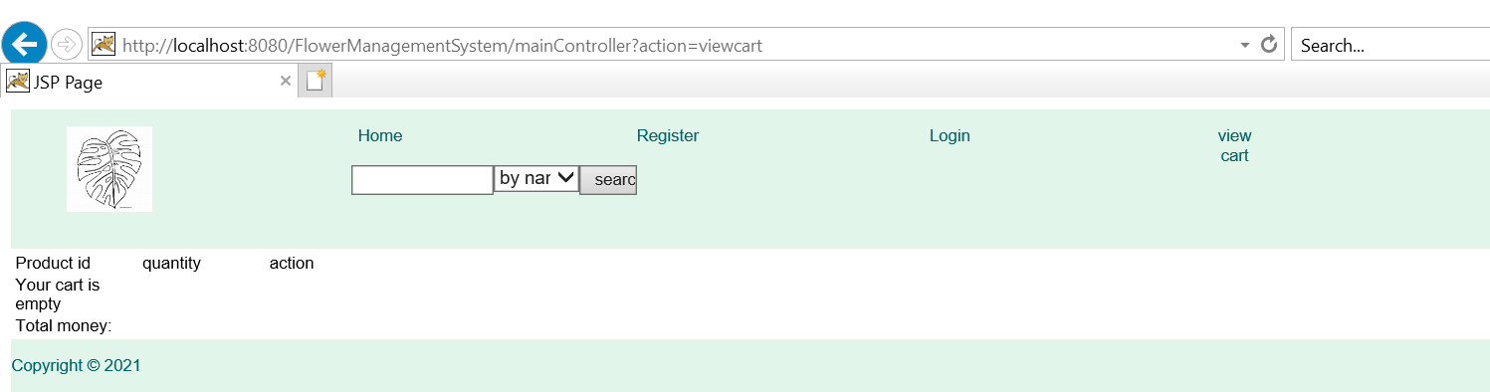

Go back to the home page and click some links “add to cart”

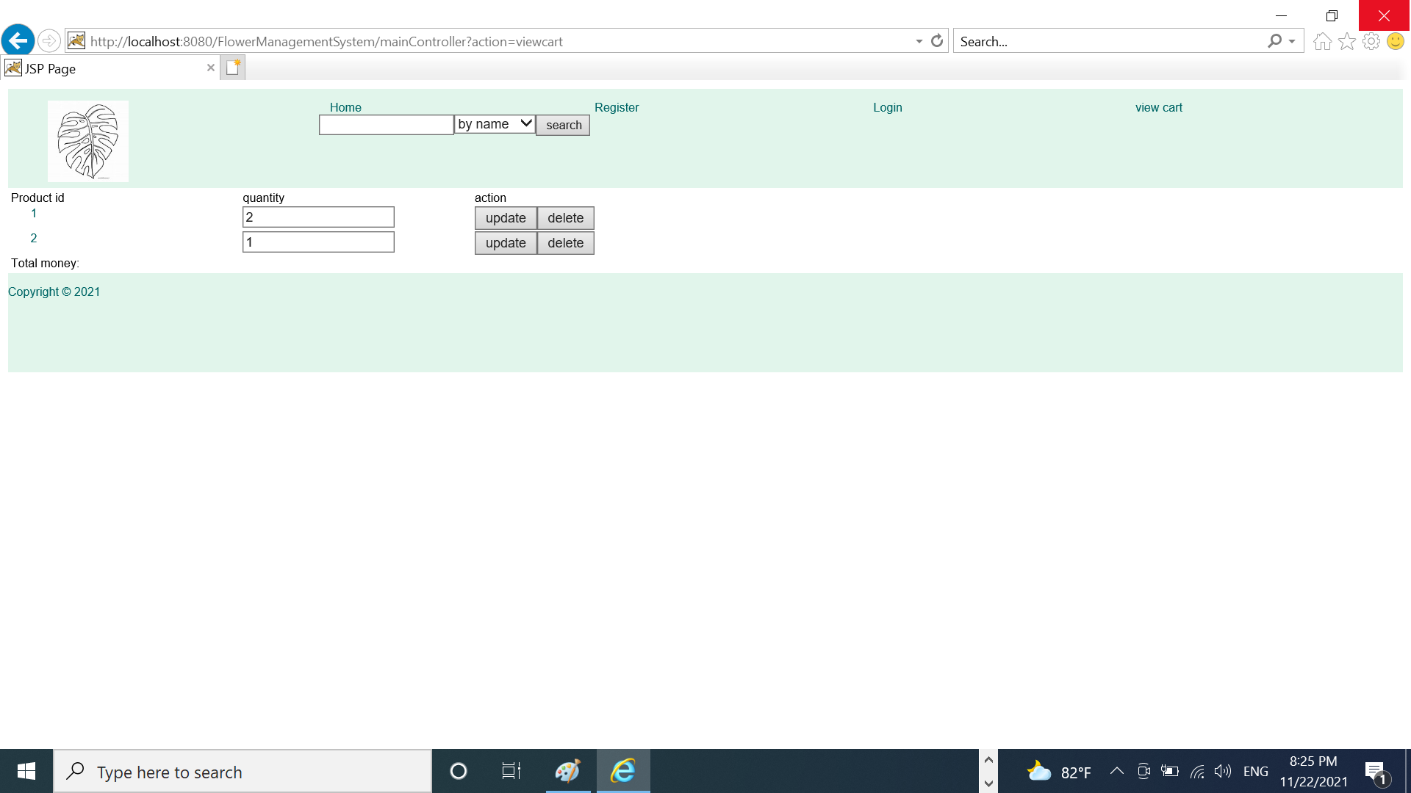

Part 3: change the quantity of the product on the shopping cart.

When the user clicks the button “update” on the page “viewcart.jsp”, we call “mainController” and transfer three data: product id, new quantity, and action=”update”. And then, “mainController” transfer this data to the updateCartServlet to process.

Sep 1: Create a new servlet named updateCartServlet

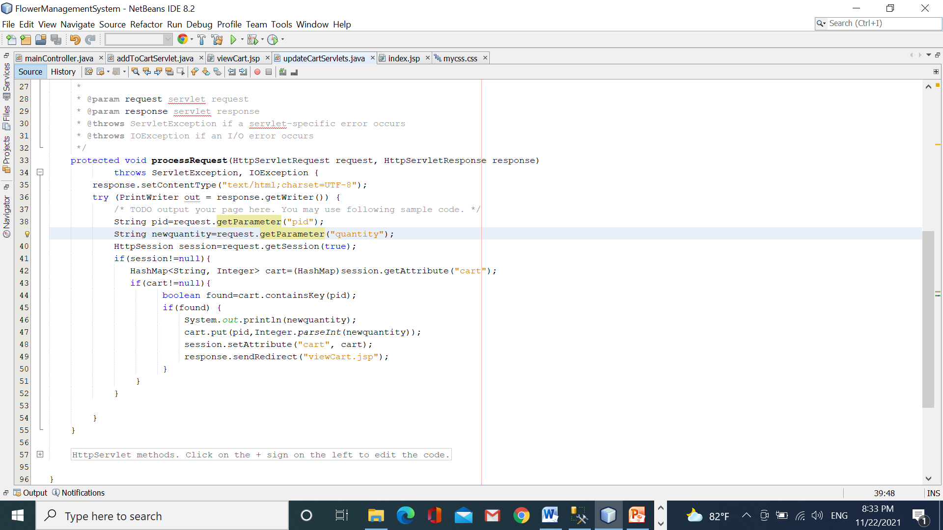

Step 2: Run your app

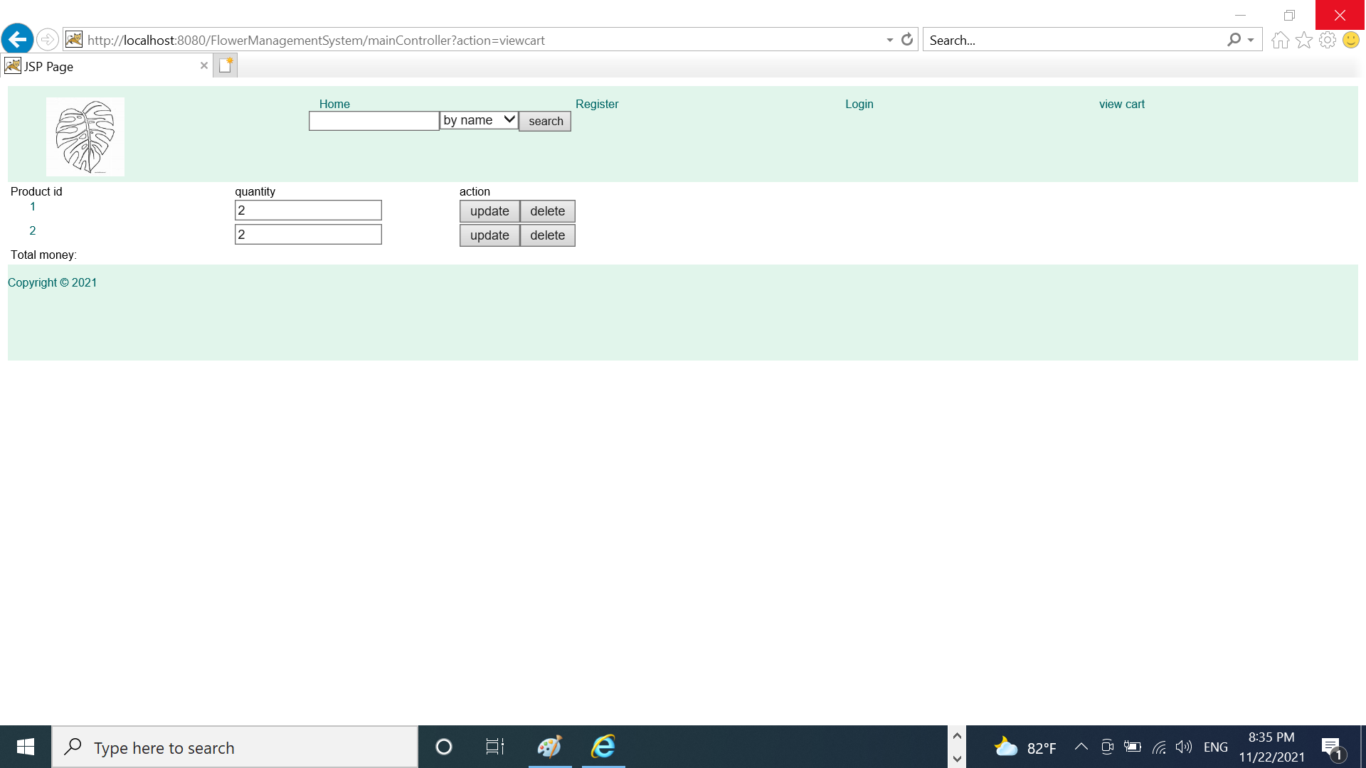

Part 4: Exception handling

During executing your app, if any exception has happened then the container will ***return immediately to the client exception obj that is presented based on HTML format***. We can use many ways to handle exceptions in your app.

* Use the file descriptor “web.xml” to setup: which pages will be opened when the error happens
* Use some methods : sendError(), setStatus(),….of response object to send error to the client
* Use the log file
* Use your ways yourself

***For example 1***: validate the user’s email on the client-side.

Open the page “register.jsp”



***For example 2***: validate the user’s phone on the server-side, if there’s an error then a message is sent to the client.

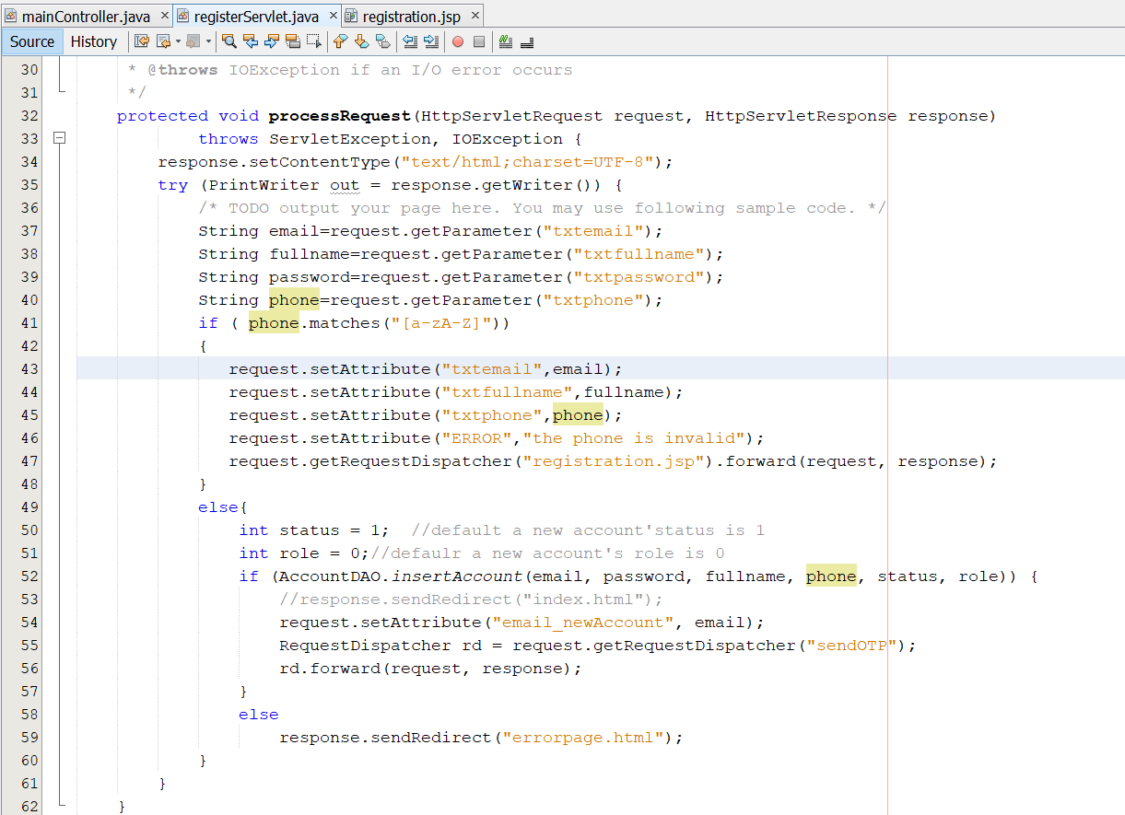

Open the page “register.jsp”, display the message if any

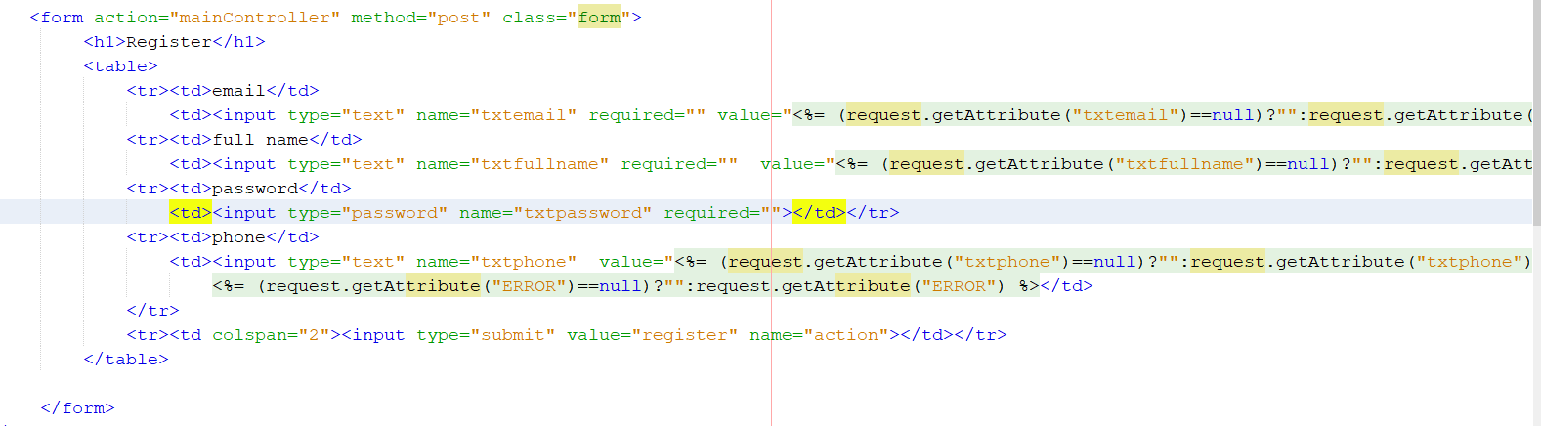

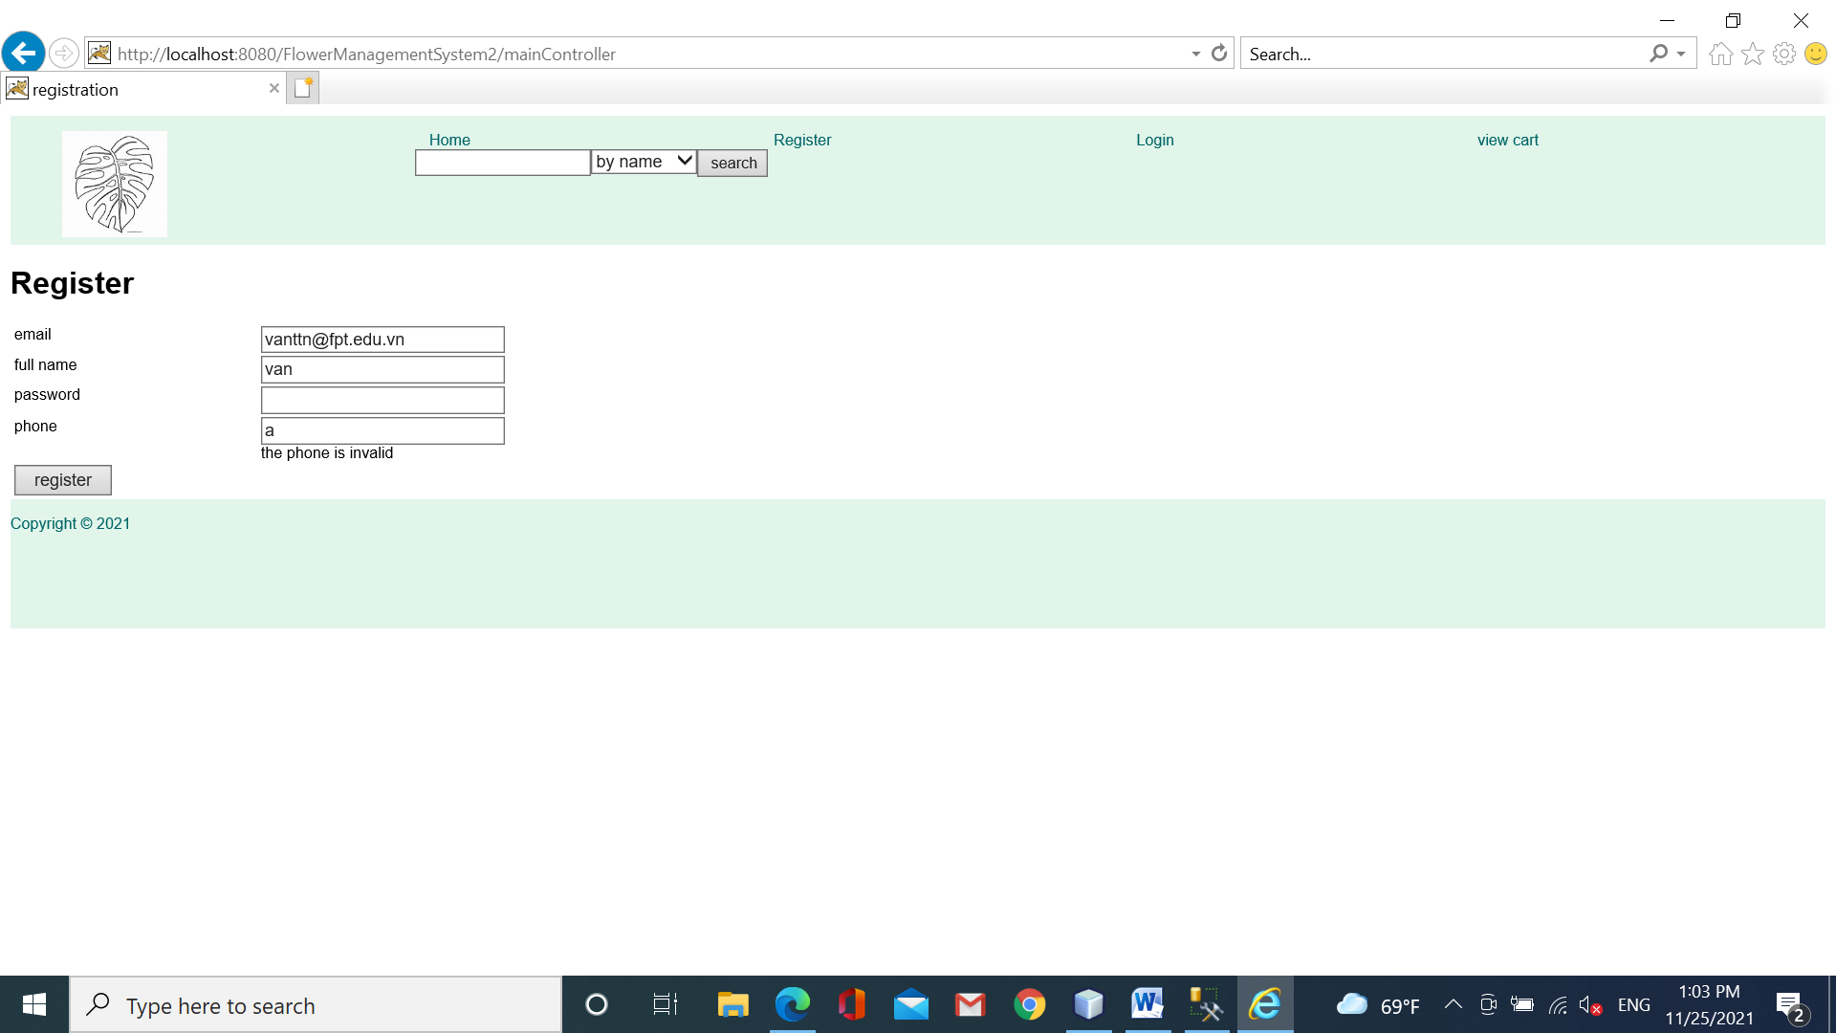

Part 5: Save shopping cart

save a new order of the customer**.** This function should be performed as a **transaction** that includes steps:

* Get the accId from table Accounts based on the email
* Insert a new Order to table Orders
* Insert each productid, quantity of the shopping cart to the table OrderDetails
* Commit transaction

**Step 1: Open the page “viewCart.jsp”, edit the code**

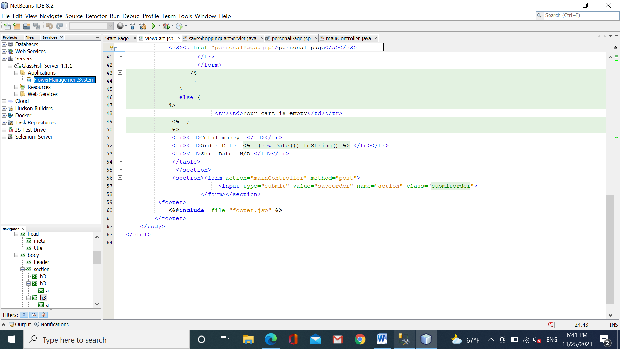

**Step 2: Open the servlet “mainController”, edit the code:**

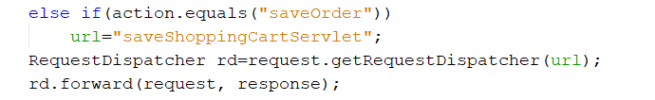

Step 3: Open the file “OrderDAO.java”, add more the code

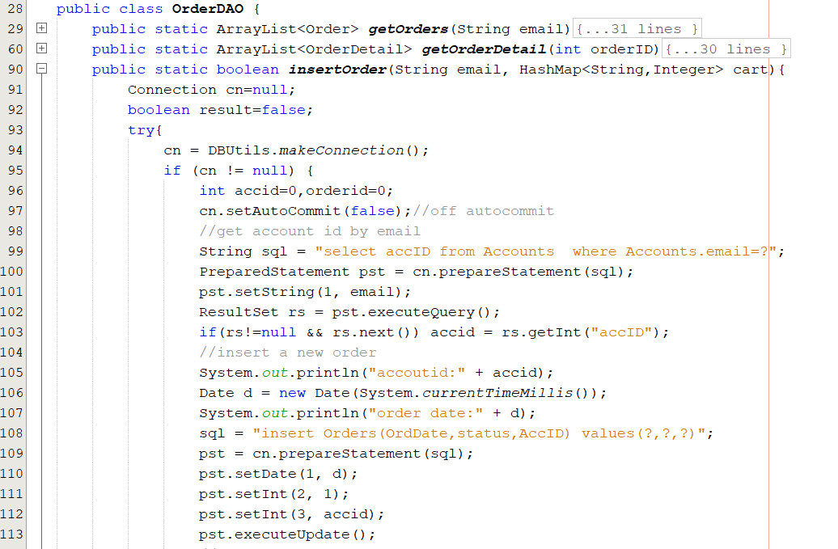

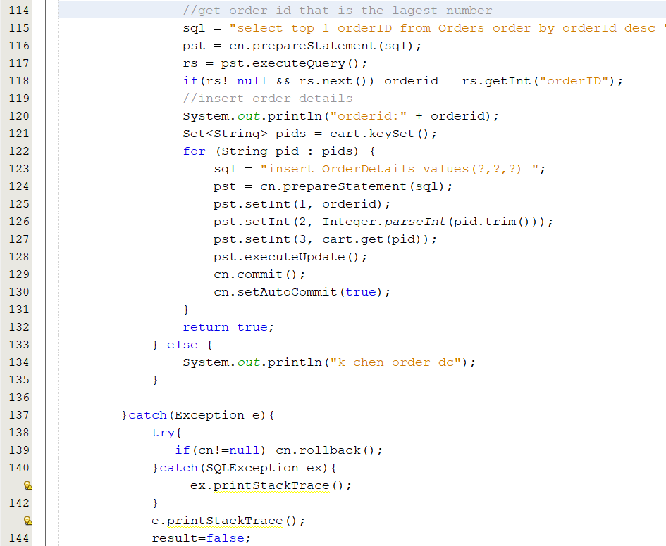

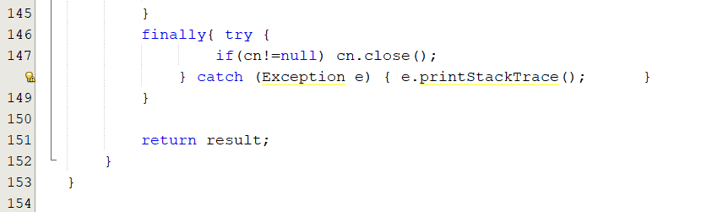

**Step 3: New a servlet named “saveShoppingCartServlet”**

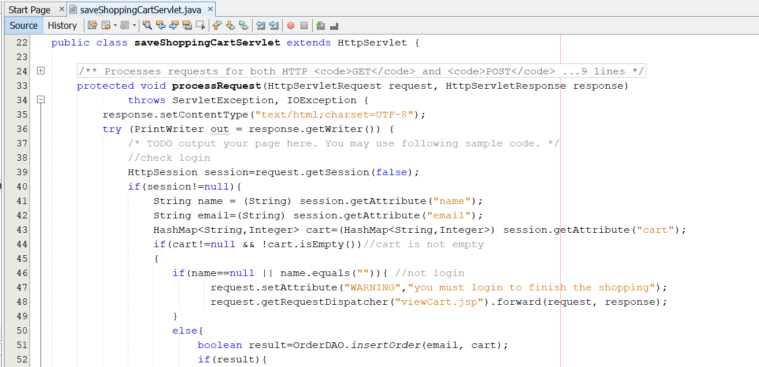

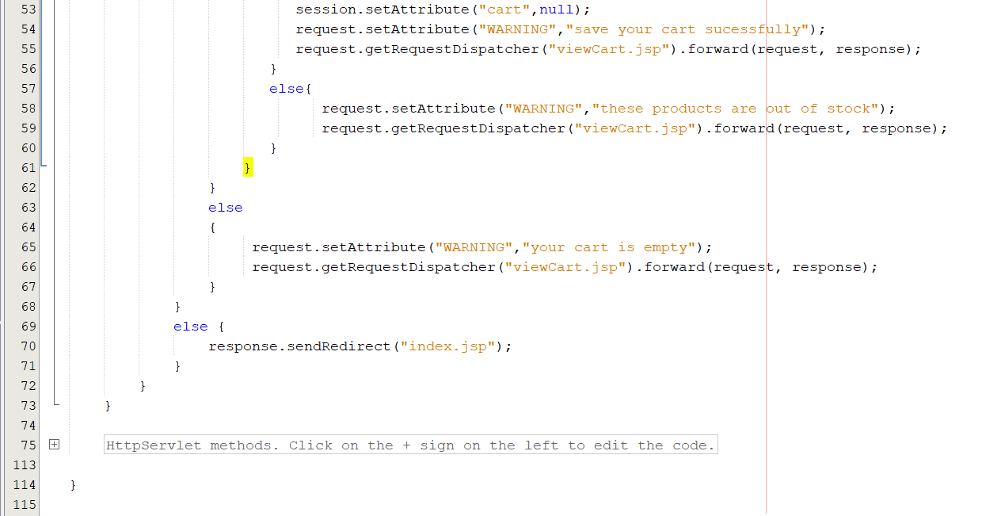

**Step 4: Open the page “viewCart.jsp”,add more the code:**

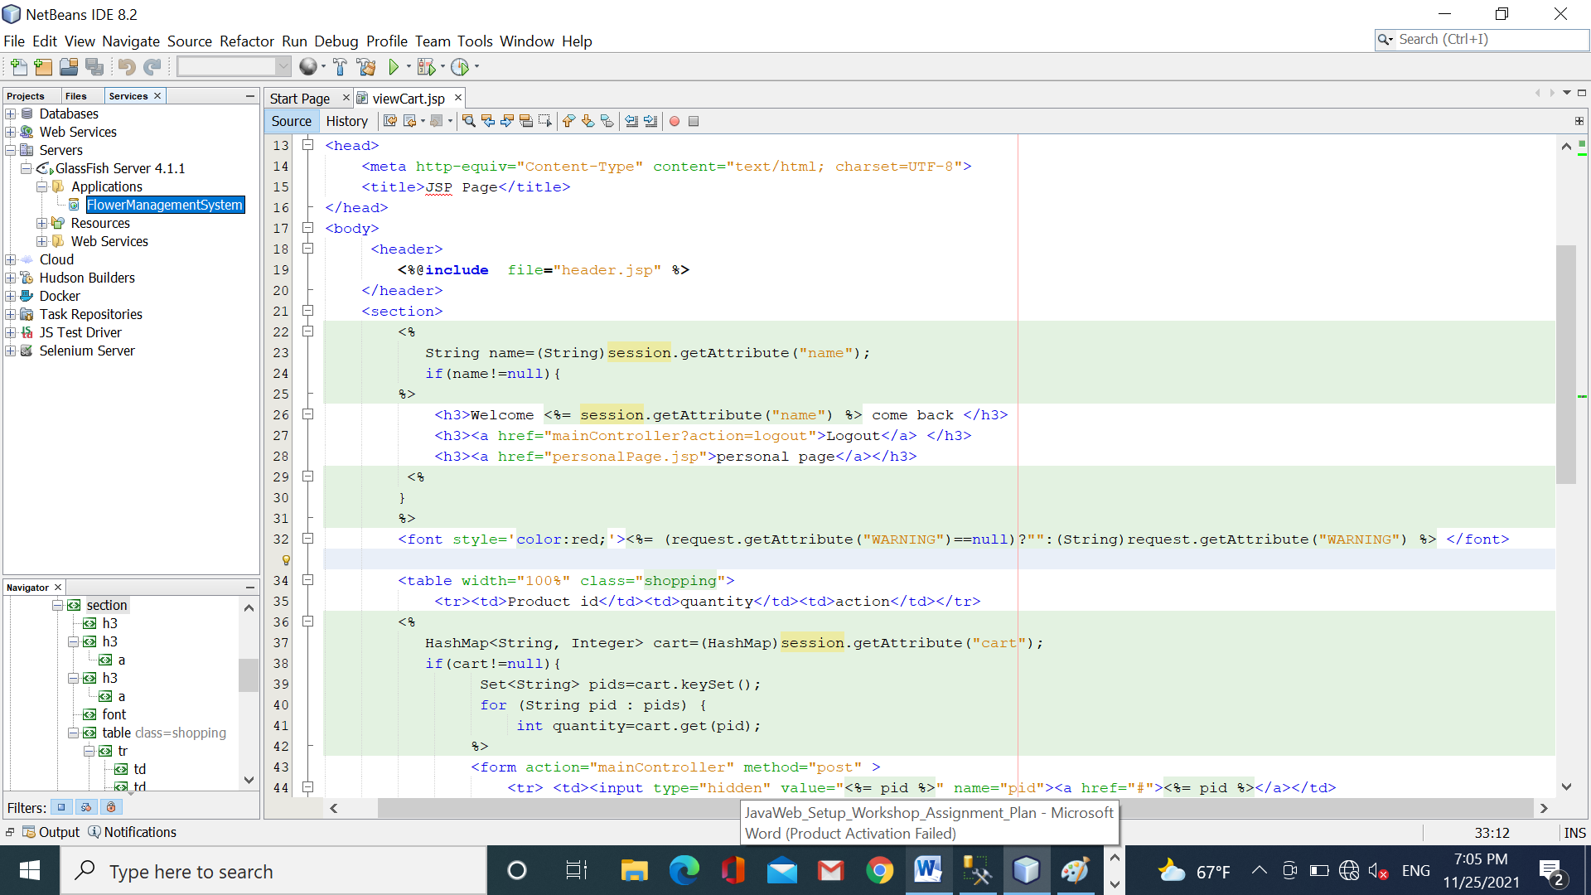

**Step 5: Open the page “login.jsp”, add more the code:**

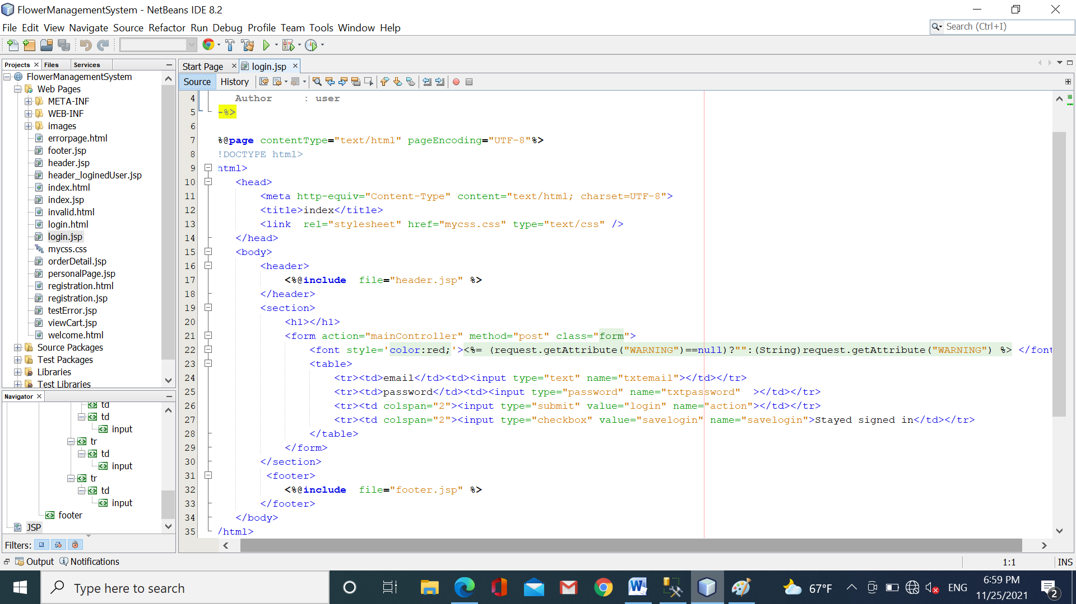

Step 6: Run your app

Test case 1: Submit the order without logging

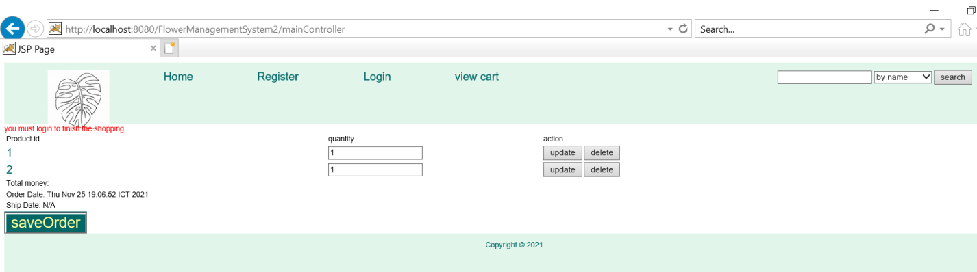

Test case 2: submit the order without any selected product

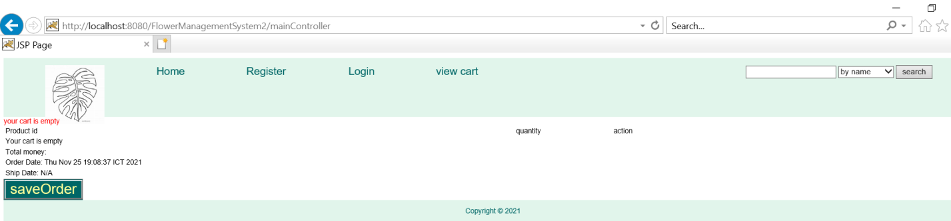

Test case 3: submit the order successfully

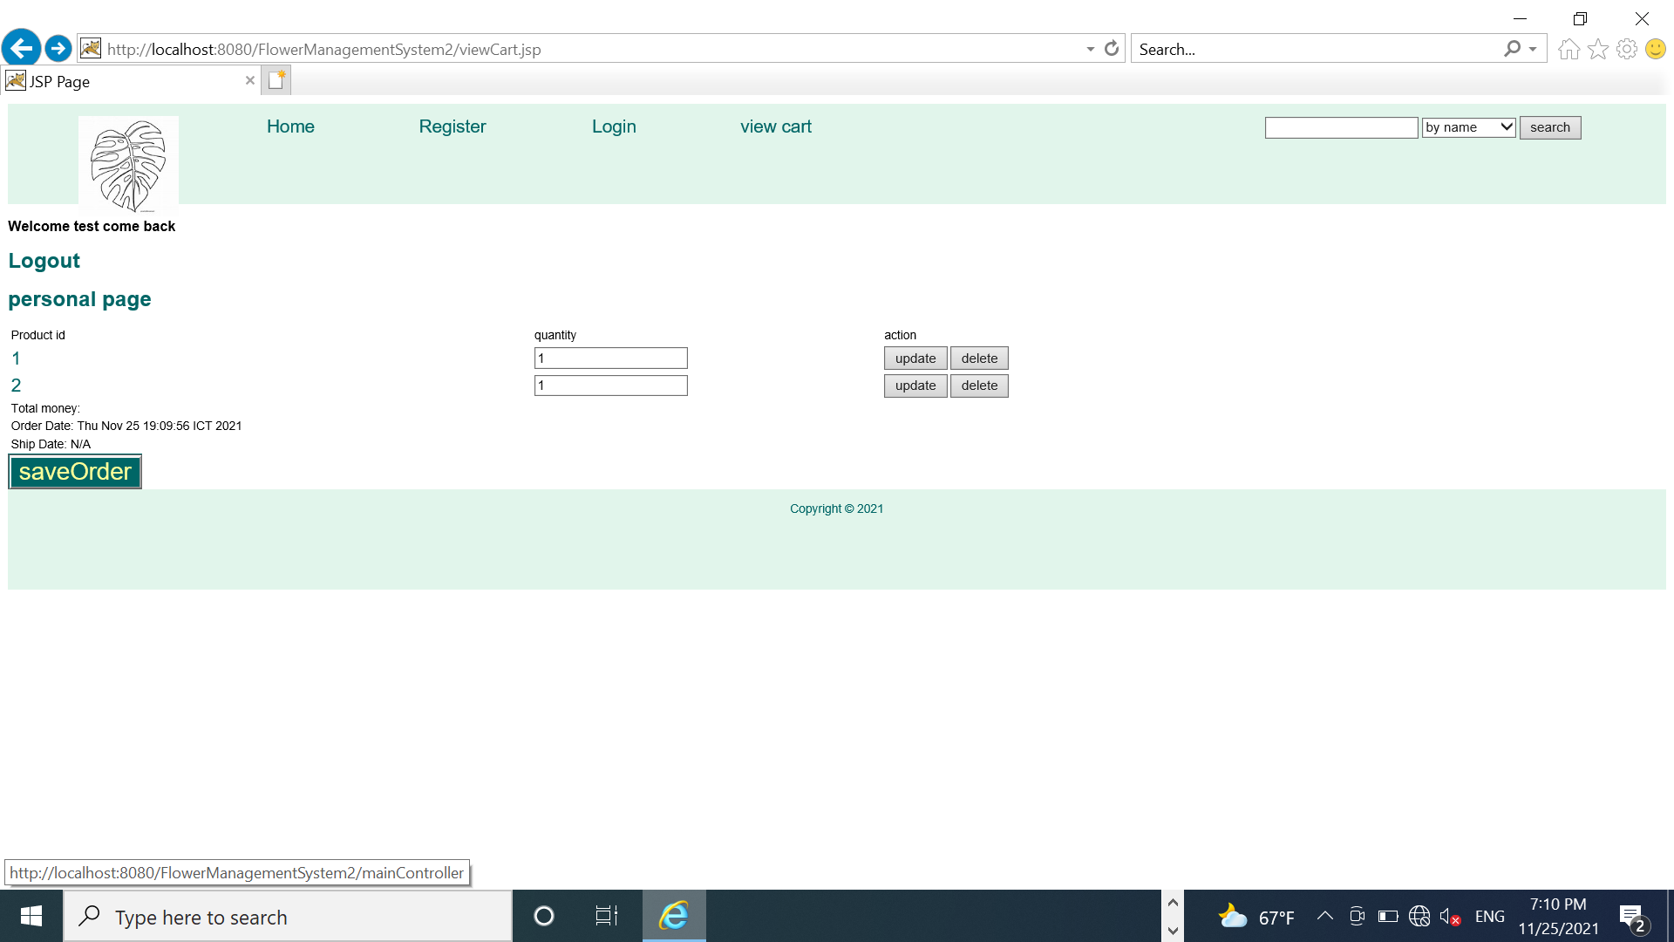

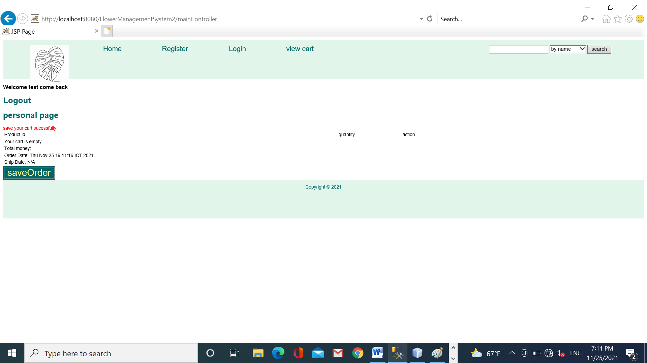

Click the link “personalPage” to view history

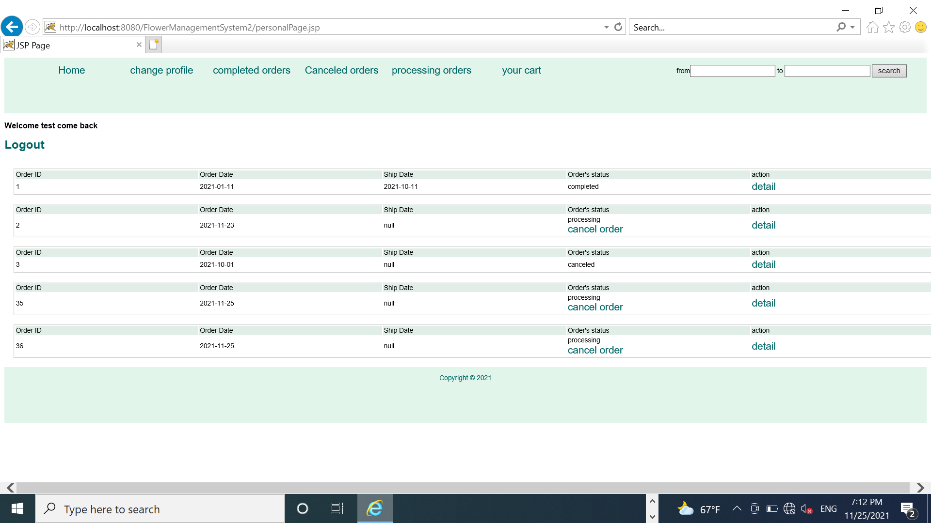

The advanced challenge:

1. You must finish the delete the product on the shopping cart
2. On page “viewCart.jsp”, you get the price, image of each product
3. Get the total money on the shopping cart
4. When the user clicks on the link in the column “product id”, your app will display the detail of this product.
5. Filter orders based on from..to. The result will be displayed on the page “personalPage.jsp”

Congratulations!!!! you have finished workshop 5 ☺ ☺

**Workshop 6: JavaBean**

**# JSP standard action # Expression language (EL)**

**Learning outcome:**

* Understand JavaBean and use JSP standard action to presentation
* Understand and apply EL in JSP pages

On the page “viewCart.jsp”, when the user clicks on the product’s id, its detail will be displayed.

Step 1:Open the file “Plant.java. the Plant class can be used as **Bean**, it must adapt the followings**:**

* + Java Bean **implemented from Serializable**
  + Bean class should **always use a package name**
  + Bean class **must have a public no-argument constructor**
  + The **properties of bean** (persistence) are **not declared “public”.** They are **accessed** through **getter and setter methods**.
  + The public **getter** method is used to **retrieve** the **properties** **of a bean class**
  + The public **setter** method is used to **set** the **properties of a bean class**
  + The first character of each property should **name** **in lower case** then the **accessor** methods are used along with the property name **with the first character of each word in upper case** (**Ex**: length – getLength and setLength)
  + The dataType of properties is **boolean** then the getter method is **isXxx** instead of getXxx

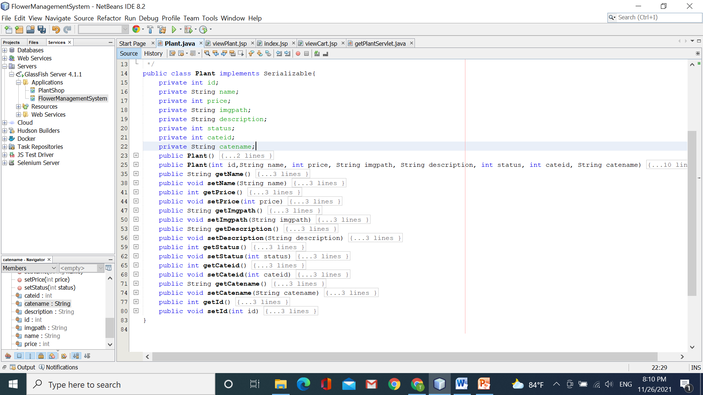

Step 2: Open the page “viewCart.jsp”, add more the code:

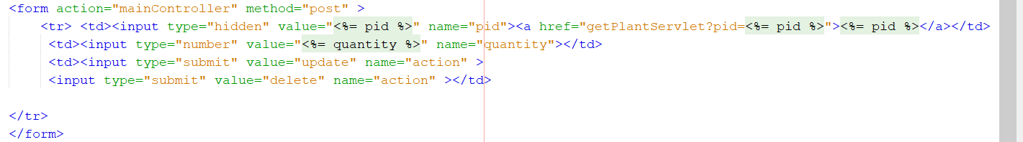

Step 3: Open the file “PlantDAO.java”, add the method “getPlant(int pid)”. Return the plant object based on the given productid.

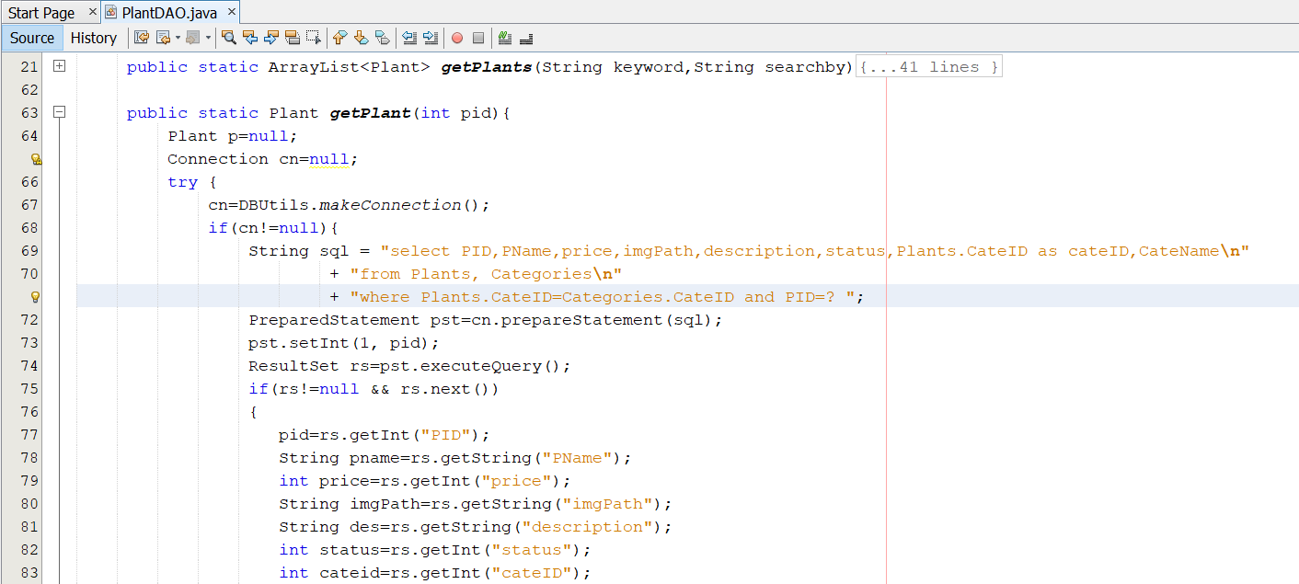

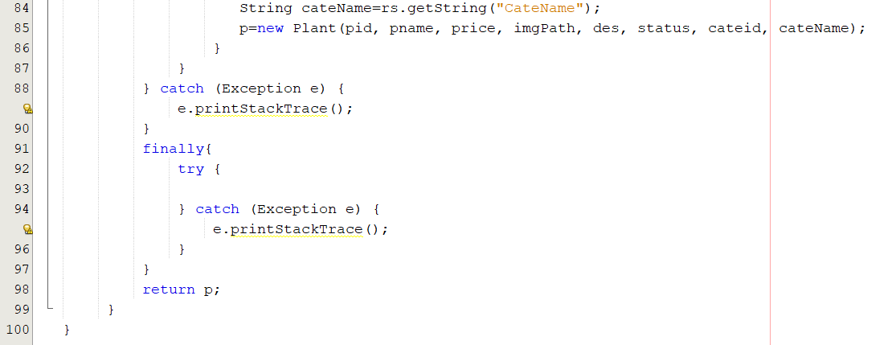

Step 4: In the package “sample.servlet”, create a new servlet named “getPlantServlet”.

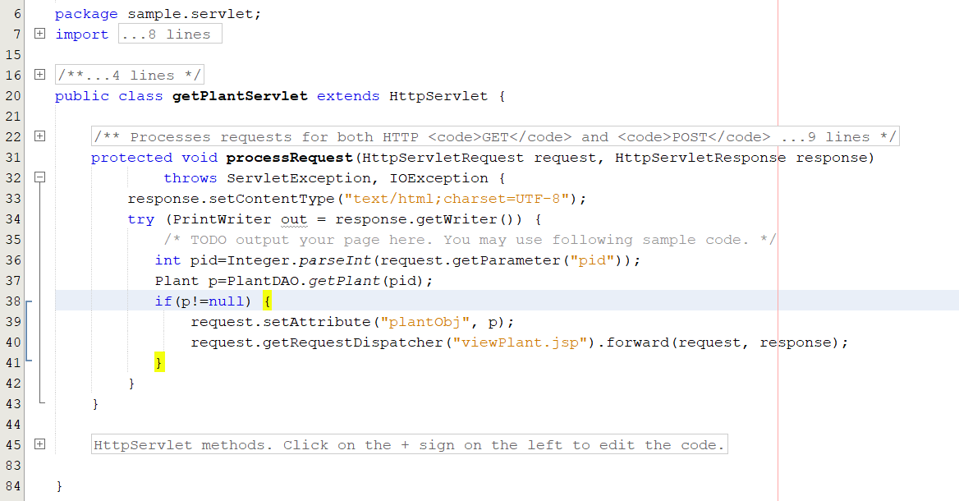

Step 5: Create a new page named “viewPlant.jsp”. For now, we use two ways to display information of the plant ( <jsp standard action, EL)

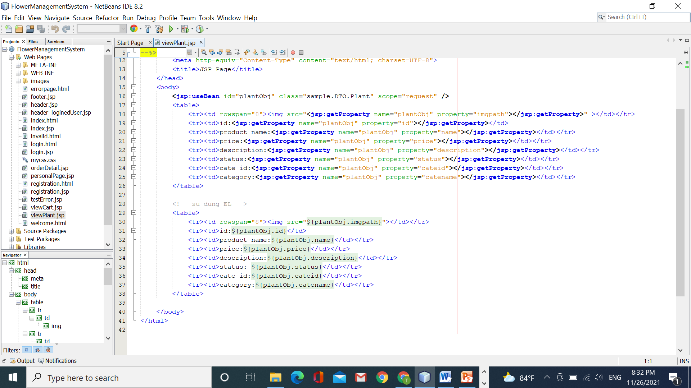

Step 6: run your app

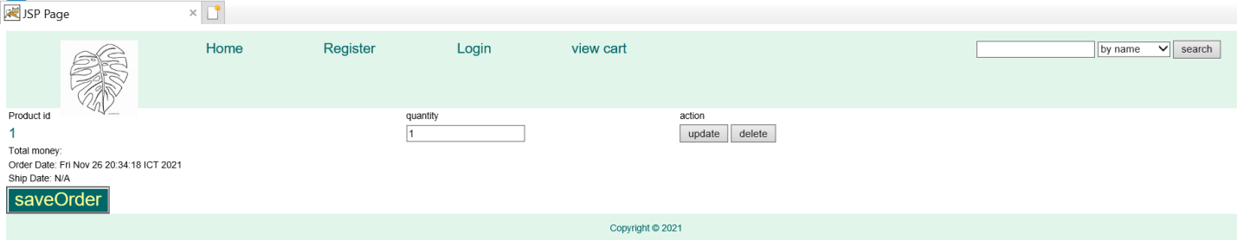

Click here

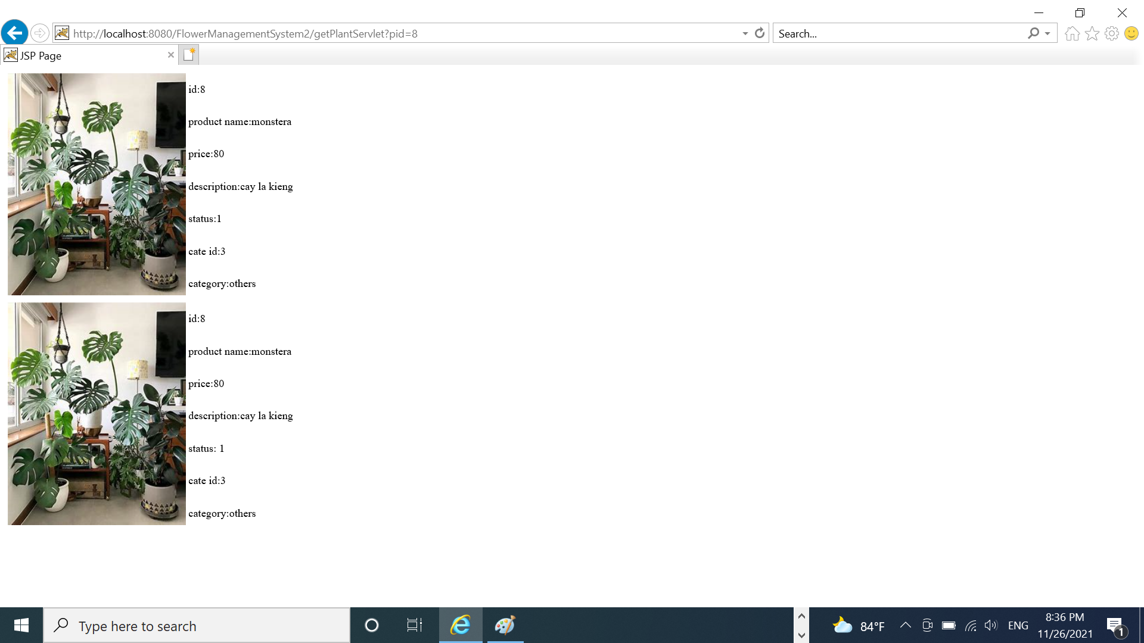

The advanced challenge: now, you should use JavaBean or EL to update all JSP pages in your app.

***Hint: Before doing advanced challenges, you should back up your app to restore if any ☹ ☹.***

Congratulations!!!! you have finished workshop 6 ☺ ☺

**Workshop 7: JSP Standard Tag Library(JSTL)**

#JSTL #CustomTag #Dynamic

**Learning outcome**:

* How to apply JSTL to remove all java code in the JSP pages

**Requirements: The admin functions after login:**

* Manage accounts: view all accounts, block/unblock an account
* View all orders, filter orders between from date and to date, filter orders of any customer.
* Manage plants ( view,create,update plants)
* Manage categories: view, create, update
* Log out

To begin to use the tag library, your project needs to do the following:

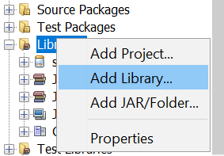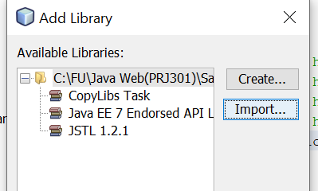

If not exist JSTL, you click the button “import”

Part 1: Create a home page for the admin

**Create a new page named “AdminIndex.jsp”. After login in the page “AdminIndex.jsp” will be shown for the admin.**

Step 1: Open the servlet “loginServlet.java”, add more the code:

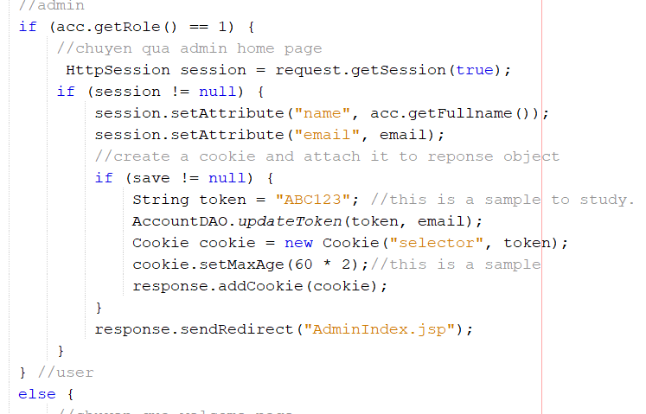

Step 2: Create a new page named “header_loginedAdmin.jsp”

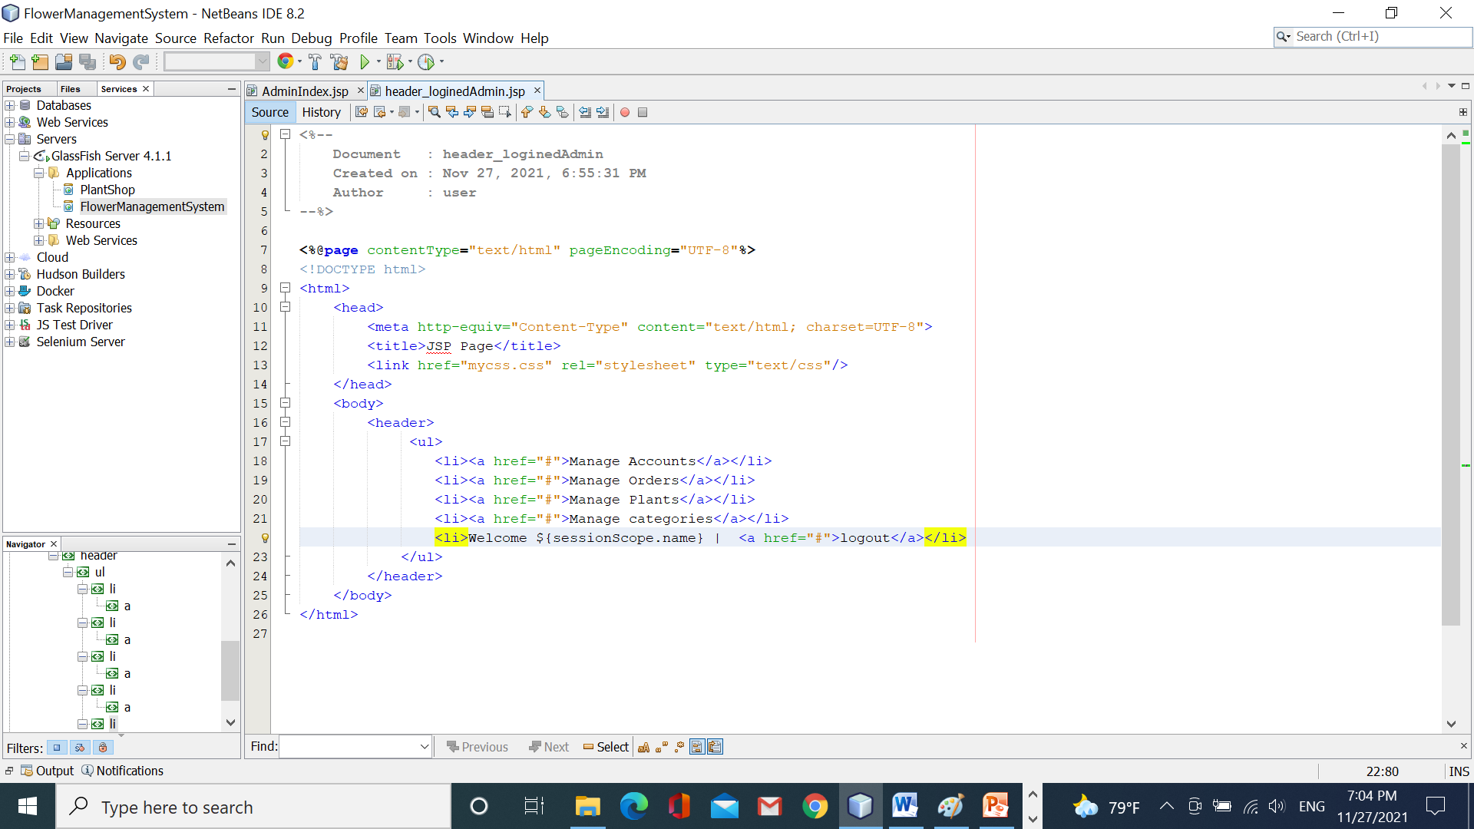

Step 3: Create a new page named “AdminIndex.jsp”

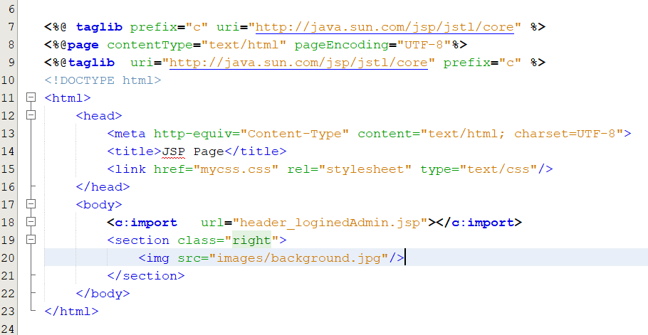

Step 4: run your app to get the result

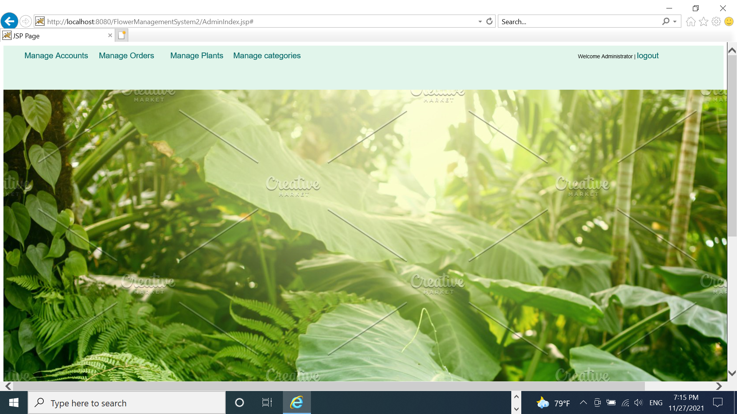

To finish this part, this index page should not be shown for illegal users. Review the page “personalPage.jsp” to do.

Part 2: Perform the function “manage Accounts”

When the admin clicks the link “manage Accounts”, the page “manageAccount.jsp” will be shown. The admin will perform block/unblock account of the user (update the column status of the account whose role is 0)

Step 1: Open the page “header_loginedAdmin.jsp”, add the code

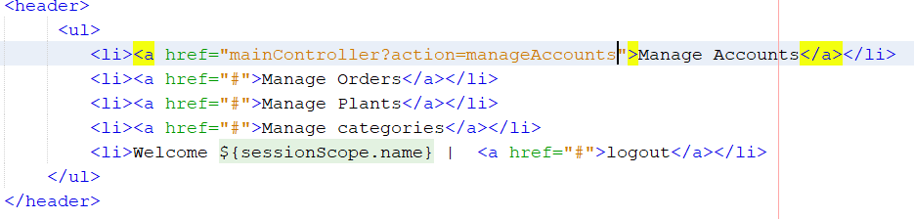

Step 2: In the servlet “mainController”, add the code:

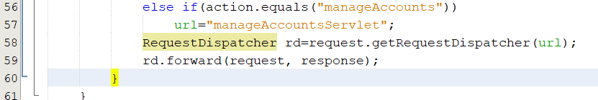

Step 3: Create a new servlet named “manageAccountsServlet.java”

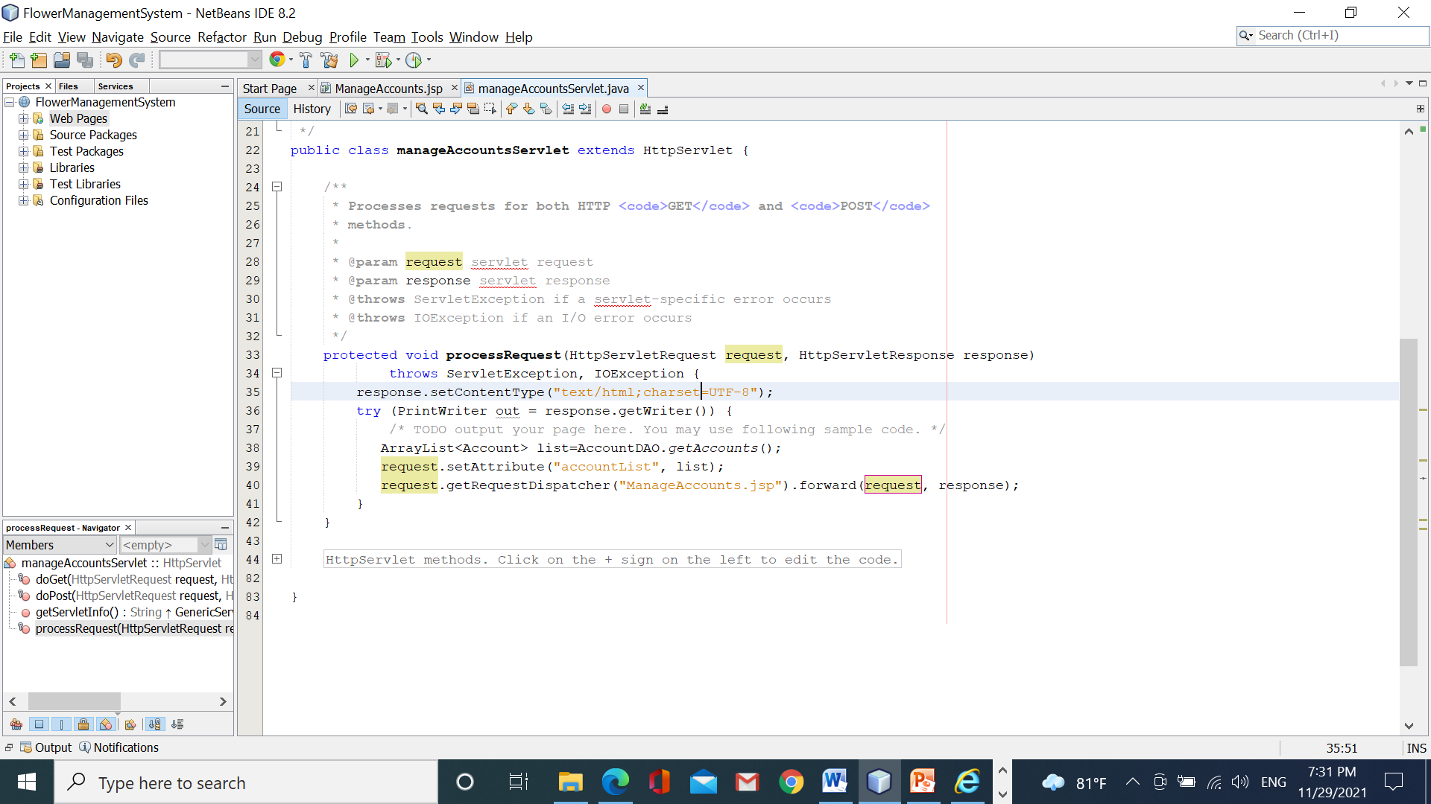

Step 4: Create a new page named “ManageAccounts.jsp”

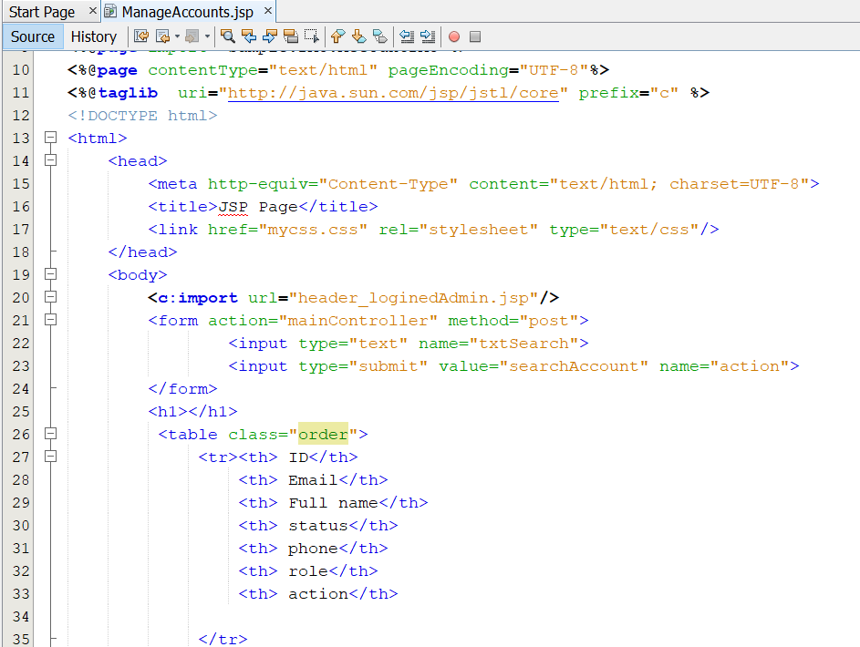

Search an account based on its full name

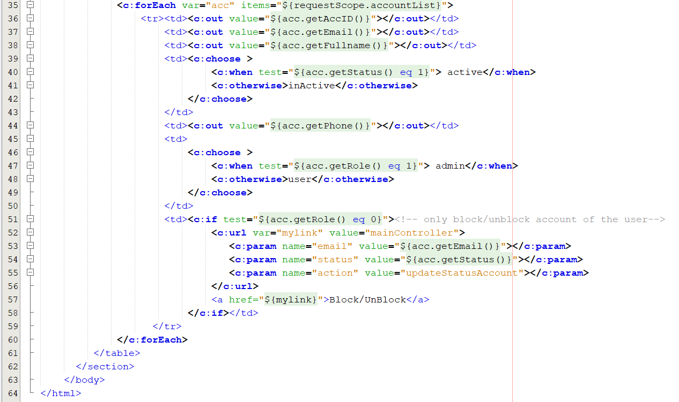

The link is used to change the account’s status.

Step 5: run your app to get the result

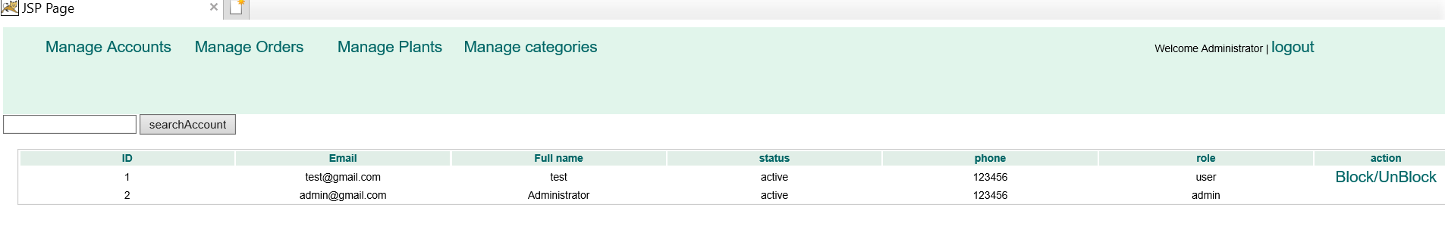

Part 3: Perform the block/unblock the account

When the admin clicks the links “block/unblock”, the account’s status will be changed

Step 1: Open the servlet “mainController”, add the code

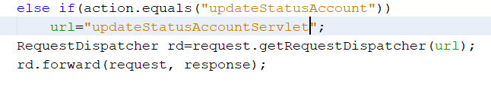

Step 2: create a new servlet named “updateStatusAccountServlet.java”

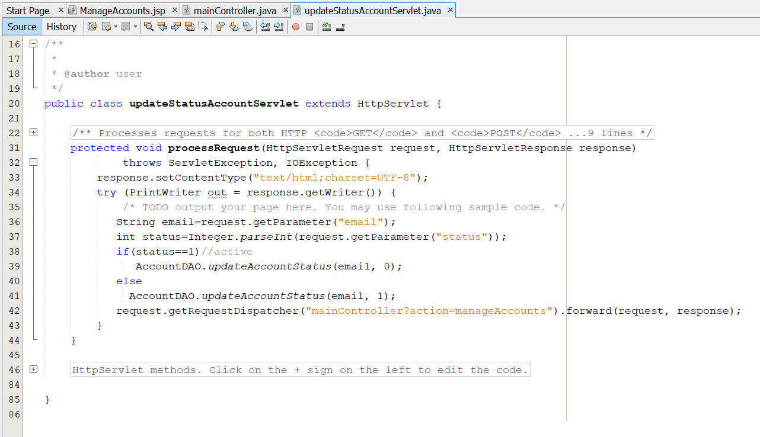

Use this code to load all accounts again

Step 3: run your app

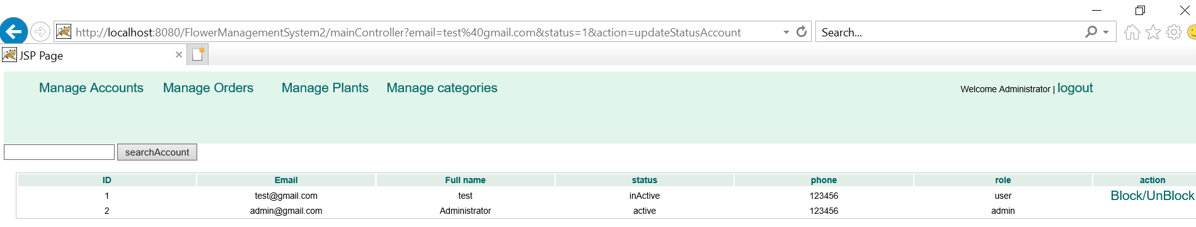

The advanced challege:

1. On the page “manage accounts”, you must finish the search account function.
2. Perform the functions: manage Orders, Manage plants, manage categories
3. Finish the logout function ( the same as the user’s logout)

Congratulations!!!! you have finished workshop 7 ☺ ☺

**Workshop 8: Filter**

# Filter chain #Request/Response Wrapper class # Fileter as Controller

**Learning outcome:**

* Understand the role of filter in the JavaEE
* Understand the role of request/response wrapper class
* Know to apply filter as the main controller

Requirements: Student must perform all demos in the lecture.

Congratulations!!!! you have finished workshop 8 ☺ ☺

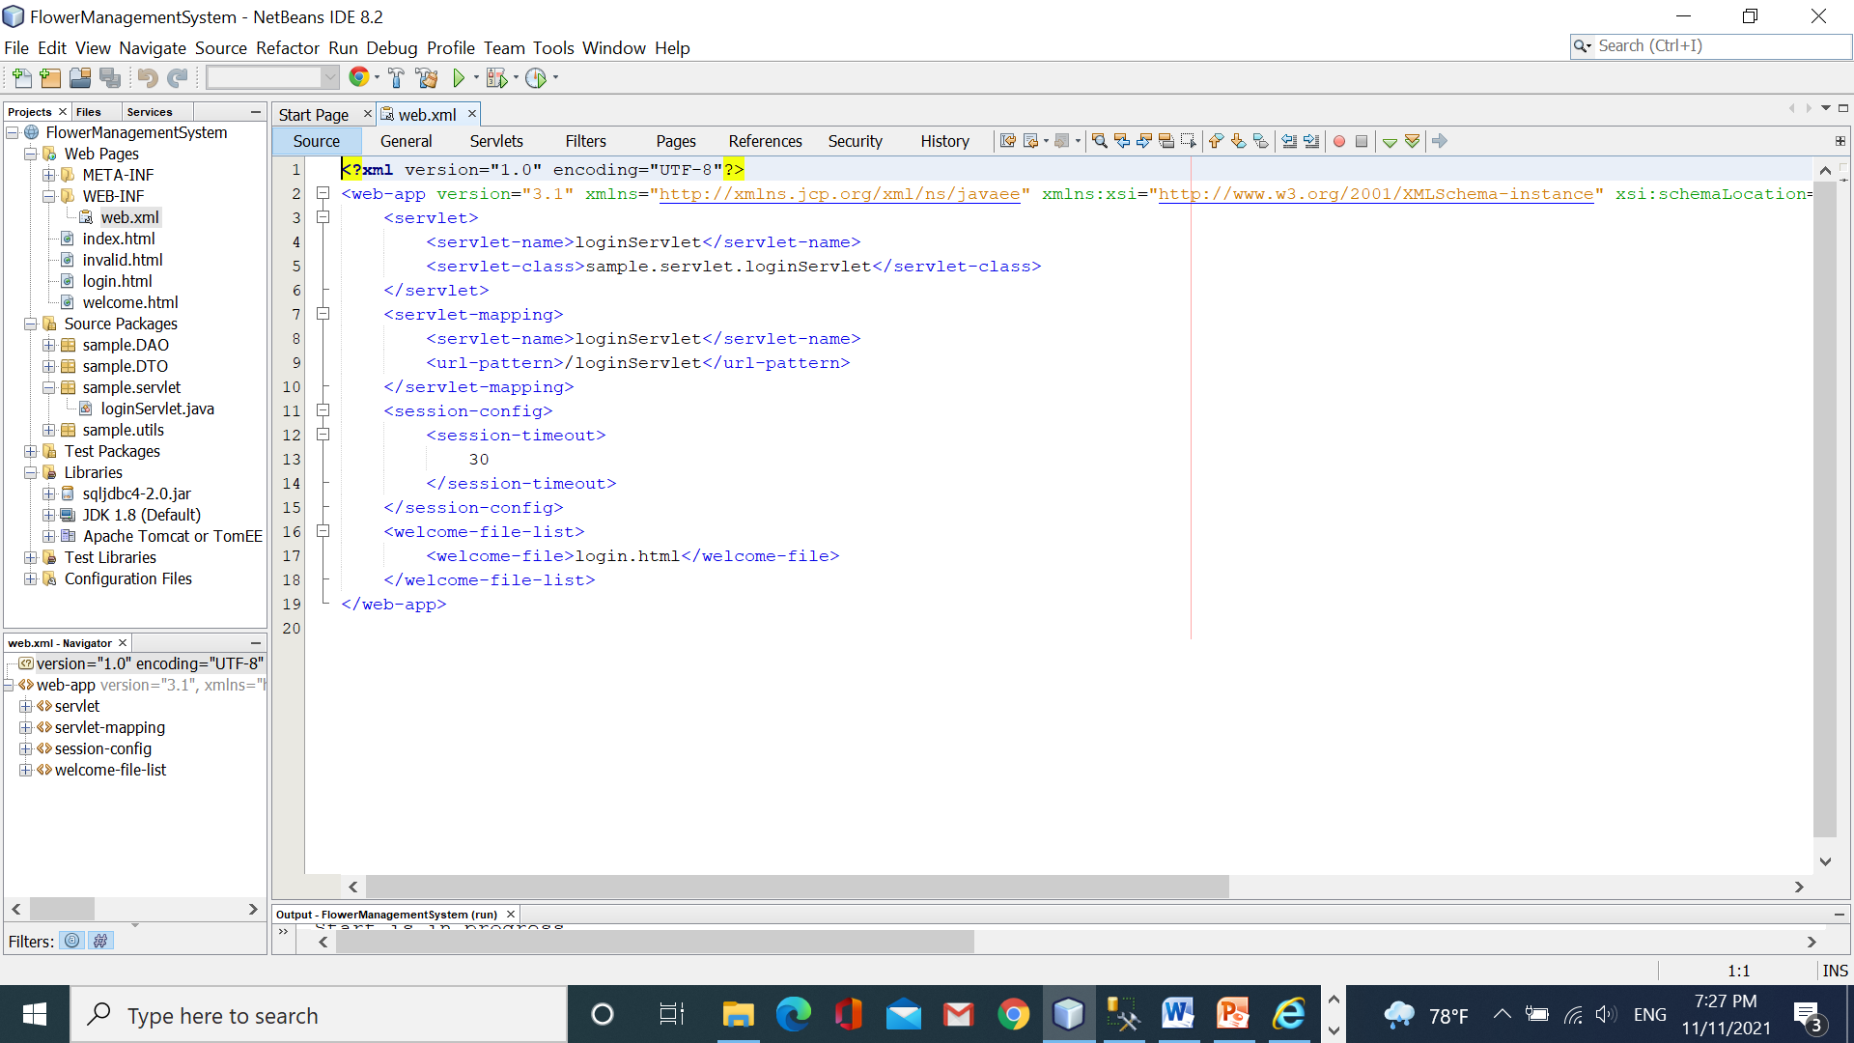loginSLoBottom of Form

Bottom of Form